

Staff Handbook 2018

Contents

1. Introduction p3
2. Values statement p4
3. The site entrances and exits p7
4. Fire and evacuation procedures p8
5. Pupil attendance p9
6. AM/ PM procedure p9
7. Attendance monitoring p9
8. Staff absence p10
9. Staff list and contact details p10
10. The school day p12
11. Curriculum Pathways p13
12. Curriculum entitlement pledge p14
13. The Curriculum p15
14. Assessment and record keeping p16
15. Core CPD p18
16. Peer Observation p19
17. Appraisal p20
18. Meetings cycle p21
19. Briefing p21
20. Safeguarding procedures p22
21. Eating with pupils p22
22. Staff resource area p22
23. Teaching and Learning Resources p23
24. Behaviour as communication
25. What to do if there is a problem

Introduction

Welcome to Tor school. This is the start of something brand new and exciting. We are the only local authority PRU in the country to have a new build, but this is not just about the building. A school is much more than bricks and mortar and the important parts are the people and the relationships they form with each other.

If you were previously employed at the Mendip Centre, The Link Education Centre, The Short Stay School or Mendip Inclusion Project you are now part of something different. Together we are stronger, more flexible and share a common set of values. How we put those values to practice is set out in this handbook.

To work here you need to understand young people. You need to be able to accept that as they grow up they often make mistakes and get things wrong. This is a natural part of developing as a person. Some young people find this more difficult than others for a variety of reasons. There are times when this makes a full-time placement in a mainstream school inappropriate. Some pupils just do not fit; that is why they end up with us. However, in a mainstream class on a Friday afternoon somewhere near here, one teacher is coping without about 30 pupils just like ours. We are privileged to have such great teacher pupil ratios.

Very often the reason young people find it hard to cope in mainstream schools, is that despite all the support they receive, staff do not have the time to build relationships and truly understand what makes them tick. Here we take the time to invest in those relationships and see them as the foundation on which everything else is built.  Some of our young people have early experiences that lead them to behave in particular ways to protect themselves from harm. Others have learned to behave in a manner that creates a sense of self-worth. Others are still emotionally at a much younger age than they actually are. We see behaviour as a form of communication as well learned responses. We see behaviours as opportunities to teach and learn. Some of our young people internalise their emotions and close down, or disassociate from those around them. Others externalise their behaviour and both of these responses can be challenging to manage in different ways.

We work hard to understand the causes of social emotional and mental health issues and develop support for the child or young person holistically through a plan involving expertise from across the school. Having said this sometimes behavioural problems are not within child but within family and community. It is not always useful to medicalise behaviour. Sometimes it’s just power play.

We ensure our young people feel safe and secure, making them feel welcome and wanted as part of a school community. Sometimes it can be as simple as a smile, a cup of tea and a biscuit. Warmth, humour and unconditional regard are inherent aspects of our provision here.

We cherish and value our staff; appreciating that there are people who work really hard in the background as well as in the classrooms, to ensure our pupils get the best life chances they can. As a member of staff here you will be expected to work hard and be totally dedicated. I need all of our staff to go the extra mile. I have high expectations and want to create an environment and ethos that is challenging but supportive. This is not a job for the faint hearted, but you will be treated with warmth, humour and positive regard. This is an amazing job and we are really privileged to work here.

We will get things wrong with our new building. What defines us is how we react when we do so. It is ok to make mistakes and to build on them without blame or fear of retribution. I hope you enjoy working here and are up for it.

Our Values

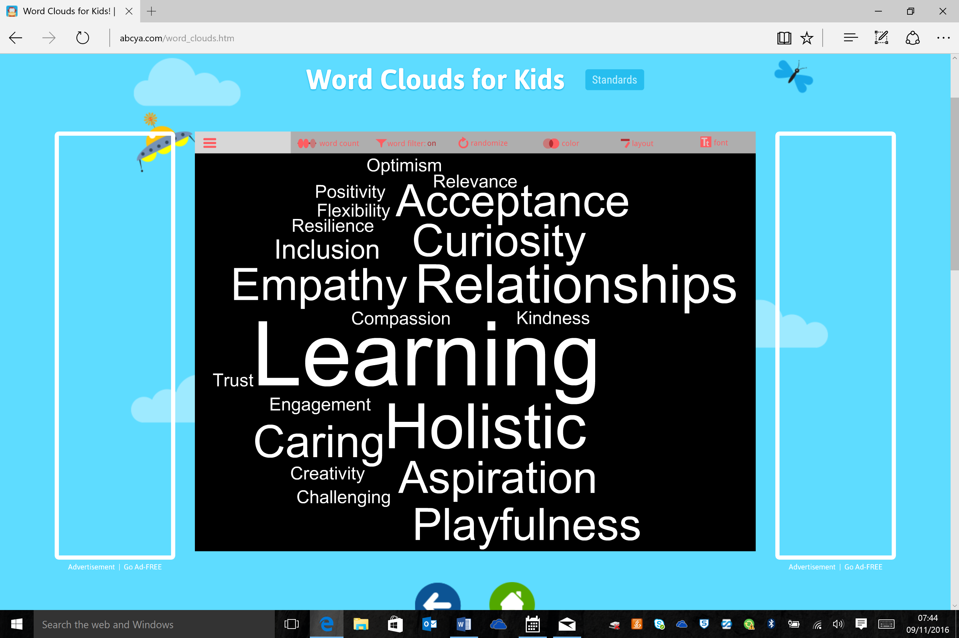

Perception is real to the perceiver. Each of these words carries meaning. Some of them are what we are, some are what we hope to achieve and see as important. You can see that Learning is the biggest word and is at the heart of everything we do. We are a school but not a mainstream school. Our young people are with us because they do not fit mainstream so we shouldn’t recreate something similar but on a smaller scale. We are an alternative provider and need to be creative and flexible in everything we do.

We believe that:

* relationships are everything
* the most important thing is the well-being of the child
* we should ensure basic needs are met before we try to get children to work
* qualifications are important but they are not everything
* we should *not* mirror mainstream school for pupils who are on roll with us.
* we should have high expectations at all times
* children are not bad people they are struggling to behave – it’s ok for them to get it wrong sometimes
* behaviour is a form of communication
* data should be used to improve children’s lives not the other way round
* we should work in ways that lead children to feel good about themselves
* humour breaks down barriers and builds self esteem
* listening to young people is essential
* bearing grudges leads to resentment – every day is a fresh start
* understanding young people and engaging with their emotional world, knowing what makes them tick is essential
* practise is worked out through relationships not formulaic strategies
* it is essential to engage parents, understand their world and talk to them often
* we should notice what young people are doing, reflect on this with them and acknowledge achievements.
* we show children we are genuinely pleased to see them
* we try not to take things personally
* learning takes place in a social context – spoken language is central to this
* staff should constantly review and renew how they work with children to find a way in
* staff should model the sort of behaviour we want from the children, especially to each other
* all feelings are ok but not all behaviours are ok
* an assessment of learning needs should always be considered alongside other assessments.

This is what we do:

* We are not frightened to show that we care
* We work hard at being good listeners and astute observers of young people
* We try to stay calm when there is verbal and physical violence.
* We try not to be shocked or frightened by young people’s behaviour
* We validate and acknowledge young people’s thoughts and emotions but we help them name them and reframe them. You can call this emotion coaching or VRFs but it’s really just common sense
* We constantly renew and review the approach we take with a young person to find a way in and talk to each other and challenge each other’s practice. This is done more formally through peer observation and solution circles
* We go out of our way to trust and support each other and show our young people that we do.
* We use humour as a way in and a way of calming and validating pupils.
* We take initiative and are flexible and creative – we offer help to each other if it’s obvious that we need it
* We talk to young people all the time and find ways to challenge and extend their vocabulary
* We eat with young people and use that as an opportunity to talk to them about them
* We use current events as a learning opportunity whenever possible
* We give young people an element of choice in their learning and make it fun. Sometimes young people do not realise they are learning
* We put the “right pupil on the right course” we tailor the curriculum to meet the needs and aspirations of young people.
* We take a no blame approach especially with parents and we work hard to communicate with them
* We invite parents to regular reviews and we go to their homes
* We work hard to get the parents to see we are on their side. This breaks down barriers and stops them feeling they are “stuck in the middle”
* We show high expectations but express low disappointment when things go wrong
* We reduce the distance between ourselves and young people by sharing our own lives and stories
* We show we are fallible and we back down and lose face sometimes
* We express warmth and affection to young people and let them know that every day is a fresh start

**In Groups and Out Groups – Us and them**

People are naturally drawn to belonging to a group. It’s how we form our identity. There is a tendency for people in one group to exaggerate the similarities between themselves and the differences between themselves and other groups. This is what has happened not only with our staff but also our pupils. Many of our young people were pushed into an out group at school and treated differently. The stroppy girls, the bottom set pains, the druggy boys, the overly anxious girls. We must be really careful that through our language and behaviour we do not reinforce these stereotypes. All Tor pupils are “our” pupils. Phrases like “our part of the school” or “our kids and your kids” and not helpful and get in the way. It would be easy to fall into the trap of treating the Blue Pathway as the PRU pupils and the Green Pathway as the Medical pupils. This is not the case and involves a mind shift on the part of staff, who will influence directly how pupils perceive themselves and form their group identity. ***When the adults change everything changes***.

It has been proven by scientific studies that contact with other groups and cooperative tasks reduce discriminatory behaviour. We must make every opportunity to do these two things with all of our pupils.

**The Site and Building**

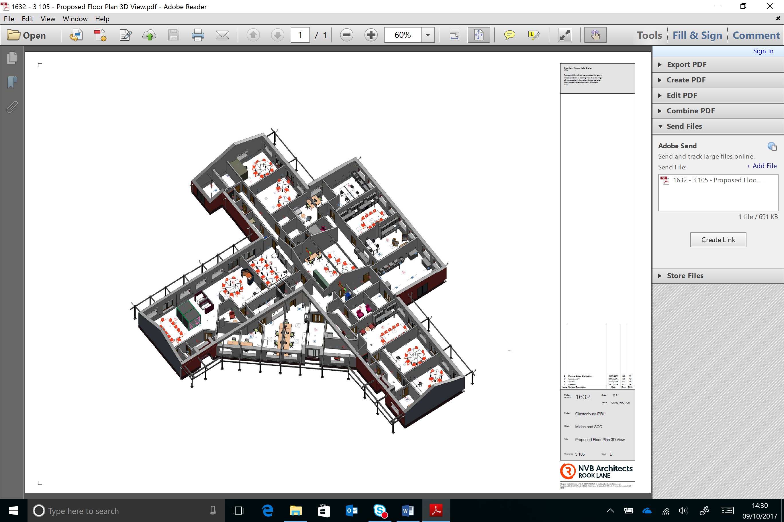

Pupils

Pupils

Main Entrance

At 7am the caretaker will unalarm and physically unlock the building at each of the 3 main entrances and also physically unlock the external gates to the sides of the building. This will all be locked and alarmed again at 7pm.

All staff will enter via the main entrance to the building when they arrive and log in using the swipe card system on Inventry. The swipe card is also the staff ID badge and must be worn at all times. The thumb print biometric system will then open the main security door to the school. When they leave the building they can swipe out, if leaving by the main door or if leaving by a pupil exit they can sign themselves out via the inventry app on their school mobile.

Visitors will also access the school using the inventry system and a badge will be printed with a bar code enabling them temporary access to the building. All visitors must wear a lanyard with the visitor badge on it. This will be managed by reception staff. Regular visitors who have been DBS checked will gain access by this system under the DBS tab.

Pupils will enter the building by the two main pupil entrances, or the main entrance. Thumb print access will enable them to enter the building from 8.30am until 4pm. The doors will open allowing access if one pupil enters the building. The doors will then close and can then be opened from inside the building. Outside of these times pupils will need to enter via the main entrance and speak to reception to gain access.

Primary pupils will be met at main reception and walked through the building by members of staff. The Headteacher and members of the senior team will meet and greet pupils in the morning outside the building.

**Fire and Evacuation Procedures**

In the event of a fire all external doors will open and everyone will walk around the outside of the building to the muster point which is the main car park. They should move in the safest direction clockwise or anti clockwise depending on where the risk is. Red fire alarm points are in each of the rooms next to external exits.

All external gates will open automatically except the two final gates which will be opened by a member of staff with a key.

Inventory can be accessed by App and a roll taken of staff and visitors by fire marshals. Our attendance app will also hold data on the pupils in the building at that time and a register should be taken.

Fire marshals will coordinate with the most senior member of staff to agree when it is safe to enter the building when all pupils, staff and visitors have been accounted for.

In the event of an emergency which is not a fire, such as an intruder in the building, a member of staff should open the exit gates by pressing one of the green emergency exit buttons situated next to each of the main external doors. Everyone should move in the same manner and direction as if it were a fire and muster at the same point. If there is a risk at this point, staff will direct everyone off site.

**Pupil Attendance**

Pupils are registered twice a day in the morning or afternoon using the Inventory App. This is done by the Tutor first thing in the morning or afternoon. If there is an offsite visit the member of staff leading the visit will mark the pupils as off site and on a trip. When leaving the building the trip leader should then mark the pupils as off site using the mobile app.

If a pupil is late they are marked as such and the number of minutes late recorded on the App.

If a pupil is absent a text message will automatically go the parents or carers and this will ask for a response. This can be a text message or return the call to a centralised admin line.

If there is no response within a reasonable time then a member of the admin team will telephone to enquire the reason for the absence.

**AM/ PM procedure**

The morning routine is as follows:

* 9.00am – all teaching staff meet briefly to make any last minute changes to timetable/ classes due to staff absence and exchange essential information.
* 9.15am All pupils and staff congregate in their designated family room, where pupils will be welcomed warmly and offered refreshment and something to eat in the morning in a nurturing manner
* All pupils will be registered at this time using our attendance App on mobile phones.
* Lessons will begin at 9.45am at the latest.

**Attendance Monitoring**

Tutors are primarily responsible for monitoring attendance and chasing this with parents and carers. Absence will not be authorised without evidence.

SLT monitor all attendance weekly using the following RAG ratings:

1 or more unauthorised absence – Orange

3 or more- Red and parents invited to an attendance meeting with the Tutor to discuss.

10 – Refer to EWO

Patterns of absence will also be monitored at to see if there is a lot of authorised absence.

Pupils whose attendance falls below 90% will have an attendance review and action plan.

Learning Plans will evaluate the impact and necessity of any targeted timetables.

**Staff absence**

If a member of staff is ill they should inform their line manager immediately on the day of absence. It is not ok to say the day before the absence that you will be away. You cannot predict that you will be ill. The line manager will inform SLT who will organise cover if needed.

If you are able to do so you should send any cover work into school by email.

If the absence is for less than 5 days the member of staff should complete a Sickness Declaration and Return to WORK Form HRAP02

The line manager will conduct a Return to Work meeting then pass this form to Admin to update SIMs.

If there are any concerns about staff attendance we will follow the SCC policy on managing sickness and absence.

**Staff Teams**

*Line managed by TS

Most staff will work across the school, utilising expertise. However you will be a Tutor to a number of young people and as a Tutor you will be attached to one of 3 Tutor Teams.

***SHOUT – Short Stay and Outreach***

This team is headed up by Tanya Howe and Matt Hill – They work with Primary and KS3 pupils in an Outreach capacity to prevent exclusion or in Short Stay capacity, working with pupils between schools or those who are with us for short periods before they move onto another provision.

**Green Team**

Working with those pupils on Green Pathway who are suited to a timetabled and need to predictability and safety of a tightly structured curriculum. This will be coordinated in February by Abby Atkins.

**Blue Team**

Working with those pupils who need a more flexible negotiated programme. This will be coordinated in February by Sue Staples.

As a subject Teacher you will ***also*** be attached to one of the following faculties and work with colleagues to develop and plan teaching resources and pedagogy. You may be a member of more than one Team

* Maths
* English
* Arts and Technology
* Science
* PE/ Outdoor Education
* Humanities

Tutor Teams and Faculty Teams will meet separately on a fortnightly basis. One week for each. We may feel that this isn’t enough for Tutor Teams and have a weekly meeting. We’ll see how it goes.

**The School Day**

|  |  |  |  |
| --- | --- | --- | --- |
| Staff arrive by | 8.45 |  | Pupils on flexible programmes transported by school staff on lease cars. |
| Team briefings and adaptations | 9.00 |  |
| Tutor/ Family Time | 9.15-9.45 | Taxis arrive |
| Lesson 1 | 9.45 – 10.30 |  |
| Break | 10.30-10.45 |  |
| Lesson 2 | 10.45-11.30 |  |
| Lesson 3 | 11.30- 12.15 |  |
| Lunch | 12.15 – 12.45 |  |
| Lesson 4 | 12.45 – 13.30 |  |
| Lesson 5 | 13.30 – 14.15 |  |
| End of day review with selected pupils | 14.15- 14.30 | Taxis leave |
| Lesson 6 extension | 14.15 – 15.00 |  |
| Staff stay until | 15.15 (except meeting days) |  |

**Curriculum Pathways**

Rather than define pupils by a label or designation pupils are assessed on entry and assigned to one of 3 curriculum pathways.

Pupils who are on Blue Pathway and Yellow Pathway will not always follow a rigid timetable structure although Maths and English will be timetabled 4 times a week for them. The rest of the week will be negotiated with the tutor. This is to enable engagement and buy in from the pupils.

Every 6 weeks the Learning Plan will be reviewed and the curriculum pathway evaluated against progress. Some pupils may dip into each pathway depending on their learning profile. So for example a pupil on Blue Pathway may also take part in some lessons on Green pathway.

**Maths and English KS4**

Maths and English are timetabled on 4 days a week for 45 minutes each during period 1 and 2. So, when Green Pathway pupils are doing Maths, Blue Pathway pupils are doing English and vice versa. There will be specialist teachers timetabled to work with pupils during these sessions. Green Pathway pupils will be in groups taught by one teacher with some support. Blue Pathway pupils will be again taught by specialists but all other teaching staff who are not on Outreach or teaching KS2 or 3 will also support Blue Pathway pupils during this time, picking up those who are not engaging and doing a lot more 1:1 time. The subject specialists will develop curriculum content and supervise the work. Groupings will be worked out based on pupil need and group dynamics.

This structure will still enable a tutor led programme with more choice for Blue Pathway pupils at other times of the day, but the choice will be more limited and constrained by availability of rooms and specialist staff. So, for example they may not be able to do Art or Science as these rooms and the teachers teaching in them may not be available. This will allow engagement but also give more structured choice preparing pupils for further education or training.

Initially from February to July 18 there will be a difficult period as pupils who are not used to this structure get accustomed to it, but later as new pupils come on board, it will be seen as the norm.

**A pledge of entitlement**

All of our pupils will be offered the opportunity to:

* Study a range of qualifications to open the door to further education or training
* Be inspired by and through the Arts
* Experience physical and outdoor education
* Take part in a trip to a museum or Art Gallery
* Make something you are proud of
* Experience the wonder of a wild and beautiful natural place in the UK or abroad
* Have a chance to express your views on local, national and/or international issues
* Take part in a public event –i.e. sports, dance, visual arts, politics or a concert
* Help others by being an active citizen
* Engage in dialogue with people from other religions and beliefs or other parts of the UK
* Visit a place of Higher Education or Training
* Experience a range of different career paths.

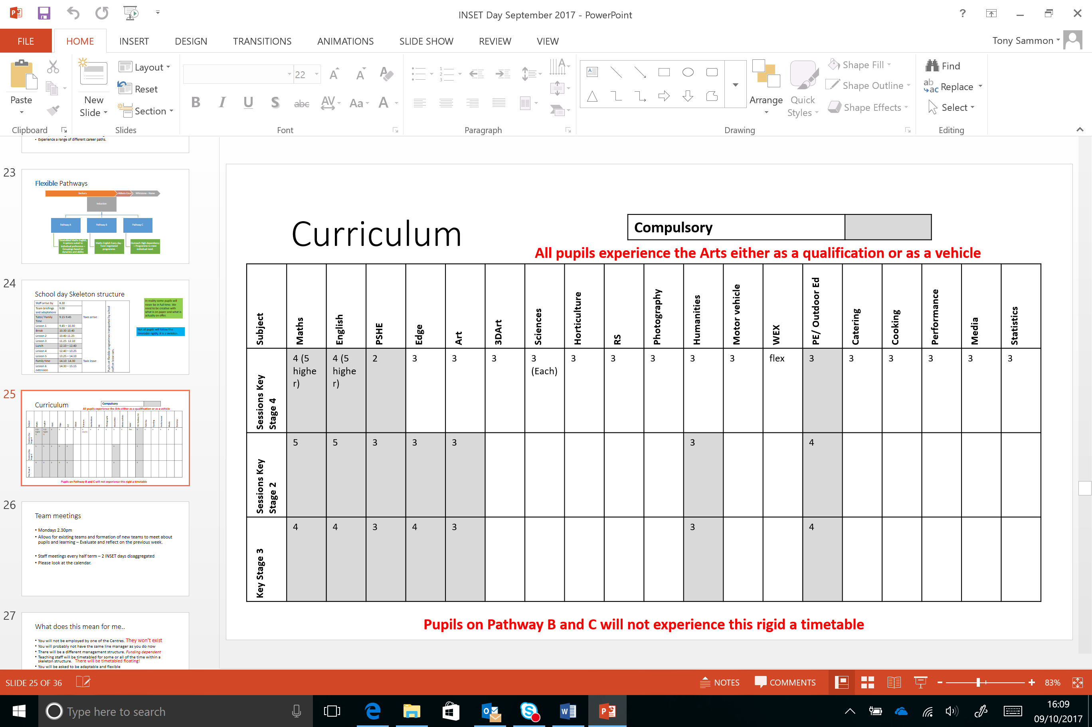

Pupils in KS4 on Green pathway will take up to 4 options in addition to Maths and English. This will form the basis of their timetable and qualifications suite. Some of our pupils, for various reasons, will not take a full range of qualifications but all will do Maths and English and we aim to get our pupils at least 5 qualifications with Maths and English.

At times a pupil will arrive with us with, a particular interest, in a curriculum area. We will endeavour to offer this as a qualification wherever we can whilst being mindful that we cannot dilute too much and spread ourselves too thinly.

**Teaching loadings**

A full-time teacher will be contracted to work for 30 sessions each week. This will include a rota at breakfast and break time. There is an expectation that staff eat with pupils at lunch and break and at breakfast. Obviously, people need a break. The actual teaching load without PPA is 27 out of 30. Part time staff will work pro rata. All staff will teach period 1 and 2. This will align teaching loads to create fairness across the school as currently some staff work longer hours than others and have more contact time with pupils.

There is also currently an inequity around the time so day for staff across current Centres. At Tor, teachers should arrive no later than 8.45am and leave no earlier than 3.15pm. Compared to many schools our teaching day is concertinaed into a shorter one, so it may feel fuller, but there is time at the beginning and end of the day. We need to look after each other and so if we see a colleague needs a break, we should help out. Some staff may have *Support* on their timetable. This is so that they can be around should difficulties occur with individual pupils and there needs to be a flexible response ie taking a pupil away from an inflammatory situation.

**Assessment and Record Keeping**

Our pupils’ achievement is evaluated against 6 dimensions which we call **Progress 6**

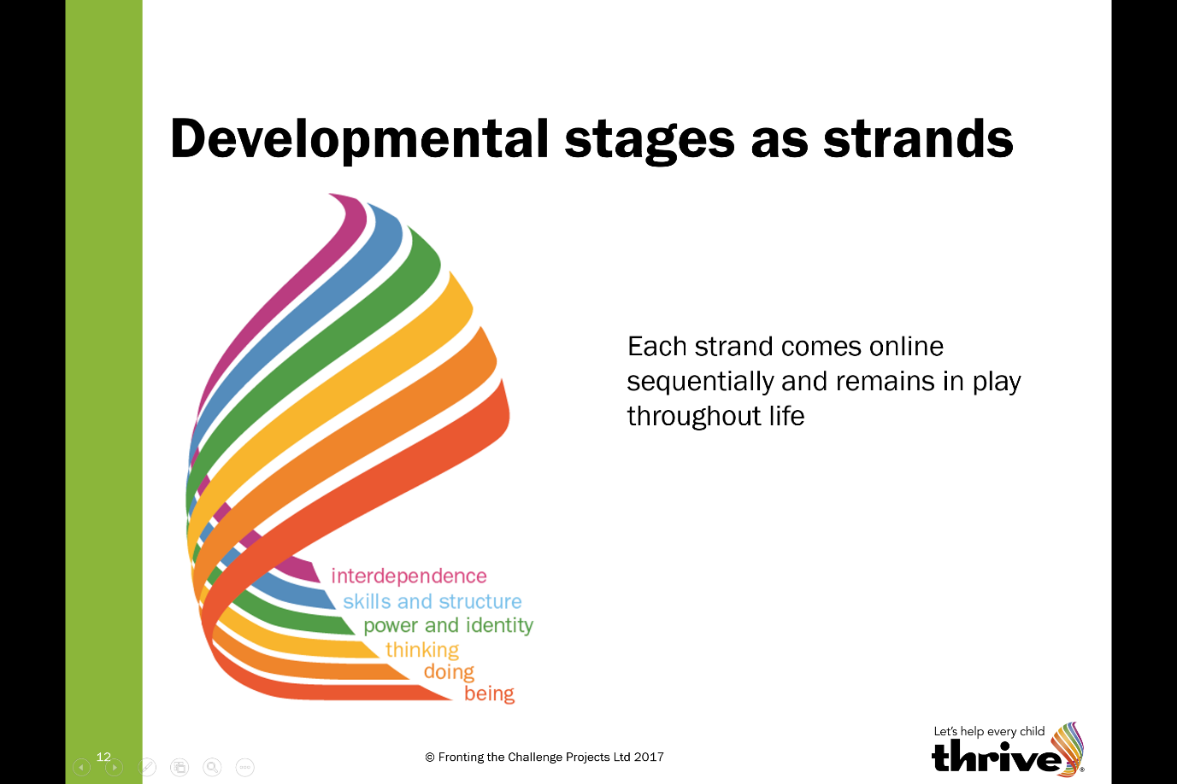A baseline assessment of each of these 6 dimensions will take place on entry and a Learning Plan then developed which will have a particular focus.

**THRIVE** is the tool we use to assess SEMH development. Thrive is a based on a model which divides child and adolescent development into 5 distinct stages.

We all have holes in our emotional development

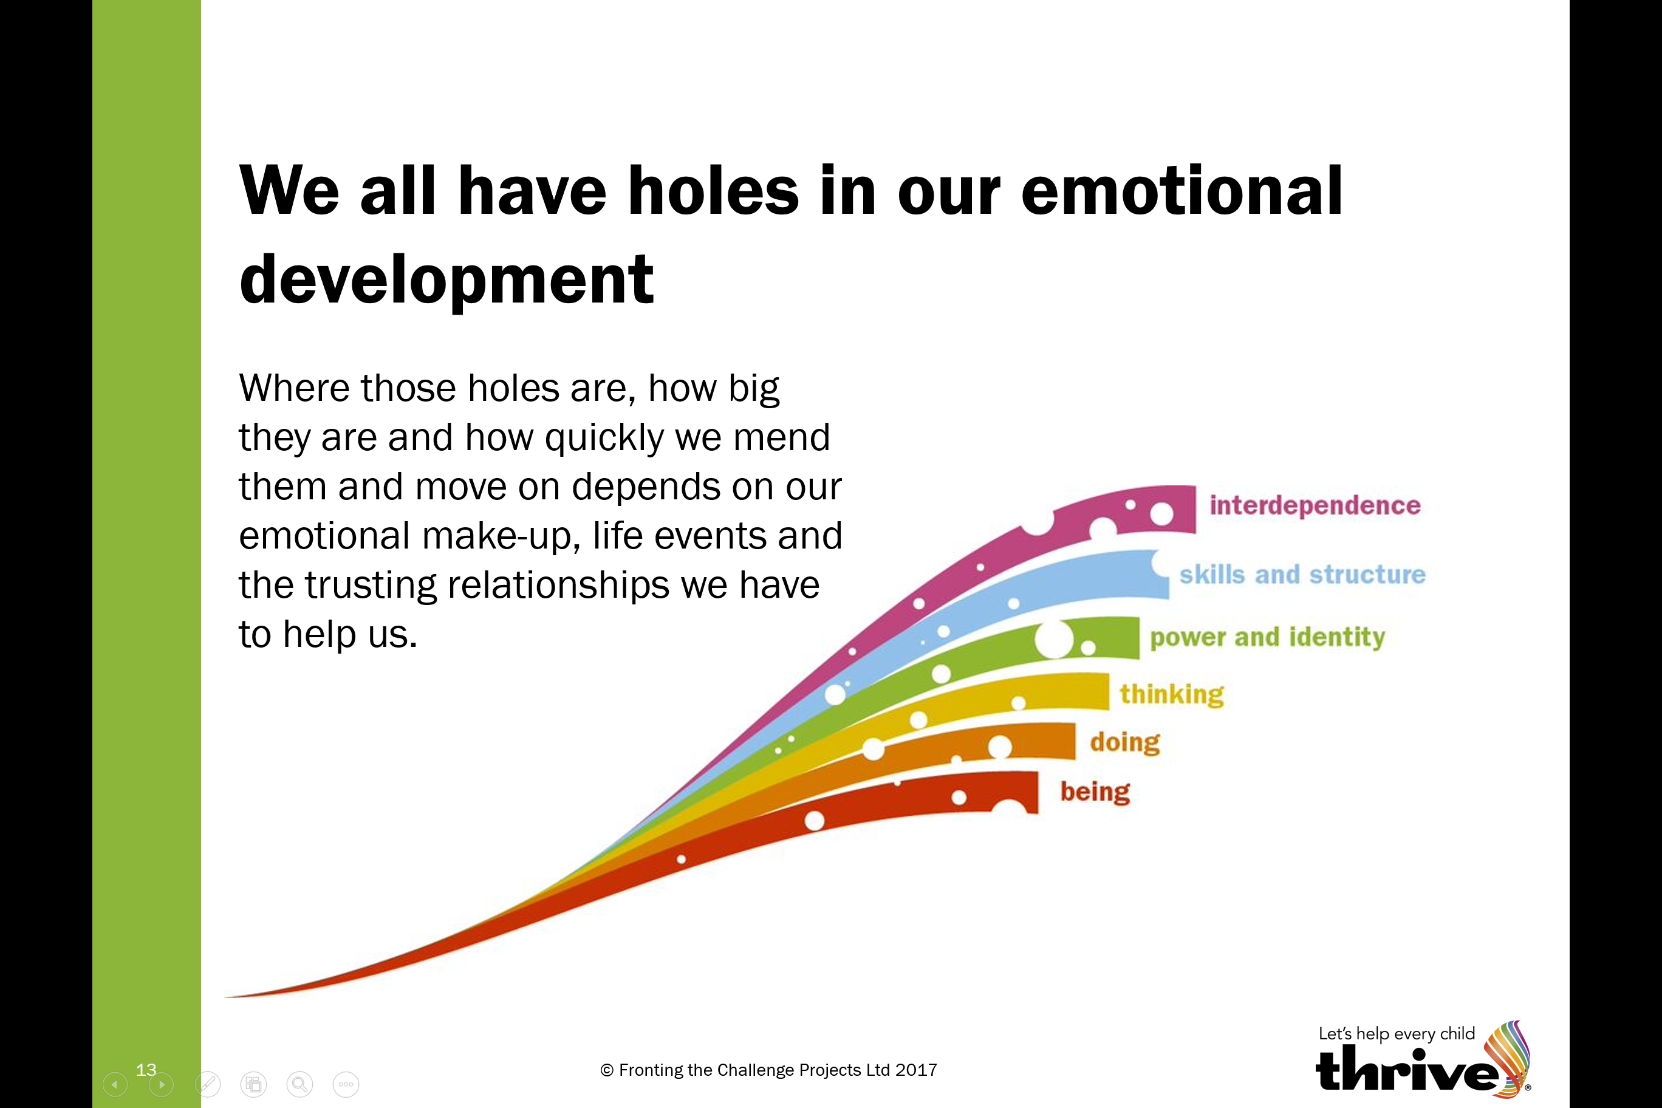

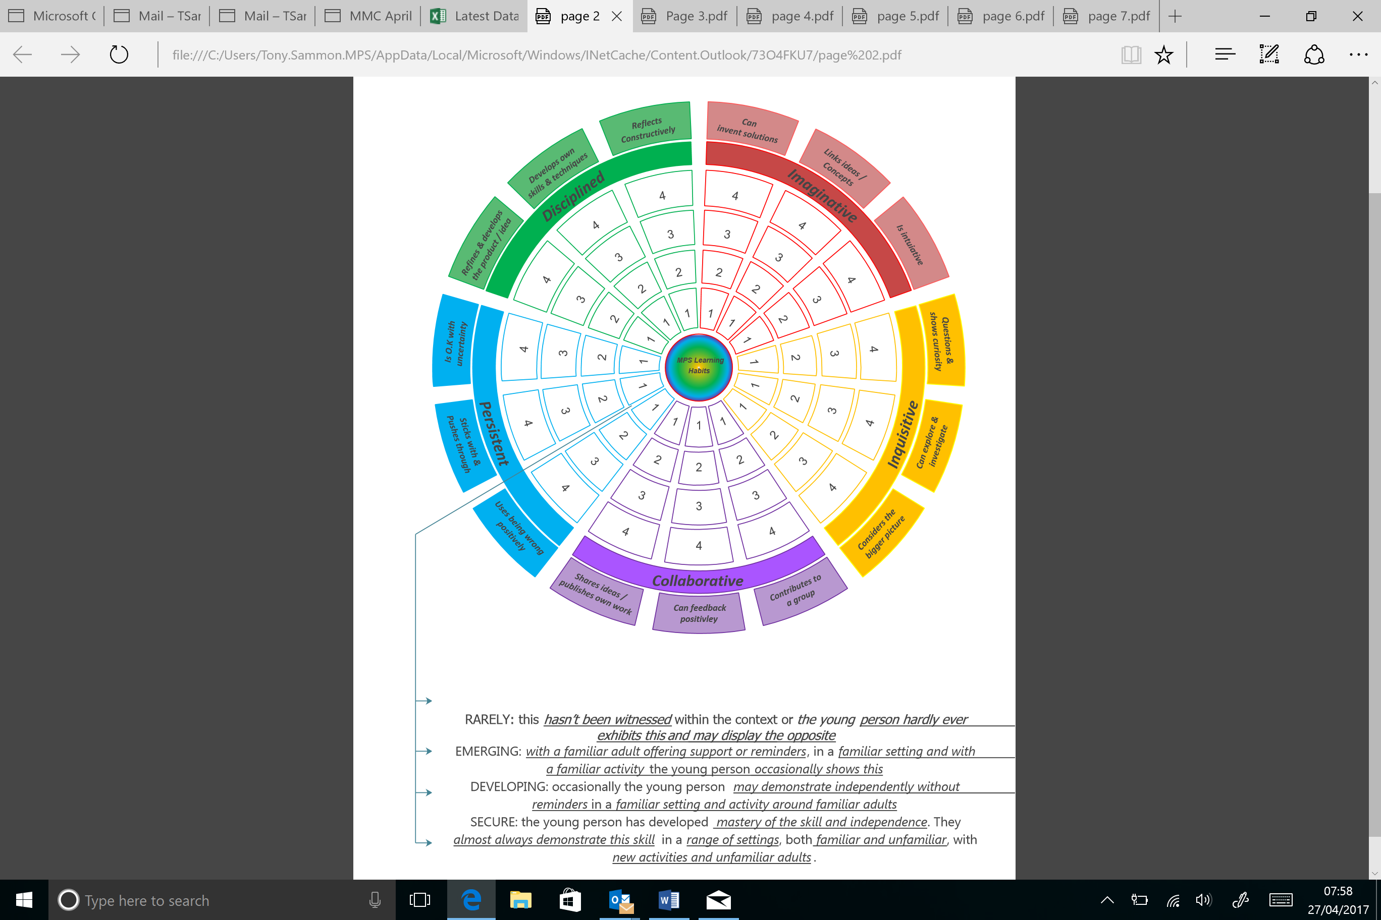A Thrive assessment enables us to see where the interruptions in development are and the online tool suggests strategies for plugging the gaps. Very often our young people have gaps at very early developmental stages such as Being and Doing. This impacts on their ability to manage emotions and moods.

**Learning Habits** is our assessment of just that. These are the skills and competences a learner needs to be successful.

The Tutor will assess the habits with our pupils and then discuss this with the team around the pupil to enable a focus on a habit which will complement the focus of the THRIVE assessment.

The subject lessons will then have a developmental and learning focus as well as a content focus.

So if a young person needs to be able to collaborate and see the need for rules the curriculum content and style of pedagogy should reflect this.

**The Learning Plan** is the foundation document which everything else is drawn from. This includes a baseline assessment, 2 THRIVE Targets, 2 Learning Habits Targets and contextual information. This is the main plan and review document for provision and should be the main focus for any review meeting or EHCP review with partner organisations. Additional paperwork will supplement reviews for pupils with Medical Needs and EHCPs.

***SENSE reports***

This is an online reporting tool and is our main management system for information about pupil progress and achievement as well as being a source of professional communication.

This is where we:

* Evaluate lessons
* Record engagement scores
* Write professional comments or record incidents
* Write Tutor reports weekly
* Record Progress data.
* Report on progress toward learning habits

Eventually it will also enable us to record against formative targets in a move toward assessment without levels.

**Core CPD**

All members of staff need to have a core knowledge and understanding beyond the generic teachers standards in the following areas:

Training is provided in each of these areas and there is also a growing knowledge bank accessed via a CPD toolkit online.

This comprises articles, videos, books etc to increase staff knowledge and to challenge thinking.

The CPD needs of all staff are assessed against teachers standards as well as this core knowledge during the appraisal process.

Members of staff are then asked to attend particular sessions throughout the year which focuses on aspects of professional development for individual staff.

**Peer Observation**

As well as ongoing “management by walking around” and seeing what is happening in individual lessons we also carry out a series of 3 peer observations each year. The purpose of these sessions is to extend teaching and learning experiences across the school, sharing expertise and encouraging professional dialogue about the learning process.

The model works as follows:

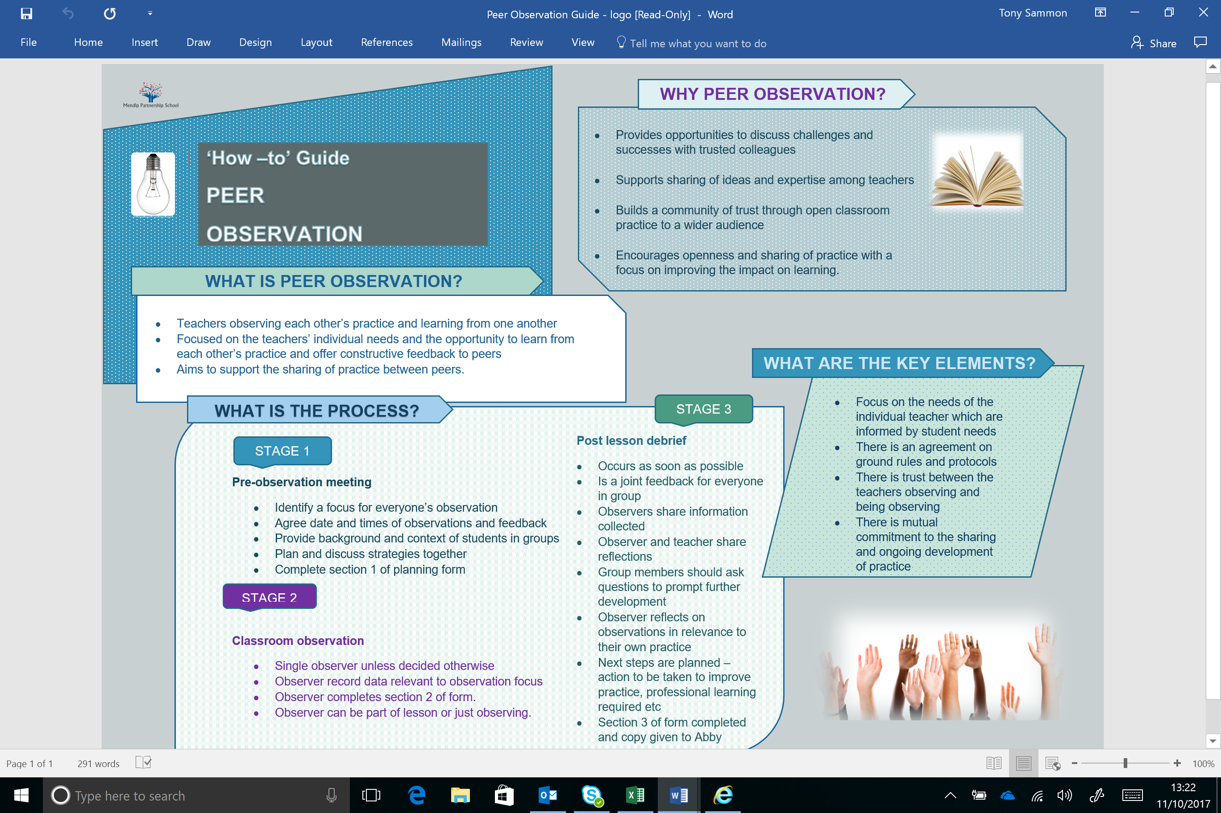

**Appraisal and Performance Perfomance Management**

People perform best when they are trusted as professionals to “get on” with the job. There should also be high challenge but low threat in any organisation to move forward and to provide development opportunities so that people are stretched and motivated.

The appraisal process is there to provide this challenge and to monitor performance of staff against agreed standards. If things begin to go wrong the appraisal process should build on regular line management so that there are no surprises, should issues of capability surface.

The process occurs as follows:

**Meetings Cycle**

Staff are expected to attend the following meetings from within directed time:

* **Monday Team Meetings** 2.30-3.30pm – Week 1 Tutor Teams/ Week 2 Curriculum Teams. We may need more time for Tutor Teams to meet.
* **Half Termly whole school meetings** 2.30-3.30pm – Whole school issues as well as CPD opportunities see calendar for dates.
* **Morning briefings** 10 -15 minutes each day with Tutor teams – Information sharing about pupils/ cover etc
* **INSET days** - 5 each year (some of which may be disaggregated)
* 5 hours of **peer observation reflection time** in observation groups.

**Briefings**

On Monday at 8.50am there is a whole staff briefing in the Art Space where we will go through main points for the week, themes and share good news.

Each morning Tutor Teams will then meet for 10 minutes at 9.00am to go through any issues that people need to be aware of that day and sort out cover arrangements and make sure everyone knows the plan for the day.

**Safeguarding Procedures**

All staff should read and be fully aware of school policy and procedures and read the core documents which are uploaded to My Concern.

***My Concern*** is the main record keeping system for any safeguarding concerns about young people. All staff will be given a log on and training in how to use My Concern.

Everyone is responsible for ensuring safeguarding procedures are adhered to. The site is secure and the access and exit arrangements will ensure we know who is on site at any time.

All staff must wear ID badges at all times. There is no exception to this. The ID badge will also enable access to the building by the inventory system.

The Safeguarding Leads are:

Tony Sammon – Headteacher

Sue Staples – Assistant Headteacher

Abby Atkins – Assistant Headteacher

Tanya Howe – Assistant Headteacher (currently absent)

Dave Curl – PFSA

Our Safeguarding Governor is – Dan Palmer

Logging an incident on My Concern should not stop you speaking to one of these people immediately to seek advice. There are posters around the school with details about how to contact these people.

**Eating with Pupils**

The staff resource area is a collaboration and Hot Desking space. It is not a staff room. Staff are expected to eat with pupils at lunch and to also spend break time in and around the family rooms. This is an opportunity to build and sustain relationships and to extend the spoken language opportunities for our pupils.

If a member of staff needs space away from pupils we can all understand and respect this.

**Smoking**

Many of our young people smoke. Previously at our Key Stage 4 PRU pupils were allowed to smoke in a safe area under controlled conditions. This was done for the best reasons and the best of intentions. In our new building with a range of different young people of differing ages this will not work. We cannot have one rule for one and one for another. We must also think about the modelling effect of younger pupils seeing older pupils smoking. There are issues of safeguarding and health concerns that we cannot ignore.

For these reasons this is a non-smoking site for pupils and staff. We need to find ways of coaching and working with our young people to last the school day without a cigarette. We will constantly review our approach to smoking including smoking cessation work. We should not get into a cycle of exclusions and punishments as this will destroy relationships, however we do need to make it clear to all pupils that it is not okay to smoke within or around the building.

**Staff Resource Area**

Located at the back of the Art Space this is a place for sharing of ideas and for Outreach staff to log on and catch up with emails etc. There are tea and coffee making facilities in this space. Tea and coffee are free for staff.

**Teaching and Learning Resources**

We have a Curriculum Network Drive which contains all Teaching and Learning resources. Within this drive is our ***Learning Habits Hub*** which has hyperlinks to Pedagogy ideas for each of the 5 segments. There is an expectation that this is a growing resource and staff will add to it as they develop and refine ideas.

There is also a physical resources store adjacent to the Arts space which houses a range of resources, games, textbooks and workbooks. To book out a resource use the Scheduler which is an online booking system. This shows where the resource is kept and who currently has it. It is important to return resources once they have been used so that others can have access to them. No-one should simply go into the resource room and take a resource without booking it out.

There is a lot of storage space in the building and staff will be allocated an area to store specific curriculum resources. For example all Maths and English resources will be in one place. There are also places to store personal teaching resources in the teaching walls and in storage units.

**ICT resources**

Our new building has some state of the art ICT facilities. There are 6 interactive Avacor Screens located around the school. These come with a pen/ stylus plus an interactive keyboard and mouse. The remote controls for these devices are kept locked in the classrooms. Staff can also use this screen as a casting device from their laptops.

All other screens around the building can be “cast to” using any lap top or Ipad. On Windows 10 devices this is done in the Action Centre tab using the Connect Symbol. The screen can then be used as an extension of the device. Volume control and on/ off buttons are controlled by remote which must be kept in the room.

**Velux Windows**

There are a number of rooms which have Velux Windows and blinds. These are controlled by remote device which enables the user to select the room and open close the windows or blinds. These remotes are kept in the main admin office and should not be operated by pupils unsupervised.

**Locking of doors**

We want to create an ethos where doors are not locked, however, some places should always be kept locked. They are:

Exam store – Separate key system

Server room – Separate key System

Disabled toilet and shower – Standard key

Main storage cupboards off the Art Space and in the SHOUT corridor – Standard key

Workshop when not being used – Standard key

Staff Resource Area when not being used – Standard key

Music room – Standard key

All staff are allocated a standard key which opens all internal doors apart from those on separate systems.

**Behaviour as communication**

Many of our young people present with challenging behaviours. There are two extremes on a continuum. Those who externalise their feelings and behave in ways that draw attention to themselves or distract from how they feel; and those who internalise and disassociate themselves from their environment effectively shutting down. Neither of these responses is healthy or ok.

Behaviour is usually, but not always a response to an emotion, but all behaviour is a form of communication and we as professionals should be adept at spotting and analysing what is being communicated.

This does not mean that all behaviour is acceptable and ok, it clearly is not. However, in the heat of the moment it is never a good idea to try to get a young person to think about why they are behaving in a particular manner; neurologically this is an impossible task. We use an emotion coaching approach, which in THRIVE language is called the Vital Relational Functions. In essence it involves a common sense approach:

***Attune***: Be alert to how they are feeling: demonstrate attuning to their emotional state showing you can catch how they feel through facial expression, body language, gesture, noises:. Demonstrate that you understand the intensity, pitch, pace, volume, expansiveness or spatial experience of the child’s emotional state.

***Validate***: Be alert to the child’s experience: validate their perspective/experience/feeling. This needs to happen before you move to help them regulate it. This is the beginning of being able to think about feelings. Avoid reassuring, persuading otherwise, contradicting.

***Containment***: Be alert to how they are feeling: demonstrate containment. Show that you catch and understand the pitch/intensity/quality of their feeling or mood and that you can bear it. Make their strong emotions a survivable experience. *Catch it, match it and digest it by thinking about it and offering it back, named, in small digestible pieces*. This will make bearable the strongest emotional state.

This shared experience builds trust for the child: in you, in adults and in the world. Be alert to how they are feeling: demonstrate emotional regulation by soothing and calming their distress. Catch the emotion, match it and help the child to regulate the feeling up or down. They need to experience being calmed before they can do it for themselves. You will be communicating the capacity to regulate emotional states by modelling how to do it.

Only after this can we ***Shine a Light on the Behaviour*** and use it as an opportunity to coach and teach the behaviour which is ok and that which is not and explain why it is not.

There are 5 qualities which make up the best background atmosphere for emotional learning – PLACE:

P=Playful

L=Loving

A=Accepting

C=Curious

E=Empathic

Rules and expectations are also a form of containment. We should always model the behaviour and language we expect from our young people. On our INSET day in January we looked at developing consistent approaches to working with young people from across the school. We agreed on the following:

|  |
| --- |
| **3 Rules**   * Ready * Respect * Safe |

|  |
| --- |
| **3 Consistent adult behaviours**   * Welcoming * Calm * Aspirational |

We also going to adopt a scripted approach to having conversations when behaviour is not following one of the 3 rules and is stopping learning taking place. This is a 30 second conversation spoken in a calm but assertive tone. Be mindful of your body language and tone; speak to the child in an adult way. Get down to or below the pupils level. There are 3 parts to the conversation:

|  |
| --- |
| 1. I notice that you … (very specific feedback on what is happening) 2. I know you are better than this, remember last week when ….(reminder of previous good behaviour) 3. This is learning time now so I’d like to have a 2 minute conversation with you about this at (lunch, break, planned time) |

It is important to then walk away and get drawn into secondary behaviour designed to drag you off at a tangent.

**6 ways of rerouting power play and tangents:**

I understand that you are (angry, upset, livid)…

I need you to …(come with me so we can resolve this properly)

Maybe you are right..(maybe I need to speak to them too)

Be that as it may ..(I still need you to join the group)

I’ve often thought the same.. (but we need to focus on)

I hear you ..(It’s not easy but I know you can do it brilliantly)

**The repair meeting**

Sometimes a longer meeting is necessary with a pupil to repair the relationship. This should be a friendly informal meeting in one of the quiet rooms with a glass of water or a cuppa provided by you for the pupil. If a pupil clams up answer the questions yourself and muse curiously.

1. What happened? Listen and don’t interrupt
2. What were you thinking/ feeling at the time?
3. What have you thought since?
4. Who else was affected by what happened?
5. How have they been affected?
6. What can we do differently in the future?

Use your judgement to phrase the questions for the pupil in front of you. The meeting should feel natural not stinted.

Learning of any kind can only take place when these consistencies are present or felt. All adults should adopt a common approach recognising that punishments or heavy sanctions do not work with our pupils. They are adept at playing games with them. Secondary behaviours designed to deflect from the original behaviour, or enter into power play should always be ignored. However, knowing that someone will at some point talk to them about their behaviour will get the message across. If someone is refusing to work or move it’s never a good idea to get drawn into long protracted tangential arguments or bargaining.

**What not to do when something goes wrong**

Emotions are caught, particularly fear. Sometimes the behaviour of our young people can be shocking, scary or upsetting. It is really hard not to show our feelings but if we demonstrate fear, anxiety or upset through our body language, facial expression tone of voice or stance then this can bring about further feelings of insecurity in the young person.

Remain calm and ask for support and help. This is never a sign of weakness. We work as a team and everyone needs to be comfortable with that.