

Safeguarding Leads

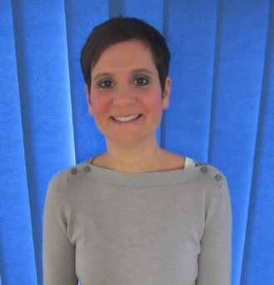

Abby Atkins  
Assistant Head Teacher

Tony Sammon Head Teacher

01458 258296

**We are committed to safeguarding and meeting the needs of our children**

**Whole safeguarding Lead** – Tony Sammon, Headteacher

**Deputy Safeguarding Lead** – Abby Atkins

**Governor with responsibility for Safeguarding –** Dan Palmer, REACH Youth Project

**Concerns about the head teacher:** report to the chair of governors, Brian Walton on: [BAWalton@educ.somerset.gov.uk](mailto:BAWalton@educ.somerset.gov.uk)

**or** any governor

**or** Anthony Goble – LADO [Local Authority Designated Lead] 0300 123 2224