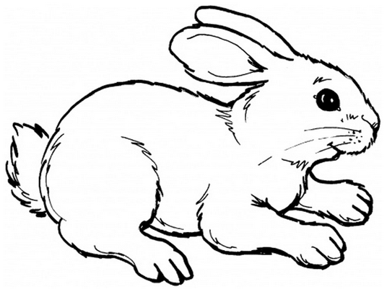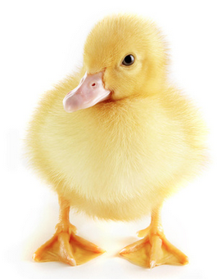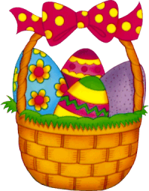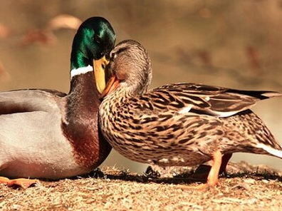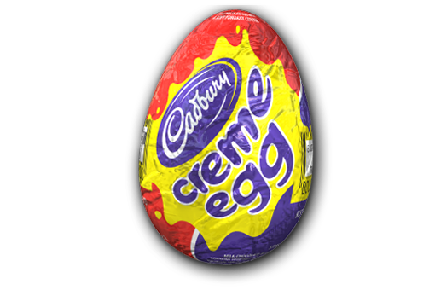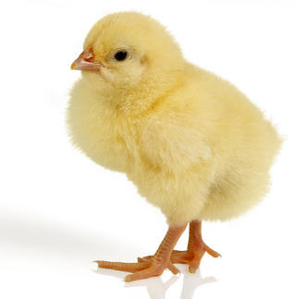

4) A bunny hops 2 times on Monday. He hops double this amount on Tuesday, three times this amount on Wednesday, and so on for a whole week! How many times does he hop **in total**?

6) The Easter bunny delivers 19 eggs to 47 different towns. How many eggs has he delivered in total?

5) The Easter bunny leaves his burrow at 1pm. It takes him 1 hour 10 minutes to deliver his first egg. It takes another 35 minutes to deliver his next egg. It takes a whole 2 hours and 25 minutes to deliver his last egg! What time is it now?

3) An Easter egg is left outside on a warm day. It takes 253 minutes to melt into a puddle! How many hours and minutes is this?

2) A mother has 12 ducklings. They all walk 25 metres to the nearest pond. How many metres do they walk in total?

1) The Easter bunny has 164 eggs to put into baskets. Each basket fits 4 eggs. How many baskets will he need?

12) A mother hen has 25 chicks! Every chick has 89 feathers. How many feathers do they have in total?

11) A granny rabbit spends 2 days knitting jumpers for baby rabbits. She can knit a jumper in only 30 minutes! How many jumpers does she make?

10) A hen coop has 28 hens inside. Half the hens have 10 chicks each. The other half have 12 chicks each. How many chicks do they have in total?

9) There are 218 ducks living in Bristol. The ducks pair up, and each PAIR has 9 ducklings. How many ducklings do they have in total?

8) A Galaxy factory produces 575ml of chocolate per second to make into mini eggs. If each egg uses 5ml of chocolate, how many eggs can it make per minute?

7) A Cadbury’s hen can lay 14 crème eggs in an hour! It lays eggs for 36 hours. How many eggs has it laid?

15) Santa and the Easter bunny meet up for breakfast in February. They meet on a prime number day. It takes place in the second half of the month. It’s not a leap year. There is no number 1 in the date. What day do they meet?

14) A child gets 1 egg on their 1st birthday. They get 2 on their 2nd, 3 on their 3rd etc. How many years will it be before they have received 91 eggs in total?

13) The Easter bunny delivers 348 eggs to Bedminster! He gives 6 eggs to each child. How many children does he deliver eggs to?

