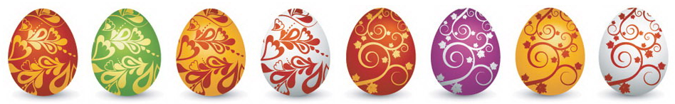

Easter Maths Challenge

Name: __________________________ Form: ________

ALL working must be shown to gain full marks. You will need a ruler, protractor and a pencil to complete the challenge. A calculator will not get you full marks.
Put your answers in the box at the end of the question. The paper is out of 35.

- The Easter Bunny can only carry 3 eggs at once. He has to choose 3 eggs from the following colours: Red, Green or Blue.

How many possible ways can the Easter Bunny carry the eggs?
(He can carry the same colour more than once)

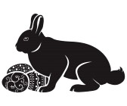

________________________________________________________

- At an Easter Egg Hunt there are 25 chocolate eggs hidden around the park. The park consists of 4 areas shown in the table below: Bushes, Play Area, Swings and Pond.

Complete the table:

Area Hidden: | Number of eggs: | Percentage of eggs:
Bushes | 14
Play Area |  | 20%
Swings | 4
Pond Area

________________________________________________________

- At 3 local supermarkets the following deals were on offer for Easter Eggs:
C
A

2 for £3.50
3 for £5
B

4 for £7

If I were to buy 12 Easter Eggs, which supermarket would be cheapest?

________________________________________________________

- Have a look at the field below:

(2X + 1)m

14m

Area = 98m²
X=

Calculate the perimeter

________________________________________________________

What fraction of the eggs are striped?

What percentage of the eggs have spots?

________________________________________________________

- A large packet of mini eggs contains 27 eggs. There are 80 children in Y8. How many packets of mini eggs should I buy so that each child gets 2 eggs?

_____________________________________________________

- In a field there are 3 types of animal: Bunnies, Lambs and Chickens.

The ratio of B:L = 12:1
The ratio of L:C = 2:5

If there are 15 chickens, how many Bunnies are there?

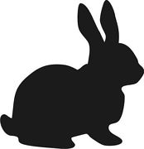

______________________________________________________
- The following is a table to do with Easter Eggs:

Type | Weight | Cost per egg | Cost per 100g
Dairy Milk | 175g | £2.00
Flake | 170g | £1.85
Mars | 180g | £1.70
Maltesers | 150g | £1.50
Creme Egg | 160g | £1.55

Complete the table and work out which egg is the cheapest per 100g:
(Tip: Remember to round up with prices)

______________________________________________________
- Use the grid lines to complete the symmetrical pattern:

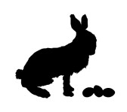
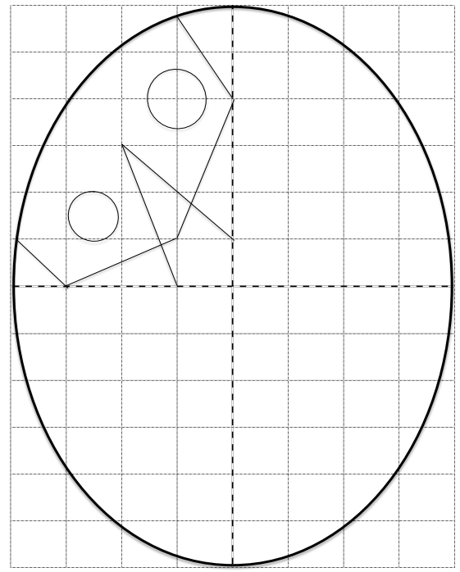

- The map below shows a field with a path and a pond. Someone has hidden 5 eggs (A,B,C,D,E) in the field with a clue to help you find them:

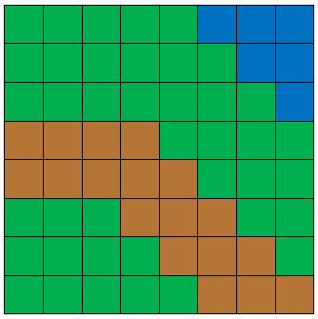

Egg A is hidden on the line y = 1
Egg C is the 4th vertex of a square
Egg B is hidden in the first quadrant
Egg C has an x coordinate 6 less than Egg A
Egg A has an x coordinate which is an even square number
Egg B has Egg A’s coordinates swapped around
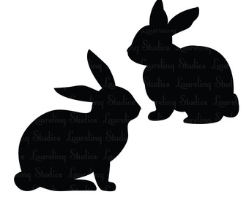
Egg D is on the line y = -2
Egg E is located on the midpoint of BD & CA
Egg D is also on the same line as Egg B

______________________________________________________

