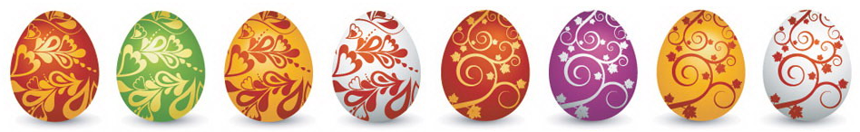

Easter Maths Challenge
ANSWERS
Name: __________________________ Form: ________

ALL working must be shown to gain full marks. You will need a ruler, protractor and a pencil to complete the challenge. A calculator will not get you full marks.
Put your answers in the box at the end of the question. The paper is out of 35.

- The Easter Bunny can only carry 3 eggs at once. He has to choose 3 eggs from the following colours: Red, Green or Blue.

How many possible ways can the Easter Bunny carry the eggs?
(He can carry the same colour more than once)

RRR GGG BBB
RRG GGR BBG
RRB GGB BBR
RGB

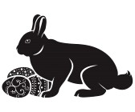

10
________________________________________________________

- At an Easter Egg Hunt there are 25 chocolate eggs hidden around the park. The park consists of 4 areas shown in the table below: Bushes, Play Area, Swings and Pond.

Complete the table:

Area Hidden: | Number of eggs: | Percentage of eggs:
Bushes | 14 | 56%
Play Area | 5 | 20%
Swings | 4 | 16%
Pond Area | 2 | 8%

________________________________________________________

- At 3 local supermarkets the following deals were on offer for Easter Eggs:
C
A

2 for £3.50
3 for £5
B

4 for £7

If I were to buy 12 Easter Eggs, which supermarket would be cheapest?
A = 4 x £5 = £20
B = 3 x £7 = £21
C = 6 x £3.50 = £21

A
________________________________________________________

- Have a look at the field below:

(2X + 1)m

14m
14(2x+1) = 28x + 14
28x + 14 = 98
28x = 84
X = 3

Area = 98m²
X= 3
14 + 14 = 28
2x + 1 + 2x + 1 = 4x + 2
4 x 3 + 12 = 14
14 + 28 = 42cm
Calculate the perimeter
42cm

________________________________________________________

1/3
What fraction of the eggs are striped?

40%
What percentage of the eggs have spots?

________________________________________________________

- A large packet of mini eggs contains 27 eggs. There are 80 children in Y8. How many packets of mini eggs should I buy so that each child gets 2 eggs?

80 children x 2 = 160 eggs

27 x 6 = 162
.:. 6 is the minimum amount

6

_____________________________________________________

- In a field there are 3 types of animal: Bunnies, Lambs and Chickens.

The ratio of B:L = 12:1
The ratio of L:C = 2:5

If there are 15 chickens, how many Bunnies are there?
2:5
L:15 .:. L = 6

12:1
B:4 .:. B = 72

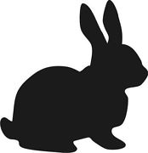

72

______________________________________________________
- The following is a table to do with Easter Eggs:

Type | Weight | Cost per egg | Cost per 100g
Dairy Milk | 175g | £2.00 | £1.15
Flake | 170g | £1.85 | £1.09
Mars | 180g | £1.70 | £0.95
Maltesers | 150g | £1.50 | £1.00
Creme Egg | 160g | £1.55 | £0.97

Complete the table and work out which egg is the cheapest per 100g:
(Tip: Remember to round up with prices)

Mars

______________________________________________________
- Use the grid lines to complete the symmetrical pattern:

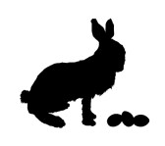
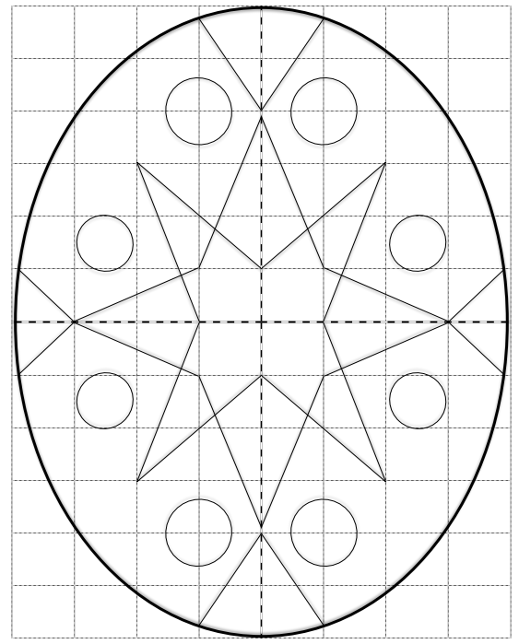

- The map below shows a field with a path and a pond. Someone has hidden 5 eggs (A,B,C,D,E) in the field with a clue to help you find them:

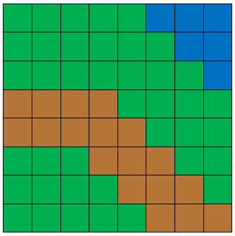
B
B

A
C
E

D

Egg A is hidden on the line y = 1
Egg C is the 4th vertex of a square
Egg B is hidden in the first quadrant
Egg C has an x coordinate 6 less than Egg A
Egg A has an x coordinate which is an even square number
Egg B has Egg A’s coordinates swapped around
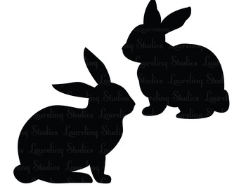
Egg D is on the line y = -2
Egg E is located on the midpoint of BD & CA
Egg D is also on the same line as Egg B

______________________________________________________

