

**Staff**

**Handbook**

**2023/24**

**Contents:**

1. Introduction……………………………………………………………………….p3
2. Values statement……………………………………………………………….p.4
3. The site entrances and exits……………………………………………….p.7
4. Fire and evacuation procedure…………………………………………..p.8
5. Pupil attendance………………………………………………………………. p.9
6. AM/ PM procedure…………………………………………………………… p.9
7. Attendance monitoring……………………………………………………...p.9
8. Staff absence………………………………………………………………….....p.9
9. Staff list and Line management structure………….………….……p.10
10. Staff support……………………………………………………………………p.10
11. The school day……………………………………………………….……….p.11
12. The Curriculum…………………………………………………….…….…..p.12
13. Meetings…………………………………………………………………………p.16
14. Assessment and record keeping……………………….……….……p.17
15. Reporting………………………………………………………….…….……..p.20
16. Qualification levels…………………………………………….…………..p22
17. The role of the Tutor………………………………………….….……….p.23
18. Post 16 ………..…………………………………………………… .………….p.24
19. Professional Development …..…………………………………………p.26
20. Safeguarding procedures…………………………..……………………p.27
21. Use of phones…………………………………………………………………p.27
22. Eating with pupils……………………………………………………………p.28
23. Teaching and Learning Resources……………………………………p.28
24. Behaviour as communication………………………………………….p.30
25. Emotion coaching……………………………………………….…………..p.33
26. Enabling environments……………………………………………………p.35

Introduction

Welcome to Tor school. A school is much more than bricks and mortar and the important parts are the people and the relationships they form with each other within it.

To work here you need to understand young people. You need to be able to accept that as they grow up they make mistakes and get things wrong. This is a natural part of developing as a person. Some young people find this more difficult than others for a variety of reasons. There are times when this makes a full-time placement in a mainstream school inappropriate. Some pupils just do not fit; that is why they come to us.

Very often the reason young people find it hard to cope in mainstream schools, is that despite all the support they receive, staff do not have the time to build relationships and truly understand what makes them tick. Here we take the time to invest in those relationships and see them as the foundation on which everything else is built.  Some of our young people have early experiences that lead them to behave in particular ways to protect themselves from harm. Others have learned to behave in a manner that creates a sense of self-worth. Others are still emotionally at a much younger age than they actually are.

We see behaviour as a form of communication as well as a learned, ingrained response. We see behaviours as opportunities to teach and learn. Some of our young people internalise their emotions and close down, or disassociate from those around them. Others externalise their behaviour and both of these responses can be challenging to manage in different ways.

We work hard to understand the causes of social, emotional and mental health issues and develop support for the child or young person holistically through a plan involving expertise from across the school. Our skill is in decoding what is really happening.

**We ensure our young people feel safe and secure, making them feel welcome and wanted as part of a school community. Sometimes it can be as simple as a smile, a cup of tea and a biscuit. Warmth, humour and unconditional regard are inherent aspects of our provision here**.

**We cherish and value our staff; appreciating that there are people who work really hard in the background as well as in the classrooms, to ensure our pupils get the best life chances they can. As a member of staff here you will be expected to work hard and be totally dedicated.**

**I have high expectations and want to create an environment and ethos that is challenging but supportive. This is not a job for the faint hearted, but you will be treated with warmth, empathy, humour and positive regard. This is an amazing job and we are really privileged to work here.**

We will get things wrong as we grow and develop. What defines us is how we react when we do so. It is ok to make mistakes and to build on them without blame or fear of retribution.

**Our Values**

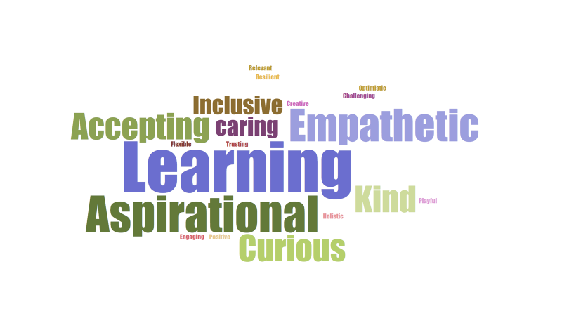

**Each of these words carries meaning. They are what we strive to be.**

You can see that Learning is the biggest word and is at the heart of everything we do. We are a school but not a mainstream school. Our young people are with us because they do not fit mainstream, so we shouldn’t recreate something similar but on a smaller scale. We are an alternative provider and need to be creative and flexible in everything we do.

**We believe that:**

* relationships underpin everything
* the most important thing is the well-being of the child
* we should ensure basic needs are met before we try to get children to work
* qualifications are important but they are not everything
* we should *not* mirror mainstream school for pupils
* we should have high expectations at all times
* children are not bad people, they are struggling to manage – it’s ok for them to get it wrong sometimes
* behaviour is often a form of communication
* data should be used to improve children’s lives not the other way round
* we should work in ways that lead children to feel good about themselves
* humour breaks down barriers and builds self esteem
* listening to young people is essential
* bearing grudges leads to resentment – every day is a fresh start
* understanding young people and engaging with their emotional world, knowing what makes them tick is essential
* practice is worked out through relationships not formulaic strategies
* it is essential to engage parents, understand their world and talk to them often
* we should notice what young people are doing, reflect on this with them and acknowledge achievements.
* we show children we are genuinely pleased to see them
* we try not to take things personally
* learning takes place in a social context – spoken language is central to this
* staff should constantly review and renew how they work with children to find a way in
* staff should model the sort of behaviour we want from the children, especially to each other
* all feelings are ok but not all behaviours are ok
* an assessment of learning needs should always be considered alongside other assessments.

**This is what we do:**

* We are not frightened to show that we care
* We work hard at being good listeners and astute observers of young people
* We try to stay calm when there is verbal and physical violence.
* We try not to be shocked or frightened by young people’s behaviour
* We validate and acknowledge young people’s thoughts and emotions but we help them name them and reframe them. This is called emotion coaching
* We constantly renew and review the approach we take with a young person to find a way in and talk to each other and challenge each other’s practice. This is done more formally through peer observation and solution circles
* We go out of our way to trust and support each other and show our young people that we do.
* We use humour as a way in and a way of calming and validating pupils.
* We take the initiative and are flexible and creative – we offer help to each other if it’s obvious that we need it
* We talk to young people all the time and find ways to challenge and extend their vocabulary
* We eat with young people and use that as an opportunity to talk to them about them and discuss the future with them
* We use current events as a learning opportunity whenever possible
* We give young people an element of choice in their learning and make it fun. Sometimes young people do not realise they are learning
* We tailor the curriculum, where possible, to meet the needs and aspirations of young people.
* We take a no blame approach especially with parents and we work hard to communicate with them
* We invite parents to regular reviews and we go to their homes
* We work hard to get the parents to see we are on their side. This breaks down barriers and stops them feeling they are “stuck in the middle”
* We show high expectations but express low disappointment when things go wrong
* We reduce the distance between ourselves and young people by sharing our own lives and stories
* We show we are fallible, and we back down and lose face sometimes
* We express warmth and affection to young people and let them know that every day is a fresh start

**In Groups and Out Groups – Us and them**

People are naturally drawn to belonging to a group. It’s how we form our identity. There is a tendency for people in one group to exaggerate the similarities between themselves and the differences between themselves and other groups. Many of our young people were pushed into an out group at school and treated differently.

We must be really careful that through our language and behaviour we do not reinforce these stereotypes. All Tor pupils are “our” pupils. Phrases like “our part of the school” or “our kids and your kids” are not helpful and get in the way. It would be easy to fall into the trap of treating learners differently because of the route they came to us.

A mindshift in pupils starts with a mind shift on the part of staff, who will influence directly how pupils perceive themselves and form their group identity. ***When the adults change everything changes***.

It has been proven by scientific studies that contact with other groups and cooperative tasks reduce discriminatory behaviour. We must make every opportunity to do these two things with all of our pupils to prepare them for the next phase in their life.

**The Site and Building**

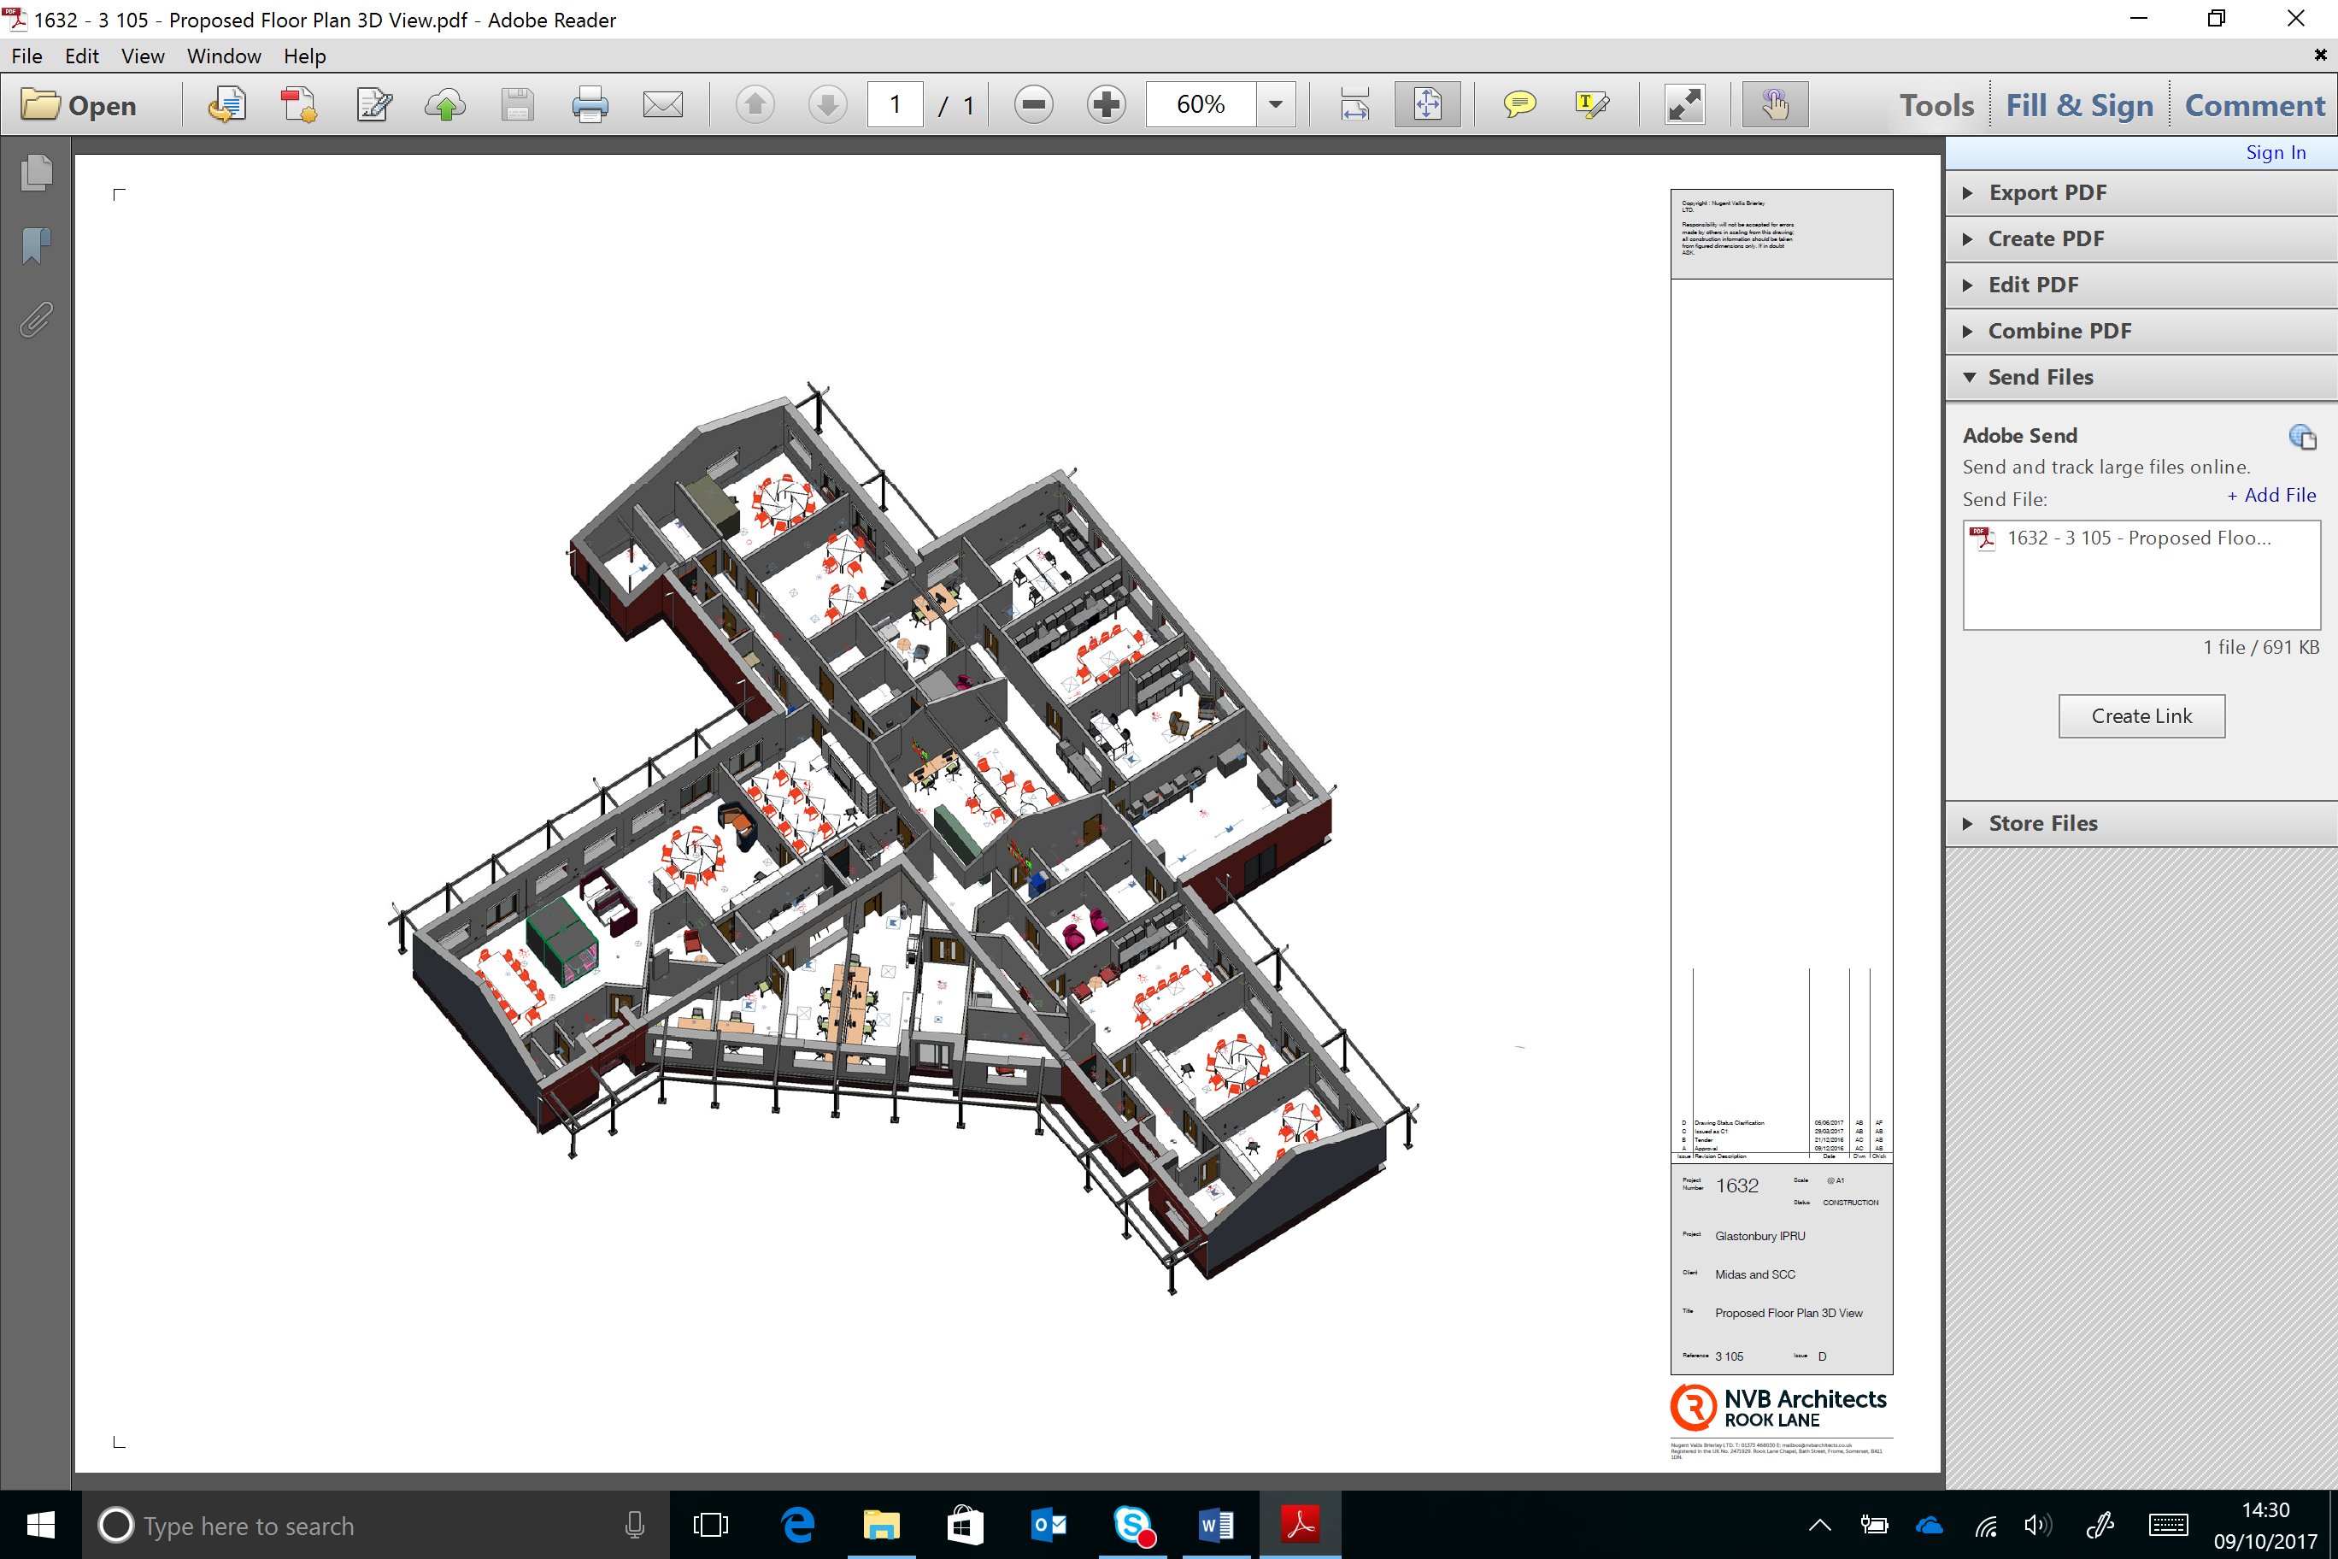

KS3 Pupils

Main Entrance

At 7am the caretaker will deactivate the alarms and physically unlock the building at each of the 3 main entrances and also physically unlock the external gates to the sides of the building. This will all be locked and alarmed again at 6pm.

All staff will enter via the main entrance to the building when they arrive and sign in using our entry system. The swipe card is also the staff ID badge and must be worn at all times. When staff leave the building they must sign out. If leaving when following a pupil, staff need to inform the office via whatsapp.

Visitors will also access the school using the digital sign in system and a badge will be printed. Visitors must wear a lanyard with the visitor badge on it. This will be managed by reception staff. If staff see someone who is not a Tor member of staff, they mist challenge them and ask to see their badge. Regular visitors who have been DBS checked will gain access by this system under the DBS tab.

A member if staff (usually SLT) will be in reception to greet students each morning. Pupils will enter the building by the KS3 entrance as in the diagram or the main entrance. The doors will open allowing access if one pupil enters the building. The doors will then close and can then be opened from inside the building. Outside of these times pupils will need to enter via the main entrance and speak to reception to gain access.

Primary pupils will be met at main reception and walked round to enter through the gates at the back of school and into the primary room.

The Headteacher, members of the senior team and staff that are available will meet and greet pupils in the morning outside the building.

**Fire and Evacuation Procedures**

In the event of a fire all external doors will open and everyone will walk around the outside of the building to the muster point which is the main car park. They should move in the safest direction clockwise or anti clockwise depending on where the risk is. Red fire alarm points are in each of the rooms next to external exits.

All external gates have a padlock. The two final gates will be opened by a member of staff with a key.

Fire marshals will coordinate with the most senior member of staff to agree when it is safe to enter the building when all pupils, staff and visitors have been accounted for.

In the event of an emergency which is not a fire, such as an invacuation or full lockdown of school, please see relevant policies.

**Pupil Attendance**

Pupils are registered at the start of the day by tutors as well as during each lesson. There are two main registration marks twice a day; once in the morning and once in the afternoon using School pod. It is essential that registers are taken promptly and accurately. If there is an offsite visit the member of staff leading the visit will mark the pupils as off site and on a trip. When leaving the building the trip leader should then mark the pupils as off site.

If a pupil is late they are marked as such and the number of minutes late recorded.

If a pupil is absent a text message will go the parents or carers and this will ask for a response. This can be a text message or return the call to our EFSW or admin team.

If there is no response within a reasonable time then our EFSW or admin team will telephone to enquire the reason for the absence.

**AM/ PM procedure**

The morning routine is as follows:

* 9.00am – all teaching staff meet for a morning briefing detailing any safeguarding and important communications.
* 9.15am All pupils and staff congregate in their designated family room or tutor base, where pupils will be welcomed warmly and offered refreshment and something to eat in the morning in a nurturing manner. There will then be a 10 minute session with the Tutor going through the day to come
* Lessons will begin at 9.30am.

**Attendance Monitoring**

Our EFSW is primarily responsible for monitoring attendance and chasing this with parents and carers but tutors also play a key role. Absence will not be authorised without evidence.

SLT monitor all attendance weekly – see attendance policy

Patterns of absence will also be monitored to pick up any concerns.

**Staff absence**

If a staff member is absent for a planned reason, e.g: training or meeting, then well planned cover work must be completed using the lesson planning proforma and handed in to the Headteacher 24hours beforehand. The work must be planned in a manner that a non-specialist can deliver it. It is also the responsibility for the teacher to also identify any pupils that need additional support and what that support is.

If a member of staff is ill, they **should inform the Headteacher immediately and the business manager** on the day of absence**. This should be a phone call and if there is no response**, then a text message. It is not ok to say the day before the absence that you will be away. You cannot predict that you will be ill.

Staff should send in their planned lesson for that day, again detailing all the required resources for the staff that are covering**. We use the Tor lesson proforma for this.**

Headteacher Telephone number – 07801575506. This phone will be on from 7am.

You should send any cover work into school by email to the Headteacher, Business manager Mandy Ramsey and your head of department.

If the absence is for less than 5 days the member of staff should complete a Sickness Declaration and Return to WORK Form HRAP02

The line manager will conduct a Return to Work meeting then pass this form to Admin to update SIMs.

If there are any concerns about staff attendance, we will follow the SCC policy on managing sickness and absence.

The **Bradford Factor** is a simple formula to help manage short term sick absences and determine when these have become excessive. The calculation for the **Bradford Factor** (B) is Number of Occasions Sick (S) x Number of Occasions Sick (S) x Total Number of Days Absent (D), or. B = S² x D. A Bradford factor higher than 144 is a cause for concern.

**Staff – Line management structure**

**Staff support**

We value our staff and the important role they play. We are all human and have the same needs. As part of our commitment to our staff, each other and our well being we have paid for all staff to be enrolled with Education Support. Education support is an organisation that is there to support all those who work in schools.

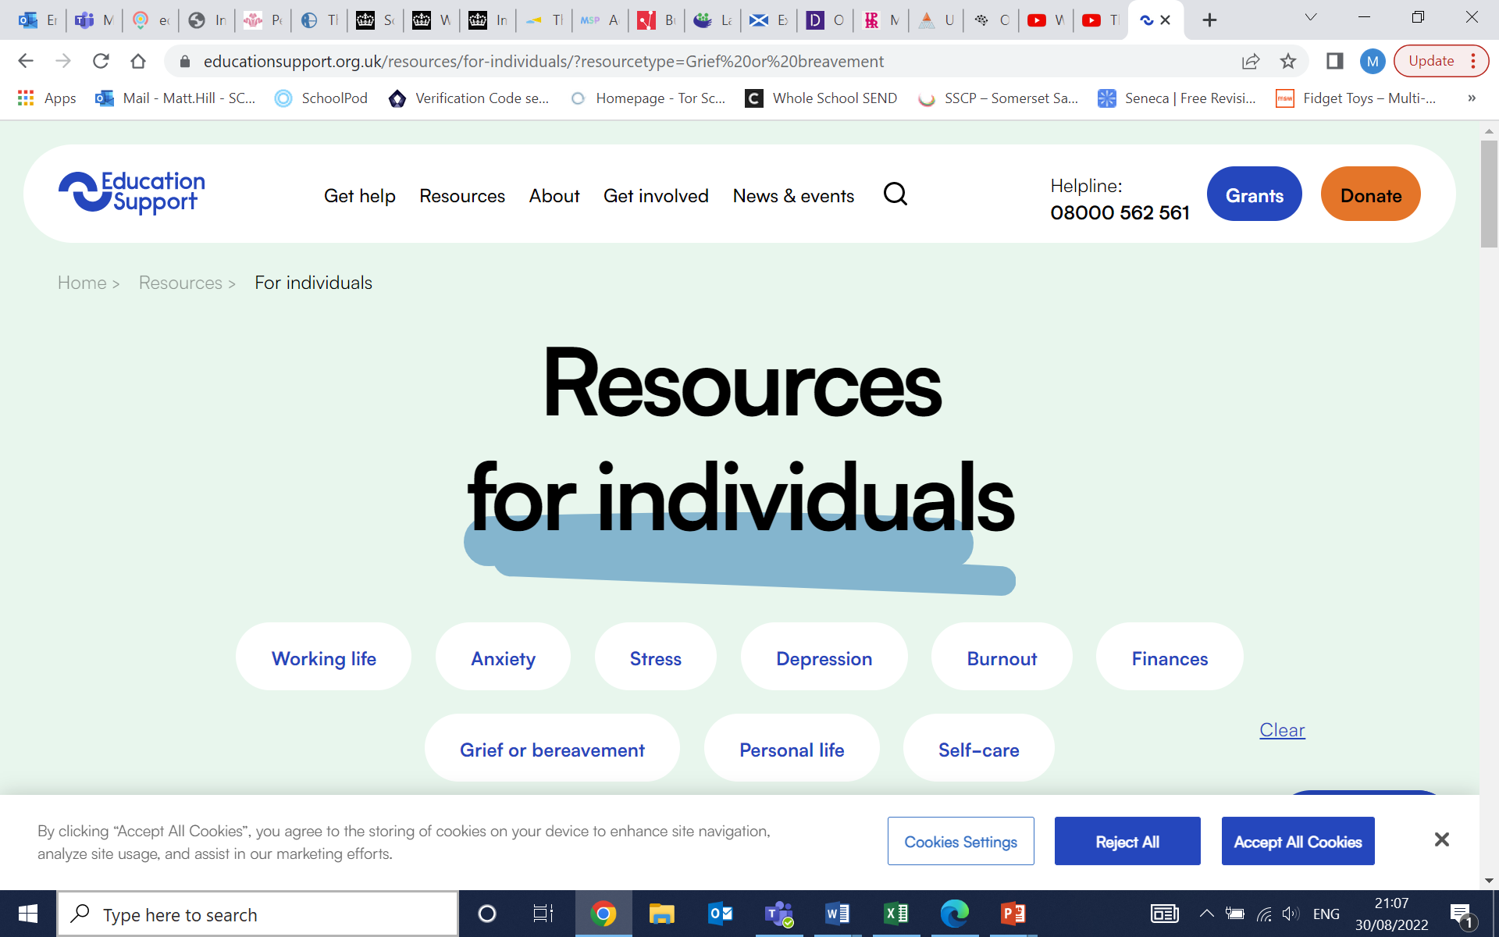 Helpline:[**08000 562 561**](tel:+448000562561)

<https://www.educationsupport.org.uk/resources/for-individuals/?resourcetype=Grief%20or%20breavement>

**The School Day**

|  |  |  |
| --- | --- | --- |
| Team briefings and adaptations | 8.45 – 9.00 |  |
| Tutor/ Family Time | 9.15 - 9.30 | Taxis arrive |
| Lesson 1 | 9.30 – 10.20 |  |
| Lesson 2 | 10.20 – 11.10 |  |
| Break | 11.10 - 11.25 |  |
| Lesson 3 | 11.25- 12.15 |  |
| Lunch | 12.15 – 12.45 |  |
| Lesson 4 | 12.45 – 13.30 |  |
| Lesson 5 | 13.30 – 14.15 |  |
| End of day review with selected pupils | 14.15- 14.30 | Taxis leave |
| Lesson 6 extension for some pupils | 14.30 – 15.30 |  |

The day ends earlier than mainstream schools and mirrors best practice in many AP schools for two reasons:

1. The intensity of the sessions and the amount of attention our pupils receive in very small groups and 1:1 means they often get cognitive overload
2. Many of our pupils have long distances to travel home, up to 70 minutes, and this can lead to additional stresses that they cannot manage

**Curriculum Statement**

Rationale

* The curriculum is one of the fundamental elements at Tor, both explicitly and implicitly, to prepare learners for the next steps.
* Our ethos and the wider enrichment opportunities we offer our young people is just as important as the knowledge and skills we want to develop in them.
* Making the curriculum relevant to our learners, and if need be bespoke, determines what they will know and their areas of progress. This will in turn impact upon their ability engage in the next stage of education after leaving us.
* Our young people are referred to us for a reason. Our curriculum utilises alternative qualifications and approaches to lessons to meet needs holistically.
* Due to large gaps in their education for a variety of reasons, it is unrealistic sometimes, in the time frame we have, that we offer the full national Curriculum. However we want to give our young people the essential knowledge and skills they need to move on successfully.
* We strive to give our learners an Education Passport of at least 5 Qualifications that are aimed at individual needs.
* We also recognise the need for our students to develop the skills that are required in the workplace and we implicitly and explicitly work with students on developing these. through these skills they can demonstrate that they have embedded the knowledge. We develop these habits through the taught curriculum and wider opportunities we offer
* Although there is a strong emphasis on the teaching of Maths and English, literacy and numeracy there is also access to a broad range of subjects and preparation for adult life has a high profile that supports holistic progress for learners.
* The subjects contain the knowledge we wish the learners to gain within each domain.
* We have pupils in KS1, KS2 & KS3 that are part of Tor School for a short period due to permanent exclusion or support programmes. The curriculum for these pupils is designed to: identify and support areas of weakness, develop skills and habits that will help them in their next setting as well as work specifically around supporting the transition from Tor to their new setting.
* There are essentially two kinds of skills we wish to develop in addition to the character based qualities.. Firstly, the habits which can enable the demonstration of knowledge and enable better learning and secondly the subject specific skills which are inextricably linked to subject content.
* The broad knowledge areas are:
  + Maths/ Numeracy
  + English/ Literacy
  + The Arts
  + Sciences
  + Vocational Learning
  + Life Skills
  + Humanities
  + Preparation for adult life – including life skills
* In addition to the above we have a programme of SEMH work which is either carried out by Tutors, by specialists or bespoke sessions designed to develop SEMH resilience . We identify areas of difficulty and establish appropriate strategies with our learners to address their needs and support them to meet our expectations.
* We build a pupil passport and learning plan based on these skills gaps which is tailored to each individual learner.
* We have a wider curriculum entitlement pledge which focusses on giving pupils ‘wider experiences’ and cultural capital whilst developing qualities that are prepare them for the wider world. This pledge is delivered through lessons as well as Curriculum enrichment sessions designed to enrich them and their experiences.
* Qualities and areas we seek to develop:

Resilience, self awareness, creativity, courage, respect & tolerance and Character alongside a range of life skills:

Speaking and Listening, Aiming High, Teamwork, Staying positive, Creativity, problem solving

* We also endeavour to provide the following:
* Be inspired by and through a range of Arts
* Experience outdoor education
* Take part in a trip to a museum or Art Gallery
* Make something they are proud of
* Experience the wonder of a wild and beautiful natural place in the UK or abroad
* Have a chance to express views on local, national and/or international issues
* Help others by being an active citizen, for example raise money for charity
* Create opportunities to develop kindness and empathy
* Engage in dialogue with people from other religions and beliefs or other parts of the UK
* Visit a place of Higher Education or Training
* Experience a range of different career paths
* Develop essential life skills such as travelling on public transport, opening a bank account, budgeting, household skills.
* Create opportunities to develop oracy skills
* A sense of belonging in an educational environment

***Mapping subjects to domains.***

The table below shows how each of the knowledge domains is mapped across each year group in Key stage 4

|  |  |  |
| --- | --- | --- |
| Domain | 10 | 11 |
| Maths/ Numeracy | Maths 4 lessons pw | Maths 4 lessons pw |
| English/ Literacy | English 4 lessons pw | English 4 lessons pw |
| The Arts | 2D Art  3D Art  Photography 4 sessions pw | 2D Art  3D Art  Photography  4 sessions pw |
| Sciences | Combined Science  4 lessons per week | Combined Science  4 lessons per week |
| Vocational Learning | Occupational Studies NCFE:  Food/ Catering  Motor Vehicle  Childcare  Sport  4 lessons per week | Occupational Studies NCFE:  Food/ Catering  Motor Vehicle  Childcare  Sport  4 lessons per week |
| Humanities | RS or Geography  4 lessons per week | RS or Geography  4 lessons per week |
| Preparation for Adult Life | PSHE/ Careers  2 lesson per week  Tutor session 1 lessons per week  Sport and fitness  Up to 3 lessons per week  Skills builder 1 lesson p/w | PSHE/ Careers  2 lesson per week  Tutor session 1 lessons per week  Sport and fitness  Up to 3 lessons per week  Skills builder 1 lesson p/w |
| Enrichment | 2 lessons per week | 2 lessons per week |

Some pupils may not access all lessons during the week as they may be on personalised timetables which includes AP, small group work or 1:1 sessions.

Pupils in KS4 will take up to 3 options in addition to Maths and English. This will form the basis of their timetable and qualifications suite. Some of our pupils, for various reasons, will not take a full range of qualifications but all will do Maths and English and we aim to get our pupils at least 5 qualifications with Maths and English.

At times a pupil will arrive with us with a particular interest in a curriculum area. We will endeavour to offer this as a qualification wherever we can whilst being mindful that we cannot dilute too much and spread ourselves too thinly.

**Key Stage 3 curriculum offer:**

2 Art

4 Eng

4 Maths

2 Enrichment

2 Food

2 Humanities

1 Preparation for adult life / PSHE

1 PE

2 Outdoor Education

2 Sci

2 Enterprise

1 Tutor

Transition work is also planned for and undertaken when the pupil has a next setting identified. The Key stage 3 team will liaise and work with all stakeholders to ensure a planned transition is in place.

**Partnership Programme (2 days)**

1 Art

2 English

2 Maths

2 Partnership work (application & development)

3 Partnership work (direct)

**Primary - Short Stay**

For those pupils attending Tor, the primary team assess pupils on entry as a means to find the gaps in learning that require support. The national curriculum is followed and a bespoke plan is designed for each pupil. Transition work is also planned for and undertaken when the pupil has a next setting identified. The primary team will liaise and work with all stakeholders to ensure a planned transition is in place.

**Medical Outreach tuition**

There are young people in Mendip who are unable to attend mainstream school due to medical and mental health reasons. We provide tuition for these young people. Depending on their age and need; the work could be based upon maintaining academic progress until such point they are able to attend mainstream again, or if they are KS4 and it is deemed in the best needs of the young person, they may attend Tor as a pupil.

**Partnership and Outreach**

We work with our primary and secondary mainstream schools to support them and their students. This work is designed to increases capacity in schools as well as work with teams of staff & students or 1:1 with staff or students.

**Teaching loadings**

Teachers should be ready for briefing at 0845 and then to receive students shortly after 0900. Teachers school day is below.

Compared to many schools our teaching day is concertinaed into a shorter one, so it may feel fuller, but there is time at the end of the day.

We need to look after each other and so if we see a colleague needs a break, we should help out.

A full time teacher will be timetabled for 23 or 24 out of 25 lessons each week. This includes Tutor Time, break and lunch. Staff will also have 3hrs 20mins of PPA time each week. There is also approximately 1 hour additional free time per week after school.

The directed time load per year is 1235 5/6 (out of the contractual 1265).

Colleagues will be asked to cover each other as this is a very small school and PPA is protected. Staff whose timetables do not have a full allocation of lessons will be utilised first for cover. Cover is assigned on an equitable basis and also factors in staff specialisms.

|  |
| --- |
| **Teachers**  Monday :0845 - 1545 |
| Tuesday: 0845 - 1530 |
| Wednesday: 0845 - 1545 |
| Thursday: 0845 - 1545 |
| Friday: 0845 - 1500 |
|  |
| Non teachers working with students  Monday: 0845 – 1630 |
| Tuesday: 0845 – 1630 |
| Wednesday: 0845 – 1630 |
| Thursday: 0845 – 1630 |
| Friday: 0845 – 1630   |  |  | | --- | --- | | **Applies to:** | | | TA's |  | | LSA's |  | | HLTA's |  | | Specialist Tutors | | |

**Meetings:**

Meetings are used to support staff and students and must be meaningful. We use meetings to discuss and develop ways to support the young people we work with and to maintain our high standards we expect of each other.

Meeting schedule:

**Mon** – PPA

**Tues** – CPD (rota of sessions)

1. SEND/Trauma

2. Safeguarding

3. Book club/T&L

4. Coaching

5. Staff meeting

6. free

(7.) free

**Weds** – Dept meetings (rota of sessions)

1. KS2 / KS3 / KS4
2. Maths / Eng
3. P4AL/PSHE
4. Creative & vocational – Art/PE/Food/MV/Sci
5. SEND
6. Medical
7. Sci, RE. OE & Hums

**Thurs:**Solution circle – fortnightly

**Fri -**  n/a

**As a Teacher of a group/class**

Staff plan well sequenced lessons that meet the needs of our learners and links to medium and long term plans. The units and schemes of work seek to develop the skills for and to prepare students for life after school. These will link to the Skillsbuilder set of skills that we want students to develop.

Curriculum planning and good teaching are they key to engagement after positive relationships

* **Expectations for cover**. Planned absence: staff plan the lesson and resource the lesson. The lesson should be able to be delivered by a non-specialist and but also be challenging – high quality, challenging but low risk. Lessons to be handed to Matt Hill and Mandy Ramsey 24hrs in advance in order for staff covering to prepare for the lesson.
* Staff covering lessons need to familiarise themselves with the lesson plan and also the pupil passports of students in the group.

**A typical lesson structure**

High challenge low threat. We need to be aspirational for our students and focus on their next steps; keeping their ‘Why’ in mind for them.

How we structure the *rhythm* of a lesson must give a feeling of predictability. This routine acts as a form of safety and enables the limbic system to relax and for the neocortex to take over.

Our learners thrive on this safety and it enables them to engage with learning much more quickly.

The beginnings (meet and greet) and ends (end and send) of lessons should act as a buffer from one lesson to another. Calming predictable starter activities, as learners enter the room, enables this safety. Scaffolding and adaptive teaching is present in lessons to enable all students to access and progress with learning. The use of questioning and oracy is an integral part of lessons where possible. Then at the end of the lesson, checking in on what has been learned, by such as a post it note activity or a quiz, enables the students to refocus on the lesson and be ready for the next one. This should be an intrinsic part of planning in any lesson academic or practical.

**Assessment and Record Keeping**

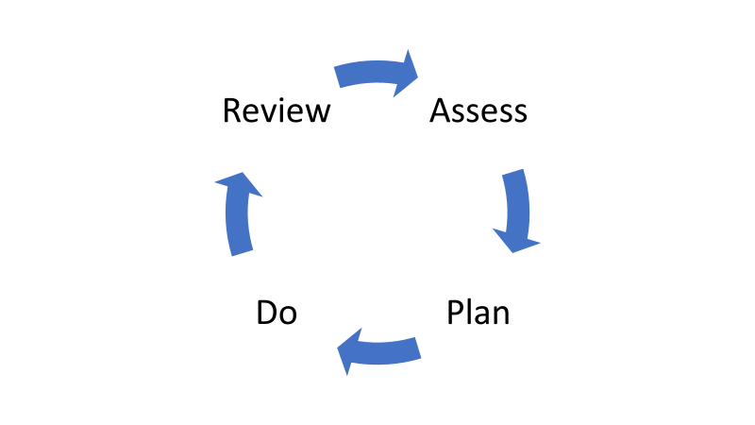

When a pupil is first enrolled with us an initial screening document is completed which includes baseline tests, Risk factors and Protective factors. This will enable us to triage tiers of support which we wrap around the learner.

Staff will regularly assess and use this inform planning for students. This also enables us to support students towards their goals.

**Tiers of Intervention**

Based on identified needs, pupils will then be supported on one of three tiers. This is reviewed as part of the solution circle programme that runs at Tor and as aprt of the regular reviews.

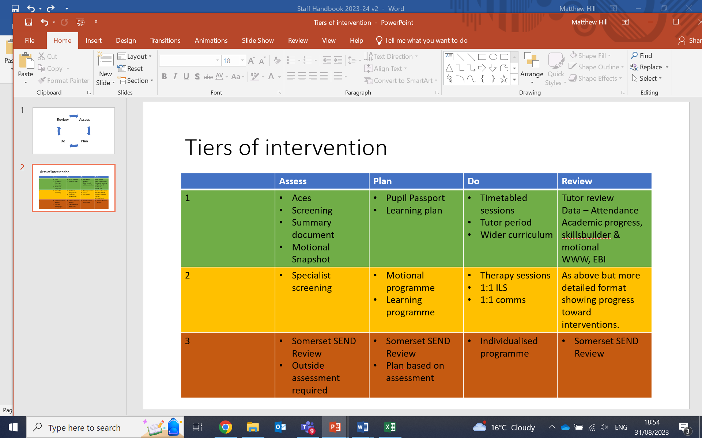

**ACES**

Are adverse Childhood Experiences. The more ACEs a person has the greater the risk of Social Emotional Mental Health or physical illness later in life. This gives us a feel of the risk factors impacting on the life of a young person.

**SKILLSBUILDER**

The SKillsbuilder programme fits really well into our startegic plan/view of preparing students for life after Tor. The skillsbuilder areas will be delivered explicitly and implicitly in school and it will be a part of the school learning plan.

Staff have a login for this and will access resources to support students.

This then informs the **Pupil passport** which is the working document teachers and support staff use to differentiate lessons and interventions.

**Motional**

Pupils assessed are routinely assessed a short while after entry at tier 1. This provides tutors and staff and underlying picture of the areas that pupil may be finding difficult. Should a pupil require it they will also have a motional plan created by their tutor. Motional is our assessment tool for SEMH. It draws on work from the Trauma Informed Schools network and the Adverse Childhood Experiences research.

Motional provides an easy-to-use online tool for identifying, assessing, and improving the emotional health and wellbeing of children and young people.  It is based on Professor Jaak Panksepp’s research on emotional systems in the brain and Dr Margot Sunderland’s extensive research, studies and expertise in executive functional skills. It records ACE and Protective Factor scores, and gives staff a whole-brain picture of students' mental health and wellbeing.

Motional measures different emotional systems in the brain (CARE, SEEKING, PLAY, FEAR, RAGE, PANIC/GRIEF based on prof Jaak Panksepp’s work) and several key executive function skills (handling stress, thinking & concentration, confidence & self-esteem, interpersonal skills, and emotional literacy – written by Dr Margot Sunderland) to give a whole brain picture of a child’s emotional and mental health.

Snapshots take about 5 minutes for someone who knows the system and the child well, up to 25-30 minutes for someone new to Motional doing a whole class. Snapshots are generally done by staff about children, and then they can create a Program of activities and relationship strategies that will target specific emotional systems for that child.

Snapshot results look like a bar graph with the answers underneath:

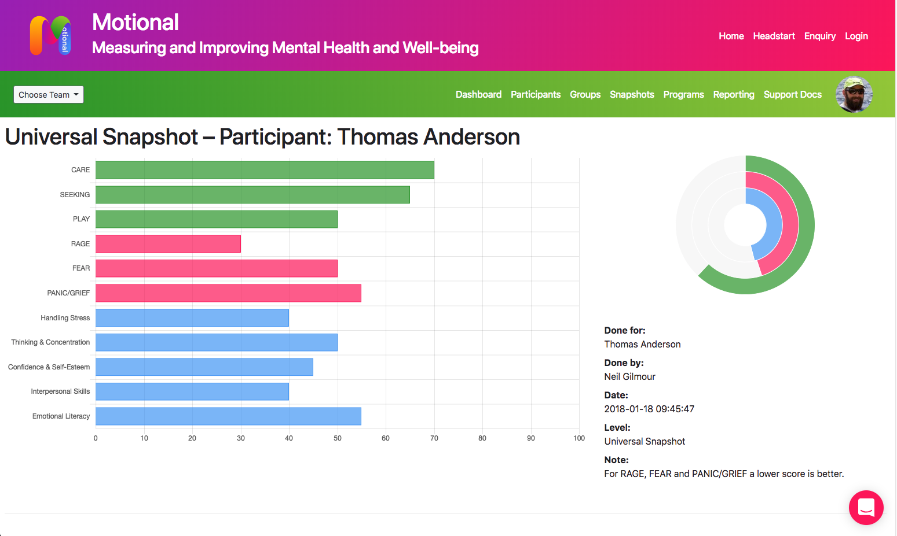

**Review**

All learners will have their provision reviewed every 6-10 weeks. The review will assess progress from baseline assessments. If a learner is dual registered with another provider the review will invite them to contribute to a shared plan.

We also have 3 Academic Review Days (ARD) each year where we invite parents/ carers and other agencies to a longer discussion about progress and celebrate achievements. For pupils at Tier 3 this is when we would complete the Somerset SEN Review or Annual review of their EHCP.

**Reporting**

We report to parents/ carers and other agencies 3 times a year Autumn, Spring and Summer. The Summer report is an end of Year summary. These reports are what are discussed at the Academic Review Day (ARD). As a Tutor you will be expected to write a report summarising progress and outlining next steps (on Schoolpod).

As a subject teacher you will be asked to assess learners against course aims and give a prediction of final grade. *If the learner keeps working at the current rate of engagement and understanding what might they achieve as a final grade.*

Reports should always be framed in the positive and wording to use a growth mindset approach.

Reports should be addressed **to the parent.**

Report template:

* Brief overview of content covered and the level of qualification being studied
* Attendance to lessons
* Engagement in the lessons
* Positive achievements
* Next steps/targets (framed in the positive) E.g stop being late = arrive on time. Stop messing around = engage in lessons more.

**Key Stage 3 & 4**

GCSE Grades now go from 1 to 9. For each Grade there are 3 letters:

Eg:

|  |  |
| --- | --- |
| 3a | At the top of this grade and could get to the next one |
| 3b | A solid grade at this level |
| 3c | There is danger of this grade slipping to the one below |

This is the same for Entry level which is divided in Entry 1, Entry 2 and Entry 3 with 3 being the highest level of Entry qualification.

|  |  |
| --- | --- |
| Entry level 3a | At the top of this grade and could get to the next one |
| Entry level 3b | A solid grade at this level |
| Entry level 3c | There is danger of this grade slipping to the one below |

Some of our vocational and practical courses are graded on a level 1 or 2 pass. Level 2 is equivalent to grade 4 in GCSE. Level 1 is equivalent to grade 3.

You will also be expected to give a grade for effort and engagement as well as make a subject comment.

Effort is how hard they have worked and Engagement is whether they arrived for lessons on time and got stuck in. These are both graded on a 1-5 scale with 5 the highest.

**Primary**

The report is primarily a qualitative statement around the success and progress made as well as the areas of challenge.  Attainment grading will also reference:

Expected Standard (EXS),

Working towards National Standard (WTS)

Working at Greater Depth (GDS)

Children working significantly below age related expectations will be marked as (SBN).

**Report example:**

Since the start of September, we have been preparing for the Functional Skills Level 1 exam. This exam consists of three areas: Reading, Writing and Speaking, Listening and Communication.

I would like ‘X’ to sit this exam in Year 10; then in Year 11 we can begin working on either Functional Skills Level 2 or her English Language GCSE.

‘X’ continues to be a whirlwind of delight to teach! She has been working hard on the `next steps' set from the previous report and this term we have focused on different writing tasks and learning about P.A.F. (Purpose, Audience and Format). ‘X’ has been taught how to write a range of different texts including emails, letters and articles. She is always keen to start her work which means she doesn't always plan her ideas. Planning is part of the exam process and ‘X’ will gain marks for this so it's important not to overlook it. Planning her ideas before writing them will also help her to understand when she should start new paragraphs; this will help to separate all her wonderful ideas so that it all makes sense. Finally, proofreading her draft carefully will help ensure she has not overlooked the all-important punctuation marks (and every correct spelling and piece of punctuation is an extra mark for ‘X’ to gain).

In our past few lessons, we have taken a break from writing tasks and have been reading stories which ‘X’ has engaged beautifully with. She was confident and brave enough to read a paragraph out loud today in front of others and I was so proud!

Targets:

° Plan your written work before you start to write.

° Keep remembering to proofread your written work and correct punctuation and paragraph mistakes so you gain the most amount of marks available in the exam.

° Build your confidence by reading out loud in class more often

**What qualification levels mean**

PROGRESSION

|  |  |  |  |
| --- | --- | --- | --- |
| **Qualification**  **Level** | **Qualification** | **New GCSE Grade** | **Old GCSE Grade** |
| **Level 3**  **Post 16** | A Levels |  |  |
| **Level 2** | * GCSE’s grade 9 – 4 * Functional Skills Maths level 2 * Functional Skills English level 2 * NCFE level 2 Food and Catering | 9  8  7 | A*  A |
| 6  5  4 | B  C |
| **Level 1** | * GCSE’s grade 3 – 1 * Functional Skills Maths level 1 * Functional Skills English level 1 * NCFE level 1 Food and Catering * NCFE Occupational Studies in the Workplace | 3  2  1 | D  E  F G |
| Failed to meet the minimum required grade or the student was entered for, but did not sit the exam. | U | U |
| **Entry Level**  Entry level qualification is available in three sub-levels, 1, 2 and 3. Entry level 3 is the most difficult. | Entry Level 3   * Maths * English * Science |  |  |
| Entry Level 2   * Maths * English * Science |  |  |
| Entry Level 1   * Maths * English * Science |  |  |

**The Role of the Tutor**

The role of the tutor is integral to the work we do at Tor. The tutor is the Key Worker for their tutee and knows their tutee and their family the best. The work we do is fundamentally based on the relationship we as staff build with the students and that tutors build with their tutees and their families.

**Meet tutee every morning for 10 minutes to 'check in' and 5 minutes at the end of lunch to ‘nudge’ them on their targets**

On entry the tutor must complete the following:

* Read pupil file
* Make contact with home via a phone call - and do a home visit
* Complete ACES
* Create pupil passport
* Create learning plan on schoolpod
* Make contact with previous school and get examples of work as well as any tricks and tips on how best to support and what triggers to avoid
* 2 weeks in create Motional and update it each term (6 times per year)

Weekly tutor tasks:

* Plan for Tutor period Friday period 1 looking at the week just gone – link to motional (ideas from tutor folder in curriculum drive)
* Plan for 1:1 tutor session for one session per week. Staff should only use one lesson for this and on a rota basis see their tutees one at a time (remove tutee from a lesson to do this) – review learning plan, SEMH work, post 16 work, MOTIONAL based work
* contact home at least one per week (phone call) - strong communication is the key (see EEF how to communicate with parents document & use radical candor)
* check all attendance/incidents/positives
* Liaison with other agencies and mainstream setting if on a Partnership place
* Act as Primary contact for parents and external agencies

Periodically:

* Arrange and facilitate WEx for students
* Hold review meetings for partnership place pupils
* Academic review days – prepare for meeting & write up review, then update learning plan
* Prepare for solution circle using the APDR document, update pupil passport and check on progress
* Liaising with EFSW regarding attendance

A large part of our work is about providing Hope and belief in young people. This is facilitated through our relationships, our P4AL programme and our curriculum.

A large part of this is the preparation for post 16 and the tutor’s role on this is vital.

**Post 16 preparation timeline and checklist for Year 10 and 11 tutors**.

**September – December:**

Week 1 September 2022

* Find out areas of interest for **YEAR 11** Work Experience- Email VB

Week 2 September.

* Year 10 and 11 inform students of work placement visits- all students should attend

Week 3 September

* Year 10 and 11 should be informed of Enterprise Day and the purpose of it (12-10-22).
* Year 11 only should have a work experience booklet to fill out and then place in ROA

Week 4 September

* Year 11 -Talk through expectations in the workplace
* Careers appointments. Parents invited, tutors to inform
* Open events at colleges – facilitated by Tor and or parents -direct parents to Tor website for details
* Tutor to update VB with developments in the Post 16 process by email

Week 1 October

* Year 10 and 11- Ensure students understand the instructions for Enterprise Day

Week 2 and 3 October

* Year 10 and 11 start writing C. Vs use the template provided
* Collect relevant Post 16 information from VB to discuss different pathways

Week 1 November

* Year 11- prepare students for Independent Careers Advice chat

Week 2 November

* ROA check- students should be accumulating photos, C.V drafts etc
* Ensure students are aware of work placement visits

Week 4 November

* Year 10 and 11- discussion around developing employability skills- checklist provided kept in their ROA
* College and training provider visits where appropriate

**January – March:**

* Careers interviews
* Writing applications to colleges, apprenticeships or alternative training if not already done so, this should be completed by the end of **January** at the latest
* VB to arrange college visits for small groups
* Tutor to email VB of any post 16 developments and keep parents informed
* Year 10 and 11 -7-2-22. Ensure students are aware of Speed dating with employers

**March – May:**

* Careers Fair - 26th April- start informing parents as early as possible- lots of providers and people who can advise on benefits and transport etc
* VB to send passports, attendance and SEND information to college

**Peer Coaching**

As a school we have taken the decision to not carry out formal lesson observations. We do not think this is the best way of assessing and evaluating staff. It is a false situation, where what you observe in a formal set up does not reflect normal daily practice. Members of SLT are constantly in and out of lessons. Seeing what is going on and talking to staff and pupils about learning, this enables us to evaluate teaching and learning much more effectively.

As an additional part of our desire to support staff and to continually understand & improve WHY do what do, What we do and HOW we do it, we are beginning to develop a coaching culture where all teaching staff and support staff will have a coach. All teaching staff will have regular meetings to coach each other together and begin to use the language of coaching with each other in our teaching practice. We will be working on developing this throughout 2023/24.

**Professional Development**

People perform best when they are trusted as professionals to “get on” with the job. There should a be high level of challenge but low level of threat in any organisation to move forward and to provide development opportunities so that people are stretched and motivated.

The Professional Development process is there to provide this challenge and to monitor performance of staff against agreed standards. If things begin to go wrong the process should build on regular line management so that there are no surprises, should issues of capability surface.

School will develop staff with meaningful CPD and CPD that is in alignment with the schools development plan.

The school has also invested in a number of books and professional literature that support staff development. Staff are encouraged to borrow the books and read them in order to further develop professionally and better support the young people and adults we work with and alongside.

The process occurs as follows:

**Briefings**

Every day at 0845 there is a whole staff briefing in the Atrium where we will go through main points for the day, themes and share good news. This will also be an opportunity to share key safeguarding messages

**Safeguarding Procedures**

All staff should attend that annual training at school, read and be fully aware of school policy and procedures in addition to reading the core documents (KCSIE) which are uploaded on the website.

***My Concern*** is the main record keeping system for any safeguarding concerns about young people. All staff will be given a log on and training in how to use it.

Everyone is responsible for ensuring safeguarding procedures are adhered to. The site is secure and the access and exit arrangements will ensure we know who is on site at any time.

All staff must wear ID badges at all times. There is no exception to this. The ID badge will also enable access to the building.

The Safeguarding Leads are:

Matt Clinkard – Assistant Headteacher (Designated Safeguarding Lead)

Matt Hill – Headteacher

Emma Hill – Assistant Headteacher

Our Safeguarding Governor is – Dan Palmer

Somerset LADO – Anthony Goble

Logging an incident on My Concern should not stop you speaking to one of these people immediately to seek advice. There are posters around the school with details about how to contact these people.

**Use of Phones**

**Staff are not to use work phones** if they are teaching and have students in front of them. The exception to this is if they are using whatsapp to request assistance.

Staff should mute whatsapp groups if they are teaching. **Staff that are not teaching will have their phones with them in order to respond and support**.

We have 3 dedicated groups that all staff are part of:

1. Tor School professional
2. Tor School
3. School lunches

There may be additional groups added when required:

1. SLT

**Staff are not to use personal phones for school whatsapp or contacting pupils.**

**Staff personal phones need to be put on airplane mode/Bluetooth off when entering school.**

**Staff must have locks on their phone.**

Staff are not to use personal phones during lesson time.

**Pupils** are expected to lock phones away in one of the lockable phone storage units in KS3 or KS4. Pupils are not allowed to use phones in lessons unless expressly told by their teacher that they can for educational reasons.

**Eating with Pupils**

Staff are expected to eat with pupils at lunch and to also spend break time in and around the family rooms. This is an opportunity to build and sustain relationships and to extend the spoken language opportunities for our pupils.

**Teaching and Learning Resources**

We have a Curriculum Network Drive which contains all Teaching and Learning resources. Long and Medium term plans are stored here.

There is also a physical resources store adjacent to the Atrium which houses a range of resources, games, textbooks and workbooks. It is important to return resources once they have been used so that others can have access to them.

There is also a staff CPD library in the staff base for staff to sign out books to read.

There is also a virtual storage area on Microsoft teams for departments to share and collaborate together.

**Locking of doors**

We want to create an ethos where doors are not locked, however, some places should always be kept locked. They are:

Exam store – Separate key system

Server room – Separate key System

Disabled toilet and shower – Standard key

Main storage cupboards off the Art Space and in the KS3 corridor – Standard key

Workshop when not being used – Standard key

Art Room when not being used – Standard Key

Staff work room when not being used – Standard Key

All staff are allocated a standard key which opens all internal doors apart from those on separate systems.

**Behaviour as communication**

Many of our young people present with challenging behaviours. There are two extremes on a continuum. Those who externalise their feelings and behave in ways that draw attention to themselves or distract from how they feel; and those who internalise and disassociate themselves from their environment effectively shutting down. Neither of these responses is healthy or ok.

Behaviour is usually, but not always a response to an emotion, but all behaviour is usually a form of communication and we as professionals should be adept at spotting and analysing what is being communicated.

This does not mean that all behaviour is acceptable and ok, it clearly is not. However, in the heat of the moment it is never a good idea to try to get a young person to think about why they are behaving in a particular manner; neurologically this is an impossible task.

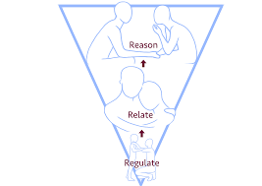***Attune***: Be alert to how they are feeling: demonstrate attuning to their emotional state showing you can catch how they feel through facial expression, body language, gesture, noises:. Demonstrate that you understand the intensity, pitch, pace, volume, expansiveness or spatial experience of the child’s emotional state.

***Validate***: Be alert to the child’s experience: validate their perspective/experience/feeling. This needs to happen before you move to help them regulate it. This is the beginning of being able to think about feelings. Avoid reassuring, persuading otherwise, contradicting.

***Containment***: Be alert to how they are feeling: demonstrate containment. Show that you catch and understand the pitch/intensity/quality of their feeling or mood and that you can bear it. Make their strong emotions a survivable experience. *Catch it, match it and digest it by thinking about it and offering it back, named, in small digestible pieces*. This will make bearable the strongest emotional state.

This shared experience builds trust for the child: in you, in adults and in the world. Be alert to how they are feeling: demonstrate emotional regulation by soothing and calming their distress. Catch the emotion, match it and help the child to regulate the feeling up or down. They need to experience being calmed before they can do it for themselves. You will be communicating the capacity to regulate emotional states by modelling how to do it.

Only after this can we ***Shine a Light on the Behaviour*** and use it as an opportunity to coach and teach the behaviour which is ok and that which is not and explain why it is not.

There are 5 qualities which make up the best background atmosphere for emotional learning – Dan Hughes PLACE concept:

P=Playful

L=Loving

A=Accepting

C=Curious

E=Empathic

Rules and expectations are also a form of containment. We should always model the behaviour and language we expect from our young people. We have developed consistent approaches to working with young people from across the school. We have agreed on the following:

* **The five Tor consistent pillars (key things that adults at Tor can do to ensure a positive ethos grows)**
* Consistent, calm adult behaviour
* First attention for best conduct
* Relentless routines / Smile and relentlessly positive
* Scripting difficult interventions
* Restorative follow up

*Praise positives and positive behaviour….you get more of the behaviour you notice most*

**CONSISTENT REWARDS**

* Verbal praise
* Positive logged on schoolpod
* Text home
* Phone call home
* New postcard – competition (we need to start sending these again)
* Nominations for students of the week changed to ‘over and above’
* Spot prize for engagement and effort

**Restorative enquiry / conversation**

* **What happened?** Listen and don’t interrupt
* **What was it like before?**
* **What were you thinking/how did it make you feel?**
* **How are things now?**
* **Who has been affected by what happened & how have they been affected?**
* **What do you think needs to happen next?**
* **(What can we do differently in the future?**

**DAILY ROUTINE**

* **0845:**Staff briefing
* **0900:**staff are ready for tutees and students as soon as they arrive.....Meet and greet – breakfast (smiles and welcomes).  Kettle filled, cups ready, bread in toaster.
* **0915 – 0930** Tutor time / family time: debrief and engage....'How are you?', mark attendance, go through the day, reflect on previous day (pin positives) **(do not let students see schoolpod).** School starts for pupils at 9.15am. No Pool.
* **Staff visible in transitions**– walk to your door with students as they move into transition spaces, staff spaces and 'chivvy' students along, greet next students with a smile
* **Pd 1 & Pd2 Lessons** meet and greet / end and send (timetables on back of door and refer to it to direct students to next lesson)
* **Staff visible in transitions**– walk to your door with students as they move into transition spaces, staff spaces and 'chivvy' students along, greet next students with a smile
* **Break duty** – (JB) to meet and greet students.We staff spaces with a minimum number of staff and the rest of us not allocated support and engage students where required. 5 min warning for pool before end of break. Those on duty in KS3 & KS4 to have a plate of toast and tea made ready for students at the end of break so they avoid wasting period 3. Duty staff then lock the kettle and toaster away.
* **Pd3 Lesson -**meet and greet / end and send (timetables on back of door and refer to it to direct students to next lesson)
* **Lunch duty -**(JB) to meet and greet students. We staff spaces with a minimum number of staff and the rest of us not allocated support and engage students where required. 5 min warning for pool before end of break. Those on duty in KS3 & KS4 to have a plate of toast and tea made ready for students at the end of break so they avoid wasting period 3. Duty staff then lock the kettle and toaster away.
* **Pd 4 & Pd5** - meet and greet / end and send (timetables on back of door and refer to it to direct students to next lesson)
* **Staff visible in transitions**– walk to your door with students as they move into transition spaces, staff spaces and 'chivvy' students along, greet next students with a smile
* **End of day - All staff see students off in the car park**

**Own the behaviour in your classroom**

**SCRIPTS**

**The principle is that we deliver the message, step away and then leave time for uptake.**

Main script we will use is below, so we can use this as a principle for others:

I notice that you … (very specific feedback on what is happening)

I know you are better than this, remember last week when ….(reminder of previous good behaviour)

This is learning time now so I’d like to have a 2 minute conversation with you about this at (the end of the session, later, tutor time)…..Thanks

Inappropriate clothing script:

(Name), the top you are wearing is not appropriate for school.  Cover it up thanks.  If you do not have a top then we can provide one for you.

Transitions

(name) It’s lesson time now. Thanks.

Students in lessons that shouldn’t be there!

(name) this isn’t your lesson. Thanks for going back to your class.

Swearing

(name) that’s inappropriate, we don’t use those words here/at Tor, thanks

Phone Use

(name), I know it’s difficult, but you need you to your phone away. Thanks

Staff actions:

**READY**

**Staff**

* Get breakfast ready and have something on the screen
* Prepared at start of lessons
* Transitions (patterns of behaviour) to support each other – staff to support at the end of sessions – all staff to hold students until the end of the lesson and tell them where they are going next
* Resourcing classrooms
* Trays – check regularly
* Staff being calm and to keep ‘energy’ in room at an appropriate level
* Tutors to speak with tutees each morning – set up the day
* All staff to give students 5 min warning before the end of break/lunch (staff to set a 5 min warning alarm on phones)

**RESPECT**

**Staff**

* Challenge students talking about staff in a negative fashion
* For school and resources in it
* Emotions – all emotions are valid
* Of pupils views – listen
* Each pupil as an individual and their story………I’ll sit with you for 5 mins then I need to get on

**SAFE**

**Staff**

* Line of sight working
* Spot when people need to step away (allow 5 mins if joining a situation to assess what is going on)– Language to be used: ‘phone call for you – Ask them to call back please’………‘they called back, can you go to the office to take the call’
* Carry phone with you & lanyard
* Listening to what students are saying
* Vigilant for drugs and knives & students leaving the building
* If things are going badly – pick off students 1 by 1

It is important to then walk away and get drawn into secondary behaviour designed to drag you off at a tangent.

**6 ways of rerouting power play and tangents/ Fogging:**

I understand that you are (angry, upset, livid)…

I need you to … (come with me so we can resolve this properly)

Maybe you are right... (maybe I need to speak to them too)

Be that as it may... (I still need you to join the group)

I’ve often thought the same... (but we need to focus on)

I hear you... (It’s not easy but I know you can do it brilliantly)

Learning of any kind can only take place when these consistencies are present or felt. All adults should adopt a common approach recognising that punishments or heavy sanctions do not work with our pupils. They are adept at playing games with them. Secondary behaviours designed to deflect from the original behaviour, or enter into power play should always be ignored. However, knowing that someone will at some point talk to them about their behaviour will get the message across. If someone is refusing to work or move it’s never a good idea to get drawn into long protracted tangential arguments or bargaining.

**What not to do when something goes wrong**

Emotions are caught, particularly fear. Sometimes the behaviour of our young people can be shocking, scary or upsetting. It is really hard not to show our feelings but if we demonstrate fear, anxiety or upset through our body language, facial expression tone of voice or stance then this can bring about further feelings of insecurity in the young person.

Remain calm and ask for support and help. This is never a sign of weakness. We work as a team and everyone needs to be comfortable with that.

**Emotion coaching**

Research shows that emotion coached children :

* are more emotionally stable
* are more resilient
* achieve more academically
* are more popular
* have fewer behavioural problems
* have fewer infectious diseases

Research into emotion coaching has demonstrated that it leads to:

* fewer callouts to address classroom  disruption
* a reduction in exclusions
* the balance of consequences & rewards was improved
* Emotion Coaching enables adults to communicate more effectively and consistently with children in stressful situations
* Adults found difficult situations less stressful & exhausting
* Emotion Coaching promotes children’s self awareness of their emotions and generates nurturing relationships

**An introduction to Gottman’s 4 ‘types’ of parents and their effects on children**

**The Dismissing Parent** disengages, ridicules or curbs all negative emotions, feels uncertainty and fears feeling out of control, uses distraction techniques; feels that emotions are toxic and unhealthy and uses the passage of time as a cure all replacement for problem solving.

Effects on the child**:**Children learn that there is something wrong with them, cannot regulate their emotions and feel that what they are feeling is not appropriate, not right and abnormal.

**The Disapproving Parent**is similar to the Dismissing Parent but more negative, judgemental and critical, controlling, manipulative, authoritative, overly concerned with discipline and strangely unconcerned with the meaning of a child’s emotional expression.

Effects on the child : Similar to the Dismissing parenting techniques

**The Laissez- Faire Parent**is endlessly permissive, offers little or no guidance about problem solving or understanding emotions; does not set any limits on behaviour, encourages ‘riding out’ of emotions until they are out of the way and out of sight.

Effects on the child : Kids can’t concentrate, can’t get along with others or form friendships and can’t regulate their emotions in a healthy way.

**The fourth and last ‘type’ of parents identified by Dr Gottman** is not a common stereotype, perhaps because it isn’t negative and children didn’t realise just what it was that made their parents so ‘good’. This ‘good’ parent is what Dr Gottman calls ‘The Emotion Coach’ and when you look back on memories of your own childhood, you may recognise some of the strategies below were used by your parents when you felt the closest to them – when you felt that they could really relate to you, when you were truly understood.

**The Five Essential Steps of Emotion Coaching.**

**Step 1 – Be aware of emotions and tune in to the child’s emotions and your own**

* pay attention to your own emotions, from happiness to sadness to anger
* understand that emotions are a natural and valuable part of life
* observe, listen and learn how your child expresses different emotions
* watch for changes in facial expressions, body language, posture and tone of voice.

**Step 2- Connect with the child. Use emotional moments as opportunities to connect**

* pay close attention to the child’s emotions
* try not to dismiss or avoid them
* see emotional moments as opportunities for teaching.
* recognise feelings and encourage the child to talk about his or her emotions
* provide guidance before emotions escalate into misbehaviour

**Step 3 – Listen to the child. Respect the child’s feelings by taking time to listen carefully**

* take the child’s emotions seriously
* show the child that you understand what he or she is feeling
* avoid judging or criticising the child’s emotions

**Step 4 – Name emotions. Help the child identify and name emotions**

* identify the emotions the child is experiencing instead of telling the child how he or she should feel
* naming emotions helps soothe a child
* set a good example by naming your own emotions and talking about them
* help the child to build a vocabulary for different feelings

**Step 5 -  Find good solutions. Explore solutions to problems together**

* redirect misbehaving children for what they do, not what they feel
* when children misbehave, help them to identify their feelings and explain why their behaviour was inappropriate
* encourage emotional expression but set clear limits on behaviour
* help children think through possible solutions
* don’t expect too much too soon
* be aware of potentially difficult settings and be prepared to help the child through them
* create situations where the child can explore without hearing lots of ‘don’ts’
* catch the child doing lots of things right and praise them
* make tasks as fun as possible e.g. with a young child, tidying up together

**Enabling Environment**

What is an enabling environment?

An enabling environment is one which provides a rich, varied and safe space at Tor in which young people learn, explore and play. The environment should be learner-centred.

It is important that staff value and encourage independence and that they know their students well enough that we understand how individual young people learn best.

Enabling environments can be split into three important factors:

• The Emotional Environment – the atmosphere of a setting and how it feels.  We win and lose all people who enter Tor based on the ‘culture/feel’ as soon as they walk in.

 • The Indoor Environment – the resources available in the indoor space, how they are accessed and how activities are led.  The use of displays to engage, make students feel safe and recognised

• The Outdoor Environment – the resources available in the outdoor space, how they are accessed and how activities are led.

General Principles

All aspects of the learning environment should be relevant to the learners who access it. It should make sense to them and should be accessible to them. A learning environment should, of course, reflect the age and developmental need of the learners, but should also promote recognition and belonging.

Displays

Displays should:

* include opportunities for interaction
* be simple and focused
* reflect up-to-date curriculum themes
* Demonstrate pupil belonging
* Reflect our values at Tor

Physical

Learning environments should:

* be clean, uncluttered and well-maintained, with learner-accessible resources
* maximise the space to support active learning
* be flexible enough to support individual needs

Cognitive load

* Adult interactions should be purposeful and timely
* Staff need to know their students so as to avoid cognitive overload
* Lessons need to be planned well enough to have low risk challenge but also avoid cognitive overload