Summer Holidays 2018
Children’s, Youth & Family Activities - Mendips

We’ve put this guide together to help mums, dads and carers to find things to do during the summer holidays. This guide is for mums, dads and carers in the Mendip area – especially Glastonbury, Street, Wells and surrounding villages.
Things can change, so please check all info yourself before you travel anywhere.
What we’ve aimed to do is include mainly free or low-cost activities; some are in towns and accessible by public transport; others are in outlying areas and require use of a car.
Some information has been provided by colleagues at the Tor School and other local schools; some has been provided by parents & carers I’ve been working with; other information is from local organisations or national websites.
Thank you to everyone who helped – if you’ve found this guide helpful, or have got ideas for improvements, please let us know.
Version 2 – 13th July 2018
Dave Curl, Parent & Family Support Adviser
dcurl1@educ.somerset.gov.uk

School holiday calendar
Somerset schools – last day of summer term *Tue 24 July (or earlier due to INSET)
Sat 21 July | Cheap cinema? P9 |  |  |  |  |  |  | Page numbers
Sun 22 July
Mon 23 July
*Tue 24 July
Wed 25 July | Active Kidz: Ninja Warrior |  | Learn to Steward at Events (age 10-20) |  |  |  |  | 11 / 22
Thu 26 July
Fri 27 July |  | Wild Art (Ham Wall) |  |  |  |  |  | 20
Sat 28 July | Cheap cinema? P9
Sun 29 July
Mon 30 July | Active Kidz: Trampoline |  |  | Go Wild at Carymoor week starts |  |  |  | 11 / 19
Tue 31 July |  | Active Kidz: Super Splash |  |  |  |  |  | 11
Wed 1 Aug | ‘Wild Academy: Birds of Prey’ (Secret World) / Wells Cathedral (free activity) / |  |  |  |  |  |  | 14 / 23
Thu 2 Aug | ‘Wild Academy: Reptiles (Secret World) |  |  |  | Mini Beast Safari (Ham Wall) |  |  | 14 / 20
Fri 3 Aug |  | Wild Art (Ham Wall) |  |  |  |  |  | 20
Sat 4 Aug | Cheap cinema? P9 | Canoeing (expensive) |  |  |  |  |  | 20
Sun 5 Aug |  | Canoeing (expensive) |  |  |  |  |  | 20
Mon 6 Aug | Off The Streets P21  *  *  * | Active Kidz: Racquet Sports Day |  |  |  |  |  | 11
Tue 7 Aug |  | Active Kidz: Art Attack |  |  |  | ‘Minibeasts’ (Carymoor) |  | 11 / 18
Wed 8 Aug |  | Active Kifz: Scoot/ Skate |  |  |  | Secret World (Wildlife) |  | 11 / 13
Thu 9 Aug |  | Woodland Survival (Carymoor) |  |  |  |  | Mini Beasts (Ham Wall) | 18 / 20
Fri 10 Aug |  | Family Festival in Glastonbury P 22 |  |  | Wild Art (Ham Wall) |  |  | 20
Sat 11 Aug | Cheap cinema? P9 |  |  |  | ‘Small Wonders’ walk (Coleford) |  |  | 16
Sun 12 Aug
Mon 13 Aug | Active Kidz: Football Day |  |  | Go Wild at Carymoor week starts |  |  |  | 12 / 19
Tue 14 Aug |  | Active Kidz: Super SPLASH! Day |  |  |  |  |  | 12
Wed 15 Aug | ‘Wild & Deadly Wednesday’ (Secret World) |  |  |  |  |  |  | 13
Thu 16 Aug
Fri 17 Aug |  | Wild Art (Ham Wall) |  |  |  |  |  | 20
Sat 18 Aug | Cheap cinema? P9
Sun 19 Aug
Mon 20 Aug |  | Active Kidz: Power Rangers Day |  |  |  |  |  | 12
Tue 21 Aug | Active Kidz: Tor Day / ‘Bats galore’ (Wells)/ ‘Pirate & Ponds’ (Carymoor) |  |  |  |  |  |  | 12 / 16 / 18
Wed 22 Aug | Active Kidz: Train Your Dragon ‘Wild Wednesday’ (Secret World)/ ‘Wild Cameras’ (Red Brick) /Wells Cathedral |  |  |  |  |  |  | 12 / 13  17 / 23
Thu 23 Aug | ‘Viking Experience’ (Carymoor) |  |  |  | Mini Beast Safari (Ham Wall) |  |  | 19 / 20
Fri 24 Aug
Sat 25 Aug | Cheap cinema? P9
Sun 26 Aug | ‘Wildlife Wonders’ (Secret World) |  |  |  |  |  |  | 15
Mon 27 Aug | ‘Wildlife Wonders’ (Secret World) |  |  |  |  |  |  | 15
Tue 28 Aug |  | Active Kidz: Super Splash! Day |  |  |  |  |  | 12
Wed 29 Aug | ‘Wild Academy: Birds of Prey’ (Secret World) |  |  |  |  |  |  | 14
Thu 30 Aug | ‘Wild Academy: Hedgerows’ (Secret World) |  |  |  | Mini Beast Safari (Ham Wall) |  |  | 14 / 20
Fri 31 Aug
Sat 1 Sep | Cheap cinema? P9 | Canoeing (expensive) |  |  |  |  |  | 20
Sun 2 Sep |  | Canoeing (expensive) |  |  |  |  |  | 20
*Mon 3 Sep
Tue 4 Sep
Somerset schools – first day of autumn term *Mon 3 Sep (or later due to INSET)

Contents
Survey – indoor activities p4
Survey – outdoor activities p5
‘Any time’ activities p6
Summer reading challenge (libraries) p7
Special educational needs/ disabilities p8
Cinema (incl. autism-friendly screenings) p9
YMCA Daycamps (Bridgwater) p10
Active Kidz p11
Secret World Wildlife Rescue p13
Somerset Wildlife Trust p16
Red Brick Building / youth club p17
Carymoor Nature Reserve p18
RSPB Ham Wall p20
‘Off the Streets’ Workshops p21
Family Festival p22
Wells Cathedral Events p23
National Citizen Service p24
Helplines p25

Survey – indoor activities
We asked local parents & carers about things to do at home.
This is what they said:
“Can you name any FREE or LOW COST activities to do at home?”

- den building
- simple baking, e.g. flapjacks
- face-painting
- playing board games
- pebble painting
- wildlife-spotting
- building insect homes
- plant seeds and watch them grow
- making playdough
- paddling pool in garden
- painting/ drawing activities.
- gluing and sticking.
- read books
- make an insect home
- change £1 or £2 into small change, hide coins in the house, let children find them!
- Get children/teenagers doing jobs around the home – or in homes of trusted friends/family – to earn pocket money!

“Where would you get ideas for activities in the home?”
- books of home science experiments
- Pinterest
- craft/ cooking books from the library
- activityvillage.co.uk
- mumsnet
- talk to friends with children

Are you doing craft activities with young children?

For £3.00, YEAST Scrapstore, Glastonbury, will let you take a carrier bag full of paper, card, cloth, whatever they have (local businesses donate).
Tel: 01458 832 345 / info@yeastscrapstore.co.uk

Please do let us know your ideas / feedback here:
https://www.surveymonkey.co.uk/r/77PTJTM
Survey – outdoor activities
We asked local parents & carers about summer holiday activities. This is what they said:
“Can you name any FREE or LOW COST activities locally?”

- parks (e.g. Wells – new park)
- park in Bath is big enough for a day out
- museums
- walks
- nature reserves
- libraries
- visit friends with similar age children
- beach
- walk in countryside
- Kick a ball/ throw a frisbee around somewhere
- trip to Vallis Vale near Frome
- walk from Wells to Croscombe via hidden footpath
- Glastonbury Tor
- pond dipping in Priddy
- local parks
- walk in the woods
- Ham Hill
- trip to seaside
- walk in nature reserve – Shapwick
- skatepark
- football
- biking
- Bristol Museum is free
- Bridgwater Inspiration Crafts – workshops for children about £3 a go

“Where would you find out about activities locally?”

- Internet / Google
- Library
- Local press
- Tourist information
- Local chat group online
- ‘Free festivals’, ‘things to do’ etc on moneysavingexpert.com
- Mumsnet
- Talk to friends with children
- Ask primary or secondary schools
- Parent forums in TES (Times Educational Supplement website (for art & craft ideas)
- Art & craft websites
- Vouchercloud offers

Please do let us know your ideas / feedback here:
https://www.surveymonkey.co.uk/r/77PTJTM
‘Any time’ activities
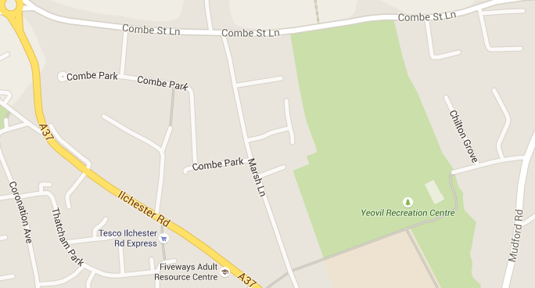
Yeovil Rec, BA21 4AW
Open every day
Cost: Free to visit with free parking… cheap and cheerful refreshment kiosk there, or take a picnic.
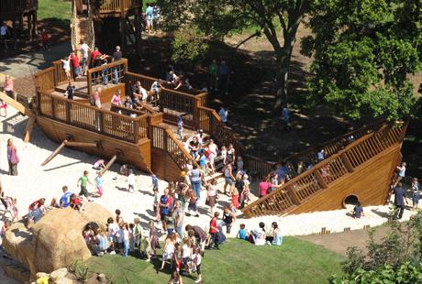
Tyre swings, zip lines, lots of sand, a giant shipwreck… free tennis courts/ multi-use games area available, pitch and putt for a small charge, other sports facilities to hire.
Price list: http://yeovilrec.co.uk/open-times-and-prices/pricelist
Holiday activities: http://yeovilrec.co.uk/families/holiday-activities

Museum of Somerset, Taunton TA1 4AA
Closed Sundays and Mondays
Cost: Free to go in (small donation requested) small charge for some activities. Tel: 01823 255 088
You’ll need to park in Taunton centre for this, or get the bus. You may need to book for SOME children’s activities – click on the link below, or just phone them to find out about their summer holiday activities for parents of different ages. Some holiday activities have a small cost involved.
Check the website for information:
http://museumofsomerset.org.uk/ -
click “what’s on” tab for up-to-date info/ newsletter sign-up.

Somerset Libraries are free to join for both children and adults.

Most libraries offer free storytelling sessions for younger children.

Older children are welcome to join this year’s summer reading challenge – 7,700 Somerset children took part last year.

For more info, go to somersetlibraries.co.uk,
click on events then your local library
or phone 0300 123 2224 and ask for Libraries
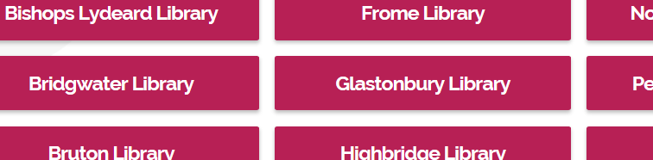

Special Education Needs & Disabilities

Somerset County Council also produces information about activity days aimed at children with special educational needs and/or disabilities.
This is in addition to the other activities listed in this guide. For further details, please click on the link below, or phone the Short Breaks Team on 01823 358117.
http://www.somerset.gov.uk/organisation/departments/disabled-children-and-young-peoples-service/

Parents of children with an autistic spectrum condition, may be interested in
Autism-friendly cinema screenings.
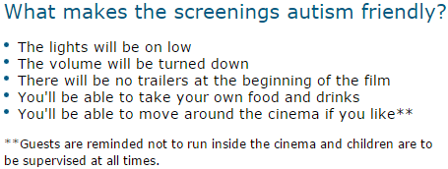

More information about participating cinemas:
http://www.dimensions-uk.org/s upport-services/autism-care/autism-friendly-screenings/

Cheap Saturday morning cinema (for families)
Cineworld Yeovil, Sat 10:00 a.m. (-ish).

Type “movies for juniors cineworld” into Google, then select ‘Yeovil’ as your cinema to see upcoming Saturday morning movies….”

Cost: around £2.00 per ticket, child or adult (more for 3-D films) – big saving on normal prices, though you might still need to buy (or take) refreshments, pay for parking etc.

YMCA Daycamps Bridgwater

(7 – 14 yrs)

most days throughout July – August school holiday

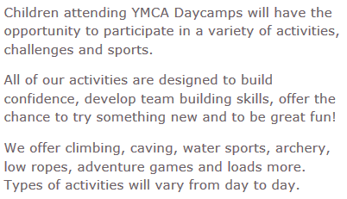

Standard day (9:00am – 5:00pm) = £20

For more info, click here OR type ‘YMCA Daycamps Bridgwater’ into search engine.

Email info@ymca-sc.org Call 01278 726 000 – if your child requires additional support, please discuss with the team in advance; Bridgwater YMCA’s aim is to be an inclusive provision.

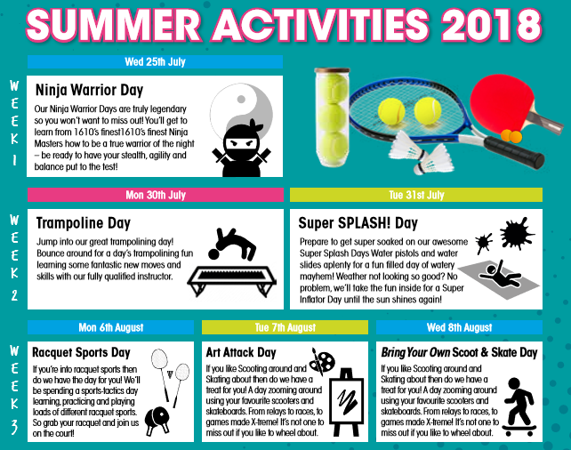

Costs range from £14.00 to £23.00 per day.
Please contact Glastonbury Leisure Centre (St Dunstan’s School Site) for more details.

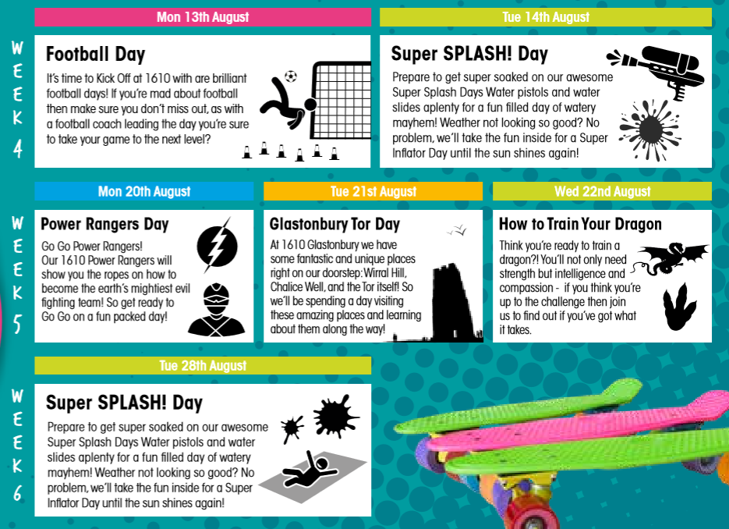

Costs range from £14.00 to £23.00 per day.
Please contact Glastonbury Leisure Centre (St Dunstan’s School Site) for more details.
Secret World Wildlife Rescue,
East Huntspill, Highbridge TA9 3PZ

Wild and Deadly Wednesdays
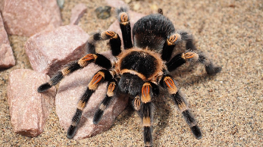

Wed 8th, Wed 15th & Wed 22nd Aug,
12 noon - 4:00 pm

The interactive, live nature show will give children and their parents the chance to get up close with spiders and bugs…..if they dare! There will also be craft activities, and refreshments are available to be purchased.

Cost: £4 per adult and £2 per child. Food on sale, or bring a picnic. Free car parking.
Click here to book tickets online: https://www.secretworld.org/events/category/public-events/
Or phone 01278 783 250

----------------------------------------------------------------------------------
Secret World Wildlife Rescue,
East Huntspill, Highbridge TA9 3PZ

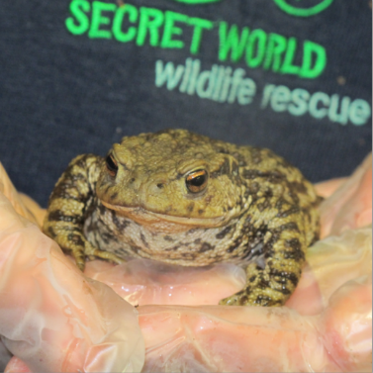
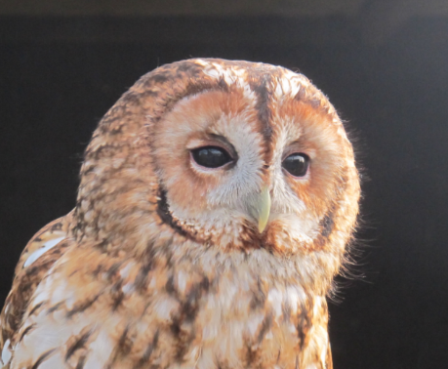
Wild Academy

Birds of Prey - Wed 1st and 29th Aug, 10am-12noon
Find out more about the UK’s amazing birds of prey: where they live, how to identify them, and what they eat. We’ll also be meeting some of our resident birds of prey and getting creative.
Reptiles and Amphibians, Thu 2nd Aug, 10am-12noon
What’s the difference between reptiles and amphibians? Discover during this fun packed session. We’ll be meeting our resident corn snake Tony, as well as making some crafts to take home.
Fruitful Hedgerows, Thurs 30th August, 10am-12noon
Hedgerows are an amazing source of food for wildlife and us! We’ll be walking along some country pathways to see what we can find in these natural larders, foraging for food for our animal casualties, and making a snack with our hedgerow bounty.

Cost: £6 per child - includes a drink and biscuit, + a hot drink for the adults.
All accompanied children welcome, best suited for children aged 5-11.
Tickets available on our website: https://www.secretworld.org/learn/wild-academy/
Or call 01278 783250

Secret World Wildlife Rescue,
East Huntspill, Highbridge TA9 3PZ

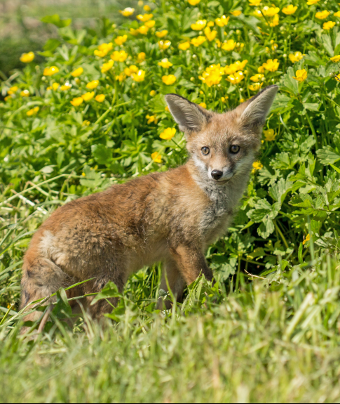
Wildlife Wonders
Sun 26th & Mon 27th Aug, 10am-4pm
Join us for some Summer family fun at Secret World this August Bank Holiday weekend for our fundraising event.

- Take part in our wildlife treasure trail
- Meet our resident birds of prey and hear their stories
- Enjoy fascinating talks about the animals we help
- Games and nature activities
- Food court and marketplace
- Craft and face painted

Cost: adults £1, children 50p
Includes a free family wildlife treasure trail
All money raised will help us to care for injured, sick and orphaned wildlife.

More Wildlife Events
For info about Somerset Wildlife Trust events for families, go to www.somersetwildlife.org, click on events,
then sign up for updates

phone 01823 652 400 / email enquiries@somersetwildlife.org /
Spaces go quickly, but the following events may still have availability (don’t wait ) :

Small wonders walk (8yrs+) - Coleford

Saturday 11 August 10:00am - 12:30pm (tbc)
Discover the 'small wonders' (including insects, galls, fungi, lichens, mosses and ferns) that local wildlife enthusiasts Veryan and Andy Conn will share with you in Coleford's meadows and woodlands.
Booking essential – please email events@somersetwildlife.org
Cost: £2.50 Adults, £1.50 Children (must be accompanied)

Bats Galore walk – Wells

Tuesday 21 August 8:00-10:00pm

A walk around the Bishops Palace Moat in Wells with local bat expert Dave Cottle and members of the Somerset Bat Group. Learn how to use a bat detector to identify diﬀerent species, and fascinating facts about bats.

Booking essential - please contact Jean (jaye.mantle@btinternet.com) or call 01749 677600

Cost : £2.00 Adults, free for children (must be accompanied).

Go Wild With Your Camera! – Red Brick Building, Glastonbury

Wednesday 22 August 2:00-4:30pm
Discover mystic mounds, mini-beasts and late ﬂowers in Somerset’s summer fields on this photography walk. Inspired by the award-winning photographs on display at the Red Brick Building, join wildlife photographers Victoria Les exploring and photographing the wildlife nearby.
Please bring your camera!
Please wear sturdy footwear and waterproofs if wet
We suggest wearing trousers, so legs are covered to reduce the risk of ticks.
If it is a hot day, please bring water, sun cream and a hat
Children must be accompanied by an adult.
Sorry - no dogs.
Where: Red Brick Building, Morland, Enterprise Park, Morland Road, Glastonbury BA6 9FT.
Booking essential: Booking essential. Please book through the Red Brick Building by clicking here or contact Victoria on victoria.vikspics@gmail.com for more information.
Cost: £5:00 Adults, £2.00 Children (must be accompanied)
Red Brick Youth Club (11 to 19 years) – term-time only
Thinking ahead to September, did you know that there’s a Youth Club at Glastonbury’s Red Brick Building? Activities = air hockey, table tennis, board games, music, crafts – sometimes cooking, stop-frame animation etc – depending on members’ needs and interests.
The club is run in association with Mendip YMCA; all staff and volunteers hold enhanced DBS checks and have received safeguarding training.
See the RBB Youth Facebook Page for more info – or contact Katherine Clarke at youth@redbrickbuilding.co.uk.
Young people must get a parent’s/ carer’s written consent in advance in order to attend.
Cost: 50p per week.

Family Fun – Meadows & Minibeasts

Tue 7th August 10:00am – 2:00pm

We’ll be making the most of all our marvellous meadows, finding out who lives here, making some crafty creatures, taking up a new orienteering challenge and lots more!

Suitable for children aged 4-11 and their parents / carers.

Booking essential –please e-mail education@carymoor.org.uk or 01963 351350
Cost: £8 per person or £25 for a family of four

Family Fun – Woodland Survival Day

Thu 9th August 10:00am – 2:00pm

Orienteering, fire-lighting and marshmallow toasting, den-building, whittling and tricky team challenges that would even test Bear Grylls!

Suitable for children aged 4-11 and their parents / carers.

Booking essential –please e-mail education@carymoor.org.uk or 01963 351350
Cost: £8 per person or £25 for a family of four

Family Fun – Ahoy there! Pirate & Pond Day

Tue 21st August 10:00am – 2:00pm

Pond-dip for beasties from our lovely new dipping platform, solve some 'river riddles' and make a willow dragonfly, then climb aboard the good ship Carymoor for lots of Piratey adventures!

Suitable for children aged 4-11 and their parents / carers.

Booking essential –please e-mail education@carymoor.org.uk or 01963 351350
Cost: £8 per person or £25 for a family of four

Other

Family Fun – Viking Experience

Thu 23rd August 10:00am – 2:00pm

Experience a day in the life of a Viking by making a mini log house, trying your hand at using wattle and daub, baking bread over an open fire and lots more!

Suitable for children aged 4-11 and their parents / carers.

Booking essential –please e-mail education@carymoor.org.uk or 01963 351350
Cost: £8 per person or £25 for a family of four

Go Wild at Carymoor – Activity Week

Mon 30th July – Fri 3rd August OR Mon 13th – Fri 17th August

9:00am – 3:00pm each day

Come and join us for a week of summer fun on our beautiful nature reserve near Castle Cary. Try your hand at surviving like Bear Grylls one day and a Viking the next, support conservation tasks on our site and explore our woodlands, meadows and ponds. Each day will be packed with hands on activities, challenges, games and craft opportunities and most importantly lots and lots of fun!

All participants will work towards a special Carymoor Environmental Award during the week, with those participants entering Year 6 in the coming academic year working towards their John Muir Discovery Award, a nationally recognised conservation Award.

Places are limited to fifteen children per week. Staff are DBS checked and have first aid training.

Booking essential – please contact karen.boswell@carymoor.org.uk or phone 01963 351350

Cost: £175 per child for a week of activities

Wild Art at Ham Wall
Fri 27th July
Fri 3rd Aug
Fri 10th Aug 11:00am – 3:00pm
Fri 17th Aug

Come and have some creative fun using natural materials to print, weave, mould and paint some amazing art.
Cost: £3 per child (discount for RSPB members); no need to book

Mini Beast Safaris at Ham Wall

Thu 2nd Aug
Thu 9th Aug
Thu 23rd Aug 11:00am – 12:30pm
Thu 30th Aug

Come on a bug hunt to find out what is lurking in the undergrowth and explore the hidden world of everything that crawls, slithers and buzzes.
Cost: £3 per child (discount for RSPB members); no need to book

for all Ham Wall activities:

Directions: Park at main Ham Wall Car Park (sat nav: BA6 9SX

More info: 01458 860494/ ham.wall@rspb.org.uk

Bring waterproofs if it's wet or sun hat and sun cream (and a drink!) if it's sunny and hot!

Look up “canoe tours Ham Wall” – available for accompanied children over 6

Sat 4th & Sun 5th Aug + Sat 1st & Sun 2nd Sep; must be booked online

Cost starts at approx. £11 per child + £15 per adult

Children’s World / Off the Streets
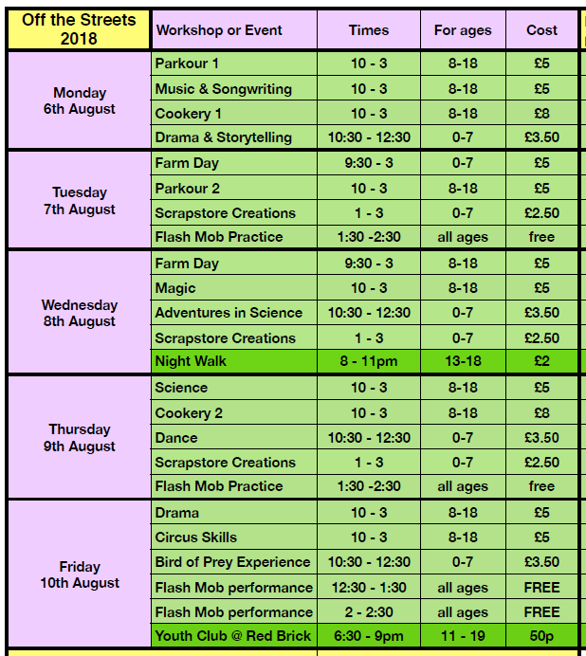
Children’s World are a Glastonbury-based children’s charity. They have been working with children of all abilities since 1981. They run ‘Off the Streets’, a range of free / low-cost activities in Glastonbury for children/ young people of different ages, from Mon 6th to Fri 10th August.

To book, visit their website http://www.childrensworldcharity.org/out-of-schools/ots/ and download a booking form OR phone 01458 833 693 / email info@childrensworldcharity.org

Glastonbury's first Family Festival!
co-hosted by Children's World and Paddington Farm Trust
Please contact Paddington Farm to book in advance. 01458 832752
info@paddingtonfarm.co.uk
www.paddingtonfarm.co.uk
Cost:
Weekend tickets £20 per child, £10 per adult
Friday 2.00pm – 6.00pm
£5 per child (5 – 16yrs) £2 per adult
Saturday 11.00am – 6.00pm
£10 per child (5 – 16yrs) £5 per adult
Sunday 11.00am – 6.00pm
£10 per child (5 – 16yrs) £5 per adult
Limited camping also available.

Learn to Steward at Events – free for anyone aged 10 to 20 (or 25 with special needs)
Wed 25th July, 9:00am to 4:00pm (regular breaks) – Somerset Youth Volunteering Network
Learn about communication, teamwork, health & safety, crowd control, first aid, evaluation etc.
Certificate available for all who complete this one-day course.
Contact Kristen, Paddy or Gerry (Children’s World) for more details. Tel: 01458 833693

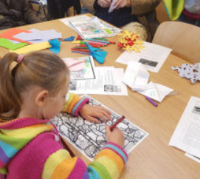
Wells Cathedral Events
Family Holiday Workshop - Leather Scraps Make and Take
Wed 1st Aug, 10:30am – 12:00
& 2:00 – 3:30pm
All are welcome to join in on this popular FREE family creative workshop - our theme today is "Leather Scraps Make and Take". Two sessions are offered at 10.30 am - 12.00 pm or 2.00 - 3.30 pm. This workshop takes place in the Education Room; all materials are provided and staff will be on hand to offer help and advice. Our workshops are free but donations to help cover cost of materials are gratefully received. No need to book, just turn up and have fun! Wells Cathedral offers family creative workshops during the school holidays; check our website or social media for details.
Cost: FREE. No need to book.
When you go into the Cathedral, say that you’re there for the workshop. You won’t be then be asked to make a donation to go in.
Family Holiday Workshop – Glass Trail and Painting
Wed 22nd Aug, 10:30am – 12:00 & 2:00 – 3:30pm
Description:All are welcome to join in on this popular event where you get to follow our glass trail and have a go at glass painting. Two sessions are offered at 10.30 am - 12.00 pm or 2.00 - 3.30 pm. This workshop takes place in the Education Room; all materials are provided and staff are on hand to offer help and advice.
Cost: £5/ family (2 children, additional children £1). No need to book.
When you go into the Cathedral, say that you’re there for the workshop. You won’t be then be asked to make a donation additional to the workshop fee.

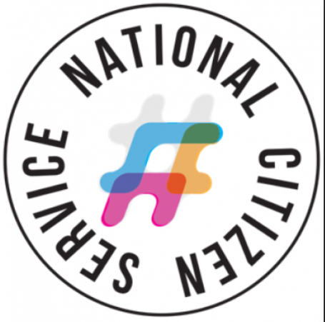
Are you aged between 15 – 17, and living in Somerset?
National Citizen Service programmes are available locally – four weeks for £50
(help may be available if cost is a problem)

WEEK 1 – ADVENTURE
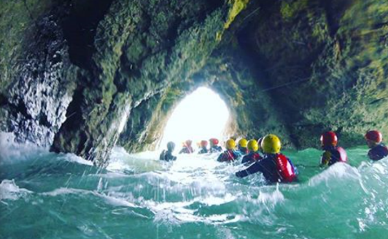

You’ll experience the freedom of living away from home in an outdoor environment. In a team of no more than 15 people you will embark on a range of adrenaline fuelled activities like rock climbing, abseiling and canoeing. You’ll get to know your NCS family, build confidence and achieve things you never thought possible!
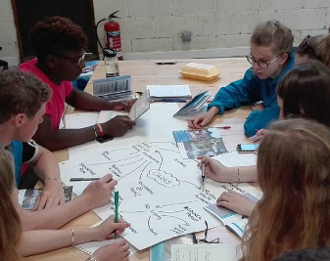
WEEK 2 –SKILLS
Reunited with your group you’ll be living away from home for the second week in university-style accommodation. Not only will you learn to cook and clean for yourself (yes, really) you’ll also learn some huge life skills that will look great on your CV! This week is all about discovering yourself and developing your skills for life.
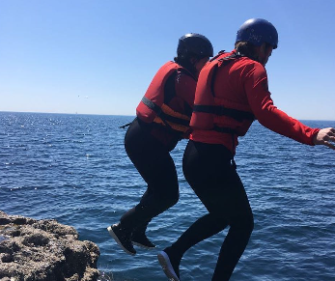

WEEK 3 & 4 – ACTION

This is where your NCS experience really comes together! You’ll return home where your NCS team will reunite using all of the fun and inspiration from the first two weeks to step up and deliver your very own social action project within your community. Plan; fundraise; make a difference! This is your chance to find something you’re passionate about and make a difference.

More info: www.ncsyes.co.uk
Tel: 0117 930 3030 (daytime)
Tel: 0800 197 8010 (after 5:30pm)

Helplines

Family Lives is a national parenting charity, which offers mums, dads and carers a helpline plus a range of support and guidance available online, including forums.
Tel: 0808 800 2222 Visit: www.familylives.org.uk

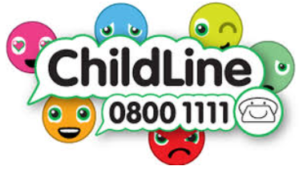
Childline is a children’s charity which offers children (under-19s) someone safe to speak to, by phone, by email or online. Tel: 0800 1111 / Visit: www.childline.org.uk

Kooth is a free, online community available to those aged 11 to 18 in Somerset. Offers a range of support, including moderated online forums, and confidential counselling from qualified youth counsellors (delivered through online chat/ messenger-type service).
Visit: www.kooth.com (NHS funded, online only)

The Mix is a national charity/ helpline/ online advice service for those aged 13 to 25. Tel: 0808 808 4994 / www.themix.org.uk

2BU Somerset offers advice and guidance to Somerset teenagers who are lesbian, gay, bisexual, trans or questioning (LGBTQ+).
Tel: 07799 136552 / Visit: www.2bu-somerset.co.uk

Are you worried about the safety or welfare of a child?
If it isn’t a 999 emergency situation, phone Somerset Direct- 0300 123 2224.

Summer Holidays 2018
Children’s, Youth & Family Activities – Mendips
Version 1 – 4th July 2018

Who we are
The Tor School opened in February 2018.
We are the Pupil Referral Unit and Medical Tuition School for the Mendip area. Our referrals come via the Panel for Excluded and Vulnerable Pupils (PEVP).
You can follow the Tor School on Twitter (@MENDIPPRU) for general school updates.

I’m the Tor School’s Parent & Family Support Adviser.
You can follow me on Twitter (@DaveCurlMendips) – occasional updates about local services, etc which could be useful for local mums, dads, carers and people who work with children/ families/ schools.

