Summer Hotel Project.

A new hotel resort.
Your task is to design a new hotel resort. It will have the main hotel, a swimming pool, a games area and its own private beach.

Your tasks;
- Design the area from a bird’s eye view using squared paper. Include all the above and label it clearly.
- Work out the size of swimming pool you can afford. (Perimeter)
- Work out how many sun loungers and umbrellas you can supply on the beach.
(Money)
- Design the best shape for the games area.
(2D shapes)
- Work out the cost of building the main hotel.
(Money)
- Work out the money you can make over the summer.
(Money)
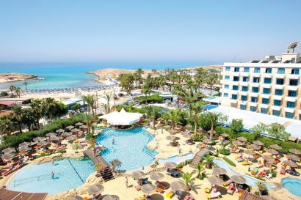

Task 1.
Design your Hotel resort.
Remember to include;
The main hotel.
The swimming pool.
The games area.
The private beach.
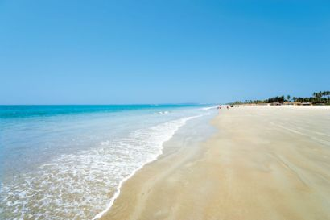

Task 2
You have £1000 to spend on you swimming pool. You need to work out what size your pool can be using the information below.

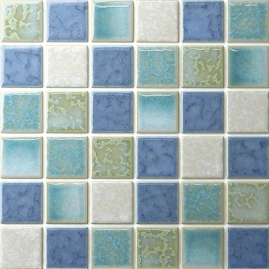
Digging an area = £20 a square metre
Pool tiles = £10 a square metre
Safety fencing = £5 a square metre
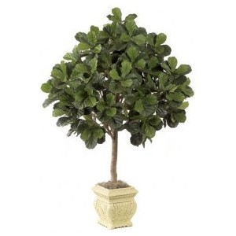
Decorative trees = £15 each
Diving boards = £12 each
Ladders = £8 each
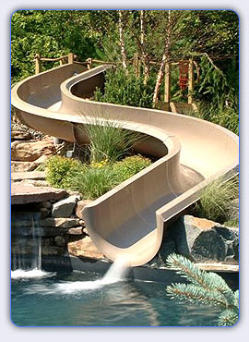
Water slides = £10 small
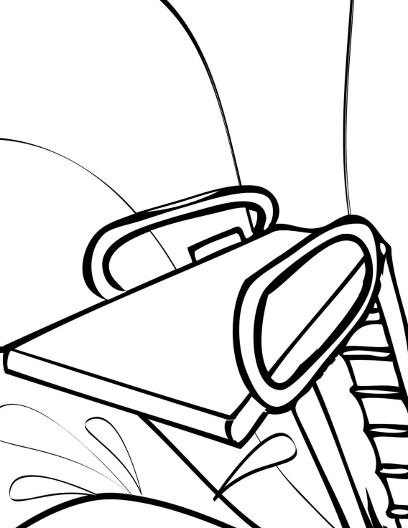
£20 medium
£30 large
£50 Super Terror Tower

Shapes of pool.

Task 3
You have £500 to spend on sun loungers and beach umbrellas.
A sun lounger costs £12 and a beach umbrella costs £7.
How many can you buy to start with?

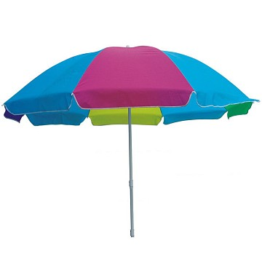
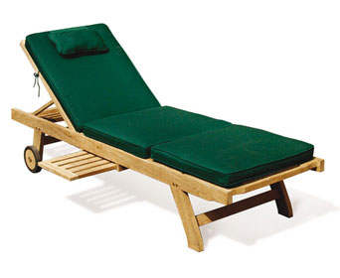
You earn a bonus from the beach awards committee. You have an extra £1000 to spend. How many extras can you buy now?

Task 4
Designing a games area is tricky. You have to think of the activities you might have there and what the best use of space is.
List the activities you would like in your games area;

On squared paper, design the area and divide it into separate activities for each area. Try out some different shapes.

Task 5
Now you must work out how much it will cost to build the main hotel building.
Each floor will cost £200 to build you then need to add rooms and decorations.

A single room will cost £100
A double room will cost £200
A deluxe room will cost £300
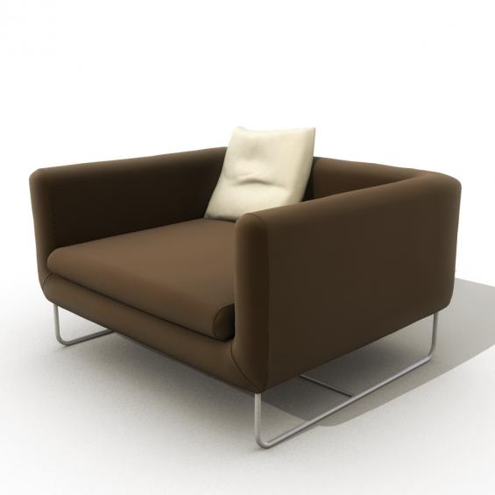
A lift will cost £1500. You may have more than one.

Decorations;
Pictures £20 each
Armchair £12 each
Sofa £21 each
Rug £7 each

You can choose how many floors you want the hotel to be but remember you must add the cost of the rooms and decorations too.
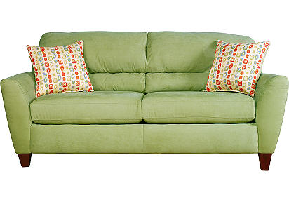

Task 6
Your hotel has been rated 5 stars and is very popular.
These are the basic costs.
A single room will cost £85 per week
A Double room will cost £110 per week
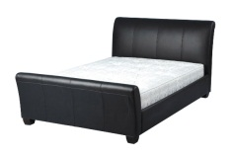
A deluxe room will cost £200 per week,
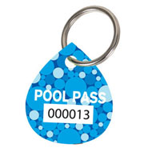
Games pass will cost £30 per week
Pool pass will cost £5 per week

- In week one the hotel had 5 bookings for double rooms, 2 bookings for single rooms and 15 bookings for deluxe rooms. Each room booked a games pass and pool pass. How much money will you make in week one.

- In week two the hotel had bookings for all 20 deluxe rooms with added games and pool passes. There were also bookings for 10 double rooms and 5 single rooms. From these 15 rooms only 10 booked pool passes and 5 booked games passes. How much money will you make in week two?

- In week three the bookings were low. Only 2 deluxe and 4 double rooms were booked. However all 6 rooms requested pool and games passes. How much money will you make in week three?

- In week four, bookings were taken for 18 deluxe, 12 double and 11 single rooms. No rooms wanted games passes but 15 of the 41 rooms booked pool passes.

- In the final week the hotel was fully booked with all 20 deluxe, 20 Double and 15 single rooms booking both a games and a pool pass.

- Now add the total money for the five weeks.

- Take away the cost of building the hotel and the £1000 you spent on the pool.

- Finally add on the £3490 you made renting out beach umbrellas and sun loungers over the five weeks.
What is your final total amount?

Congratulations if you made a profit!!
(Positive number as a final total)

