

**Staff**

**Handbook**

**2021/22**

**Contents:**

1. Values statement………………………………………………………………….p.4
2. The site entrances and exits………………………………………………….p.7
3. Fire and evacuation procedure……………………………………………..p.8
4. Pupil attendance…………………………………………………………………. p.9
5. AM/ PM procedure……………………………………………………………… p.9
6. Attendance monitoring………………………………………………………...p.9
7. Staff absence…………………………………………………………………….....p.9
8. Staff list and Line management structure……………………………p.10
9. The school day…………………………………………………………………….p.12
10. The Curriculum………………………………………………………………..p.13
11. Assessment and record keeping………………………………………p.17
12. Reporting………………………………………………………………………..p.21
13. The role of the Tutor……………………………………………………….p.22
14. Peer Coaching………………………………………………………………….p.22
15. Professional Development …..…………………………………………p.23
16. Briefing……………………………………………………………………………p.24
17. Safeguarding procedures (including COVID)……………………p.24
18. Eating with pupils……………………………………………………………p.25
19. Teaching and Learning Resources……………………………………p.25
20. Behaviour as communication………………………………………….p.26

Introduction

Welcome to Tor school. We are one of the few local authority PRUs in the country to have a new build, but this is not just about the building. A school is much more than bricks and mortar and the important parts are the people and the relationships they form with each other.

We have grown and developed from 4 previously separate provisions - The Mendip Centre, The Link Education Centre, The Short Stay School or Mendip Inclusion Project. Together we are stronger, more flexible and share a common set of values. How we put those values to practice is set out in this handbook.

To work here you need to understand young people. You need to be able to accept that as they grow up they often make mistakes and get things wrong. This is a natural part of developing as a person. Some young people find this more difficult than others for a variety of reasons. There are times when this makes a full-time placement in a mainstream school inappropriate. Some pupils just do not fit; that is why they come to us. However, in a mainstream class on a Friday afternoon somewhere near here, one teacher is coping without about 30 pupils just like ours. We are privileged to have such great teacher pupil ratios.

Very often the reason young people find it hard to cope in mainstream schools, is that despite all the support they receive, staff do not have the time to build relationships and truly understand what makes them tick. Here we take the time to invest in those relationships and see them as the foundation on which everything else is built.  Some of our young people have early experiences that lead them to behave in particular ways to protect themselves from harm. Others have learned to behave in a manner that creates a sense of self-worth. Others are still emotionally at a much younger age than they actually are. We see behaviour as a form of communication as well as learned often ingrained responses. We see behaviours as opportunities to teach and learn. Some of our young people internalise their emotions and close down, or disassociate from those around them. Others externalise their behaviour and both of these responses can be challenging to manage in different ways.

We work hard to understand the causes of social, emotional and mental health issues and develop support for the child or young person holistically through a plan involving expertise from across the school. Having said this, sometimes behavioural problems are not within child, but within family and community. It is not always useful to medicalise behaviour. Sometimes it’s just power play. At other times learners are trying to find their way in the pecking order and play up to the crowd. Our skill is in decoding what is really happening.

We ensure our young people feel safe and secure, making them feel welcome and wanted as part of a school community. Sometimes it can be as simple as a smile, a cup of tea and a biscuit. Warmth, humour and unconditional regard are inherent aspects of our provision here.

We cherish and value our staff; appreciating that there are people who work really hard in the background as well as in the classrooms, to ensure our pupils get the best life chances they can. As a member of staff here you will be expected to work hard and be totally dedicated. I need all of our staff to go the extra mile. I have high expectations and want to create an environment and ethos that is challenging but supportive. This is not a job for the faint hearted, but you will be treated with warmth, humour and positive regard. This is an amazing job and we are really privileged to work here.

We will get things wrong as we grow and develop. What defines us is how we react when we do so. It is ok to make mistakes and to build on them without blame or fear of retribution. I hope you enjoy working here and are up for it.

Our Values

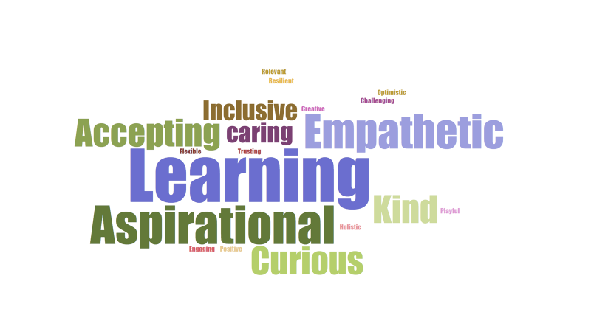

Perception is real to the perceiver. Each of these words carries meaning. They are what we strive to be. You can see that Learning is the biggest word and is at the heart of everything we do. We are a school but not a mainstream school. Our young people are with us because they do not fit mainstream, so we shouldn’t recreate something similar but on a smaller scale. We are an alternative provider and need to be creative and flexible in everything we do.

**We believe that:**

* relationships are everything
* the most important thing is the well-being of the child
* we should ensure basic needs are met before we try to get children to work
* qualifications are important but they are not everything
* we should *not* mirror mainstream school for pupils who are on roll with us.
* we should have high expectations at all times
* children are not bad people they are struggling to behave – it’s ok for them to get it wrong sometimes
* behaviour is often a form of communication
* data should be used to improve children’s lives not the other way round
* we should work in ways that lead children to feel good about themselves
* humour breaks down barriers and builds self esteem
* listening to young people is essential
* bearing grudges leads to resentment – every day is a fresh start
* understanding young people and engaging with their emotional world, knowing what makes them tick is essential
* practise is worked out through relationships not formulaic strategies
* it is essential to engage parents, understand their world and talk to them often
* we should notice what young people are doing, reflect on this with them and acknowledge achievements.
* we show children we are genuinely pleased to see them
* we try not to take things personally
* learning takes place in a social context – spoken language is central to this
* staff should constantly review and renew how they work with children to find a way in
* staff should model the sort of behaviour we want from the children, especially to each other
* all feelings are ok but not all behaviours are ok
* an assessment of learning needs should always be considered alongside other assessments.

**This is what we do:**

* We are not frightened to show that we care
* We work hard at being good listeners and astute observers of young people
* We try to stay calm when there is verbal and physical violence.
* We try not to be shocked or frightened by young people’s behaviour
* We validate and acknowledge young people’s thoughts and emotions but we help them name them and reframe them. You can call this emotion coaching or VRFs (Vital Relational Functions) but it’s really just common sense
* We constantly renew and review the approach we take with a young person to find a way in and talk to each other and challenge each other’s practice. This is done more formally through peer observation and solution circles
* We go out of our way to trust and support each other and show our young people that we do.
* We use humour as a way in and a way of calming and validating pupils.
* We take initiative and are flexible and creative – we offer help to each other if it’s obvious that we need it
* We talk to young people all the time and find ways to challenge and extend their vocabulary
* We eat with young people and use that as an opportunity to talk to them about them
* We use current events as a learning opportunity whenever possible
* We give young people an element of choice in their learning and make it fun. Sometimes young people do not realise they are learning
* We put the “right pupil on the right course” we tailor the curriculum to meet the needs and aspirations of young people.
* We take a no blame approach especially with parents and we work hard to communicate with them
* We invite parents to regular reviews and we go to their homes
* We work hard to get the parents to see we are on their side. This breaks down barriers and stops them feeling they are “stuck in the middle”
* We show high expectations but express low disappointment when things go wrong
* We reduce the distance between ourselves and young people by sharing our own lives and stories
* We show we are fallible, and we back down and lose face sometimes
* We express warmth and affection to young people and let them know that every day is a fresh start

**In Groups and Out Groups – Us and them**

People are naturally drawn to belonging to a group. It’s how we form our identity. There is a tendency for people in one group to exaggerate the similarities between themselves and the differences between themselves and other groups. Many of our young people were pushed into an out group at school and treated differently. The stroppy girls, the bottom set pains, the druggy boys, the overly anxious kids. We must be really careful that through our language and behaviour we do not reinforce these stereotypes. All Tor pupils are “our” pupils. Phrases like “our part of the school” or “our kids and your kids” are not helpful and get in the way. It would be easy to fall into the trap of treating learners differently because of the route they came to us. A mindshift in pupils starts with a mind shift on the part of staff, who will influence directly how pupils perceive themselves and form their group identity. ***When the adults change everything changes***.

It has been proven by scientific studies that contact with other groups and cooperative tasks reduce discriminatory behaviour. We must make every opportunity to do these two things with all of our pupils to prepare them for the next phase in their life.

**The Site and Building**

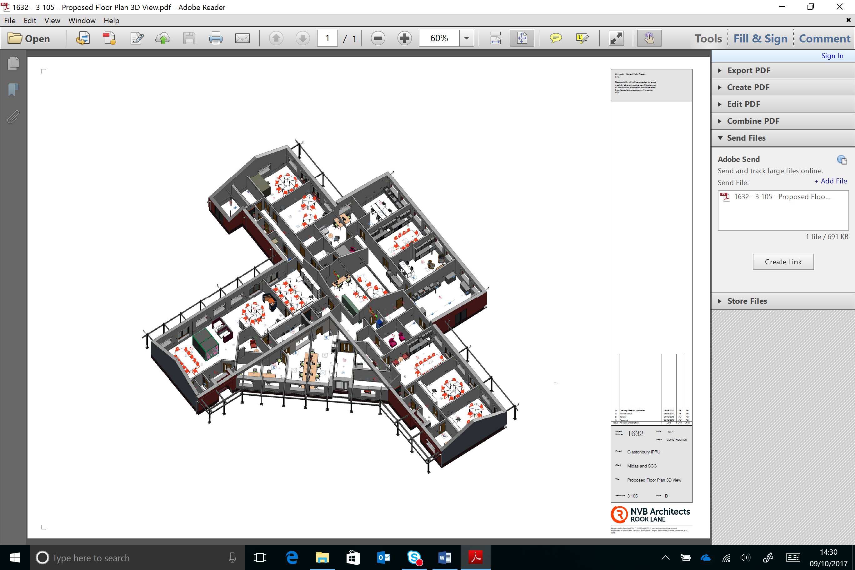

KS4 Pupils

Short Stay Pupils

Main Entrance

At 7am the caretaker will deactivate the alarms and physically unlock the building at each of the 3 main entrances and also physically unlock the external gates to the sides of the building. This will all be locked and alarmed again at 7pm.

All staff will enter via the main entrance to the building when they arrive and sign in using our entry system The swipe card is also the staff ID badge and must be worn at all times. The thumb print biometric system will then open the main security door to the school. When they leave the building they can swipe out, if leaving by the main door or if leaving by a pupil exit they can sign themselves out.

Visitors will also access the school using the digital sign in system and a badge will be printed with a bar code enabling them temporary access to the building. All visitors must wear a lanyard with the visitor badge on it. This will be managed by reception staff. Regular visitors who have been DBS checked will gain access by this system under the DBS tab.

Pupils will enter the building by the two main pupil entrances, or the main entrance. Thumb print access will enable them to enter the building from 8.30am until 4pm. The doors will open allowing access if one pupil enters the building. The doors will then close and can then be opened from inside the building. Outside of these times pupils will need to enter via the main entrance and speak to reception to gain access.

Primary pupils will be met at main reception and walked through the building by members of staff. The Headteacher and members of the senior team will meet and greet pupils in the morning outside the building.

**Fire and Evacuation Procedures**

In the event of a fire all external doors will open and everyone will walk around the outside of the building to the muster point which is the main car park. They should move in the safest direction clockwise or anti clockwise depending on where the risk is. Red fire alarm points are in each of the rooms next to external exits.

All external gates have a padlock. The two final gates will be opened by a member of staff with a key.

Fire marshals will coordinate with the most senior member of staff to agree when it is safe to enter the building when all pupils, staff and visitors have been accounted for.

In the event of an emergency which is not a fire, such as an intruder in the building, a member of staff should open the exit gates by pressing one of the green emergency exit buttons situated next to each of the main external doors. A single alarm code will repeat twice. Everyone should move in the same manner and direction as if it were a fire and muster at the same point. If there is a risk at this point, staff will direct everyone off site.

**Pupil Attendance**

Pupils are registered during each lesson. There are two main registration marks twice a day in the morning and afternoon using School pod. It is essential that registers are taken promptly and accurately. If there is an offsite visit the member of staff leading the visit will mark the pupils as off site and on a trip. When leaving the building the trip leader should then mark the pupils as off site.

If a pupil is late they are marked as such and the number of minutes late recorded.

If a pupil is absent a text message will go the parents or carers and this will ask for a response. This can be a text message or return the call to our EFSW or admin team.

If there is no response within a reasonable time then our EFSW or admin team will telephone to enquire the reason for the absence.

**AM/ PM procedure**

The morning routine is as follows:

* 8.50am – all teaching staff meet for a morning briefing detailing any safeguarding and important communications.
* 9.30am All pupils and staff congregate in their designated family room or tutor base, where pupils will be welcomed warmly and offered refreshment and something to eat in the morning in a nurturing manner. There will then be a 10 minute session with the Tutor going through the day to come and nudging level best
* Lessons will begin at 9.45am.

**Attendance Monitoring**

Our EFSW is primarily responsible for monitoring attendance and chasing this with parents and carers. Absence will not be authorised without evidence.

SLT monitor all attendance weekly – see attendance policy

Patterns of absence will also be monitored to pick up any concerns.

**Staff absence**

If a member of staff is ill, they should inform the Headteacher immediately on the day of absence. It is not ok to say the day before the absence that you will be away. You cannot predict that you will be ill. Headteacher Telephone number – 07801575506. This phone will be on from 7am.

If you are able to do so you should send any cover work into school by email to the Headteacher, Business manager Mandy Ramsey and you head of department.

If the absence is for less than 5 days the member of staff should complete a Sickness Declaration and Return to WORK Form HRAP02

The line manager will conduct a Return to Work meeting then pass this form to Admin to update SIMs.

If there are any concerns about staff attendance, we will follow the SCC policy on managing sickness and absence.

The **Bradford Factor** is a simple formula to help manage short term sick absences and determine when these have become excessive. The calculation for the **Bradford Factor** (B) is Number of Occasions Sick (S) x Number of Occasions Sick (S) x Total Number of Days Absent (D), or. B = S² x D. A Bradford factor higher than 144 is a cause for concern.

**Staff – Line management structure**

|  |
| --- |
|  |

**Maternity**

Most teaching staff will work across the school, utilising expertise. However, you will also be a Tutor to a number of young people and be part of our Pastoral Team. The role of Tutor is your most important one. As a Tutor you are the hub for your tutee and the main point of contact for parents and other agencies. The relationship is key. There will be times when you need to deliver tough messages. This is your job as the adult. Be friendly but not a friend.

***Curriculum Teams***

As a Teacher you will ***also*** be attached to one of the following areas and work with colleagues to develop and plan teaching resources and pedagogy. You may be a member of more than one Team

* + Maths/ Numeracy
  + English/ Literacy
  + The Arts
  + Science
  + Vocational Learning
  + Humanities
  + Preparation for Adult Life/ PSHE
  + Primary
  + Partnership – outreach and support programmes
  + Support staff

**The School Day**

|  |  |  |  |
| --- | --- | --- | --- |
| Staff arrive by | 8.45 |  | Pupils on flexible programmes transported separately. |
| Team briefings and adaptations | 8.50 |  |
| Tutor/ Family Time | 9.30-9.45 | Taxis arrive |
| Lesson 1 | 9.45 – 10.30 |  |
| Lesson 2 | 10.30-11.15 |  |
| Break | 11.15-11.30 |  |
| Lesson 3 | 11.30- 12.15 |  |
| Lunch | 12.15 – 12.35 |  |
| Tutor Nudging | 12.35 – 12.45 |  |
| Lesson 4 | 12.45 – 13.30 |  |
| Lesson 5 | 13.30 – 14.15 |  |
| End of day review with selected pupils | 14.15- 14.30 | Taxis leave |
| Lesson 6 extension for some pupils on Outreach | 14.15 – 15.00 |  |
| Staff stay until | 15.15 (except meeting days) and on Friday 14.30 |  |

Curriculum Statement

Rationale

* The curriculum is one of the fundamental elements at Tor, both explicitly and implicitly, to prepare learners for the next steps.
* Our ethos and the wider enrichment opportunities we offer our young people is just as important as the knowledge and skills we want to develop in them.
* Making the curriculum relevant to our learners, and if need be bespoke, determines what they will know and their areas of progress. This will in turn impact upon their ability engage in the next stage of education after leaving us.
* Our young people are referred to us for a reason. Our curriculum utilises alternative qualifications and approaches to lessons to meet needs holistically.
* Due to large gaps in their education for a variety of reasons, it is unrealistic sometimes, in the time frame we have, that we offer the full national Curriculum. However we want to give our young people the essential knowledge and skills they need to move on successfully.
* We strive to give our learners an Education Passport of at least 5 Qualifications that are aimed at individual needs.
* Although there is a strong emphasis on the teaching of Maths and English, literacy and numeracy there is also access to a broad range of subjects and preparation for adult life that supports holistic progress for learners.
* The subjects contain the knowledge we wish the learners to gain within each domain.
* We also have a set of Learning Habits/employability skills that we want learners to develop and through these skills demonstrate that they have embedded the knowledge. We develop these habits through the taught curriculum and wider opportunities we offer
* We have pupils in KS1, KS2 & KS3 that are part of Tor School for a short period due to permanent exclusion or support programmes. The curriculum for these pupils is designed to: identify and support areas of weakness, develop skills and habits that will help them in their next setting as well as work specifically around supporting the transition from Tor to their new setting.
* There are essentially two kinds of skills we wish to develop. Firstly, the habits which can enable the demonstration of knowledge and enable better learning and secondly the subject specific skills which are inextricably linked to subject content.
* The broad knowledge areas are:
  + Maths/ Numeracy
  + English/ Literacy
  + The Arts
  + Sciences
  + Vocational Learning
  + Life Skills
  + Humanities
  + Preparation for adult life – including life skills
* In addition to the above we have a programme of SEMH work which is either carried out by Tutors, by specialists or bespoke sessions designed to develop SEMH resilience . We identify areas of difficulty and establish appropriate strategies with our learners to address their needs and support them to meet our expectations.
* We build a pupil passport based on these skills gaps which is tailored to each individual learner.
* We have a wider curriculum entitlement pledge which focusses on giving pupils ‘wider experiences’ and cultural capital whilst developing qualities that are prepare them for the wider world. This pledge is delivered through lessons as well as Curriculum enrichment sessions designed to enrich them and their experiences.
* Qualities and areas we seek to develop:

Resilience, self awareness, creativity, courage, respect & tolerance and Character alongside a range of life skills

* We also endeavour to provide the following:
* Be inspired by and through a range of Arts
* Experience outdoor education
* Take part in a trip to a museum or Art Gallery
* Make something you are proud of
* Experience the wonder of a wild and beautiful natural place in the UK or abroad
* Have a chance to express your views on local, national and/or international issues
* Help others by being an active citizen, for example raise money for charity
* Create opportunities to develop kindness and empathy
* Engage in dialogue with people from other religions and beliefs or other parts of the UK
* Visit a place of Higher Education or Training
* Experience a range of different career paths
* Develop essential life skills such as travelling on public transport, opening a bank account, budgeting, household skills.
* Create opportunities to develop oracy skills
* A sense of belonging in an educational environment

***Mapping subjects to domains.***

The table below shows how each of the knowledge domains is mapped across each year group in Key stage 4

|  |  |  |
| --- | --- | --- |
| Domain | 10 | 11 |
| Maths/ Numeracy | Maths 4 lessons pw | Maths 4 lessons pw |
| English/ Literacy | English 4 lessons pw | English 4 lessons pw |
| The Arts | Fine Art  3D Art  Photography 4 sessions pw | Fine Art  2D Art  3D Art  Photography  4 sessions pw |
| Sciences | Individual Sciences  4 lessons per week | Individual Sciences  4 lessons per week |
| Vocational Learning | Occupational Studies NCFE:  Food/ Catering  Motor Vehicle  Childcare  Sport  4 lessons per week | Occupational Studies NCFE:  Food/ Catering  Motor Vehicle  Childcare  Sport  4 lessons per week |
| Humanities | RS or Geography  4 lessons per week | RS or Geography  4 lessons per week |
| Preparation for Adult Life | PSHE/ Careers  2 lesson per week  Tutor session 1 lessons per week  Sport and fitness  Up to 4 lessons per week | PSHE/ Careers  2 lesson per week  Tutor session 1 lessons per week  Sport and fitness  Up to 4 lessons per week |
| Enrichment | 2 lessons per week | 2 lessons per week |

Some pupils may not access all lessons during the week as they may be on personalised timetables which includes AP or 1:1 sessions of SEMH.

Pupils in KS4 will take up to 3 options in addition to Maths and English. This will form the basis of their timetable and qualifications suite. Some of our pupils, for various reasons, will not take a full range of qualifications but all will do Maths and English and we aim to get our pupils at least 5 qualifications with Maths and English.

At times a pupil will arrive with us with, a particular interest, in a curriculum area. We will endeavour to offer this as a qualification wherever we can whilst being mindful that we cannot dilute too much and spread ourselves too thinly.

We also have a Secondary Short Stay Curriculum which is different to that for pupils with us for the whole of KS4.

**Short Stay**

2 Art

1 iTHRIVE

4 Eng

4 Enrichment

2 Food

2 Humanities

4 Maths

2 Preparation for adult life / PSHE

1 PE

1 Outdoor Education

2 Sci

1 Tutor

Transition work is also planned for and undertaken when the pupil has a next setting identified. The Short stay team will liaise and work with all stakeholders to ensure a planned transition is in place.

**Partnership Programme (2 days)**

1 Art

2 English

2 Maths

2 Partnership work (application & development)

3 Partnership work (direct)

**Primary - Short Stay and Outreach**

For those pupils attending Tor, the primary team assess pupils on entry as a means to find the gaps in learning that require support. The national curriculum is followed and a bespoke plan is designed for each pupil. Transition work is also planned for and undertaken when the pupil has a next setting identified. The primary team will liaise and work with all stakeholders to ensure a planned transition is in place.

**Medical Outreach tuition**

There are young people in Mendip who are unable to attend mainstream school due to medical and mental health reasons. We provide tuition for these young people. Depending on their age and need: the work could be based upon maintaining academic progress until such point they are able to attend mainstream again; or if they are KS4 and it is deemed in the best needs of the young person, they may attend Tor as a pupil.

The day ends earlier than mainstream schools and mirrors best practice in many AP schools for two reasons:

1. The intensity of the sessions and the amount of attention our pupils receive in very small groups and 1:1 means they often get cognitive overload
2. Many of our pupils have long distances to travel home and the day can often feel long as it is

**Teaching loadings**

Teachers should arrive no later than 8.45am and leave no earlier than 3.15pm. Compared to many schools our teaching day is concertinaed into a shorter one, so it may feel fuller, but there is time at the beginning and end of the day. We need to look after each other and so if we see a colleague needs a break, we should help out.

A full time teacher will be timetabled for 23 out of 25 lessons each week. This does not include Tutor Time, break and lunch

The directed time load is 1138 hours per year out of the contracted 1265. This allows 127 extra which can be utilised throughout the year.

Colleagues will be asked to cover each other as this is a very small school and directed time is relatively low compared to mainstream. Staff whose timetables do not have a full allocation of lessons will be utilised first for cover. Cover is assigned on an equitable basis and also factors in staff specialisms.

**Assessment and Record Keeping**

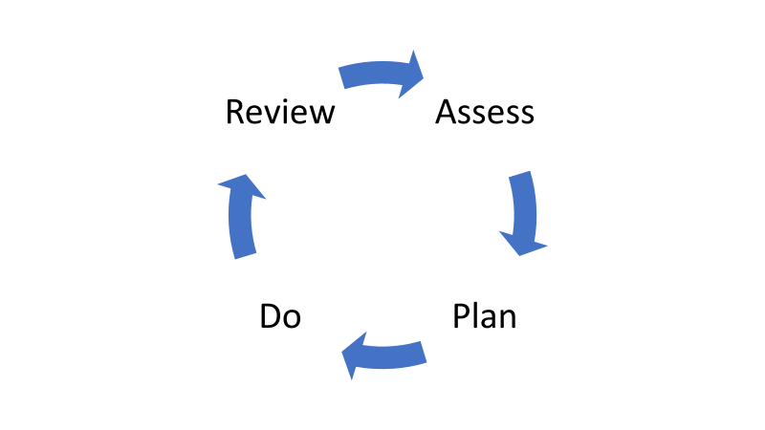

When a pupil is first enrolled with us an initial screening document is completed which includes baseline tests, Risk factors and Protective factors. This will enable us to triage tiers of support which we wrap around the learner.

**Tiers of Intervention**

Pupils will then be supported on one of three tiers.

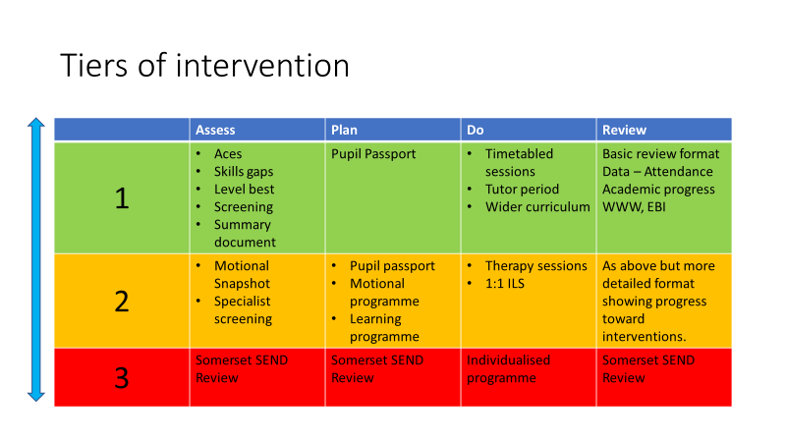

**ACES**

Are adverse Childhood Experiences. The more ACEs a person has the greater the risk of Social Emotional Mental Health or physical illness later in life. This gives us a feel of the risk factors impacting on the life of a young person.

**Skills Gaps**

Based on Ross Green’s Collaborative Problem solving approach which takes the assumption that ***Kids do well if they can*** and that young peope are behaviourally challenging because they lack the skills not to be. There is a gap between their ability to cope and our expectations. So, we don’t change our expectations we skill the pupils up so thay can meet them.

The skills gaps checklist enables us to assess the things a young person is currently finding difficult about school or life in general.

There are usually goals to behaviour. Misbehaviour can also be evaluated in terms of what the learner is gaining.

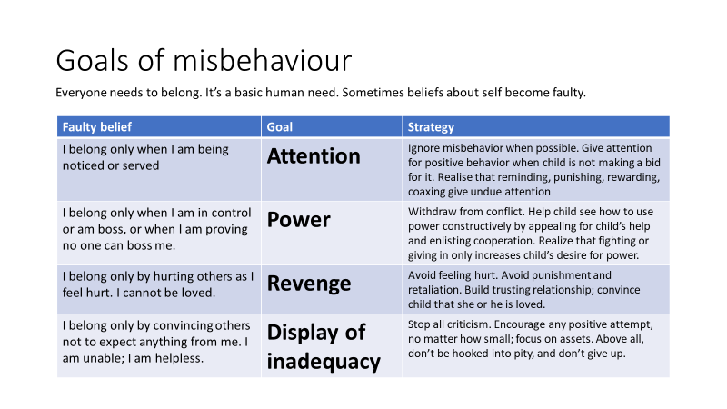

**Level Best**

Is part of our assesment tool informed by the skills gaps. There are two parts:

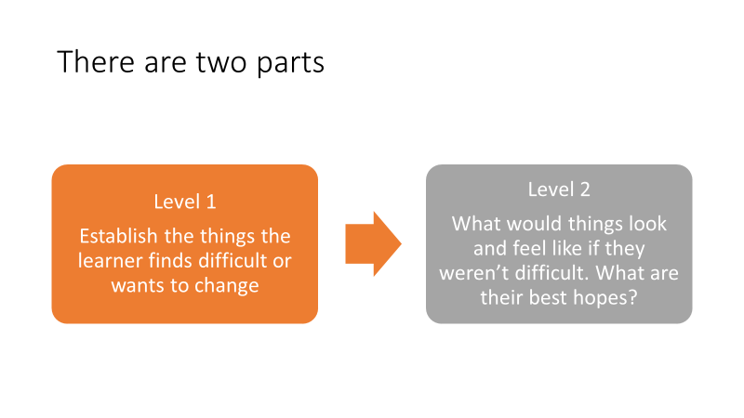

This then informs the **Pupil passport** which is the working document teachers and support staff use to differentiate lessons and interventions.

**Motional**

Pupils assessed at tier 2 will also undergo a more detailed diagnostic SEMH assessment. Motional is our assessment tool for SEMH. It draws on work from the Trauma Informed Schools network and the Adverse Childhood Experiences research.

Motional provides an easy-to-use online tool for identifying, assessing, and improving the emotional health and wellbeing of children and young people.  It is based on Professor Jaak Panksepp’s research on emotional systems in the brain and Dr Margot Sunderland’s extensive research, studies and expertise in executive functional skills. It records ACE and Protective Factor scores, and gives staff a whole-brain picture of students' mental health and wellbeing.

Motional measures different emotional systems in the brain (CARE, SEEKING, PLAY, FEAR, RAGE, PANIC/GRIEF based on prof Jaak Panksepp’s work) and several key executive function skills (handling stress, thinking & concentration, confidence & self-esteem, interpersonal skills, and emotional literacy – written by Dr Margot Sunderland) to give a whole brain picture of a child’s emotional and mental health.

Snapshots take about 5 minutes for someone who knows the system and the child well, up to 25-30 minutes for someone new to Motional doing a whole class. Snapshots are generally done by staff about children, and then they can create a Program of activities and relationship strategies that will target specific emotional systems for that child.

Snapshot results look like a bar graph with the answers underneath:

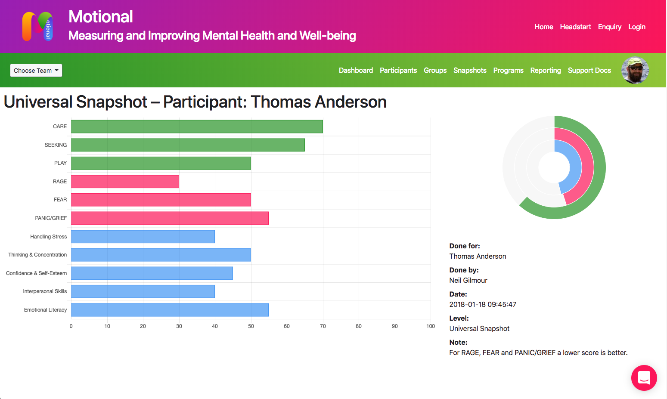

**Review**

All learners will have their provision reviewed every 6-10 weeks. The review will assess progress from baseline assessments. If a learner is dual registered with another provider the review will invite them to contribute to a shared plan.

We also have 3 Academic Review Days (ARD) each year where we invite parents/ carers and other agencies to a longer discussion about progress and celebrate achievements. For pupils at Tier 3 this is when we would complete the Somerset SEN Review.

**Reporting**

We report to parents/ carers and other agencies 3 times a year Autumn, Spring and Summer. The Summer report is an end of Year summary. These reports are what are discussed at ARD. As a Tutor you will be expected to write a report summarising progress and outlining next steps.

As a subject teacher you will be asked to assess learners against course aims and give a prediction of final grade. *If the learner keeps working at the current rate of engagement and understanding what might they achieve as a final grade.*

GCSE Grades now go from 1 to 9. For each Grade there are 3 letters:

Eg:

|  |  |
| --- | --- |
| 3a | At the top of this grade and could get to the next one |
| 3b | A solid grade at this level |
| 3c | There is danger of this grade slipping to the one below |

This is the same for Entry level which is divided in Entry 1, Entry 2 and Entry 3 with 3 being the highest level of Entry qualification.

|  |  |
| --- | --- |
| Entry level 3a | At the top of this grade and could get to the next one |
| Entry level 3b | A solid grade at this level |
| Entry level 3c | There is danger of this grade slipping to the one below |

Some of our vocational and practical courses are graded on a level 1 or 2 pass. Level 2 is equivalent to grade 4 in GCSE. Level 1 is equivalent to grade 3.

You will also be expected to give a grade for effort and engagement as well as make a subject comment.

Effort is how hard they have worked and Engagement is whether they arrived for lessons on time and got stuck in. These are both graded on a 1-5 scale with 5 the highest.

**A typical lesson structure**

How we structure the *rhythm or dance* of a lesson must give a feeling of predictability. This routine acts as a form of safety and enables the limbic system to relax and for the neocortex to take over.

Our learners thrive on this safety and it enables them to engage with learning much more quickly.

The beginnings and ends of lessons should act as a buffer from one lesson to another. Calming predictable starter activities, as learners enter the room, enables this safety. Then at the end of the lesson, checking in on what has been learned, by such as activities as exit cards, enables the learner to refocus on the lesson and be ready for the next one. This should be an intrinsic part of planning in any lesson academic or practical.

**The Role of the Tutor**

**Peer Coaching**

As a school we have taken the decision to not carry out formal lesson observations. We do not think this is the best way of assessing and evaluating staff. It is a false situation, where what you observe in a formal set up does not reflect normal daily practice. Members of SLT and Team Leaders are constantly in and out of lessons. Seeing what is going on and talking to staff and pupils about learning, this enables us to evaluate teaching and learning much more effectively.

As an additional part of our desire to support staff and to continually understand & improve WHY do what do, What we do and HOW we do it, we are beginning to develop a coaching culture where all teaching staff and support staff will have a coach. All teaching staff will have regular meeting to coach each other together and begin to use the language of coaching to challenge each other in our teaching practice. We will be working on developing this throughout 2021/22.

**Professional Development**

People perform best when they are trusted as professionals to “get on” with the job. There should a be high level of challenge but low level of threat in any organisation to move forward and to provide development opportunities so that people are stretched and motivated.

The Professional Development process is there to provide this challenge and to monitor performance of staff against agreed standards. If things begin to go wrong the process should build on regular line management so that there are no surprises, should issues of capability surface.

The process occurs as follows:

**Briefings**

Every day at 8.50am there is a whole staff briefing in the Atrium where we will go through main points for the day, themes and share good news. This will also be an opportunity to share key safeguarding messages

**Safeguarding Procedures**

All staff should read and be fully aware of school policy and procedures and read the core documents which are uploaded on the website.

***SchoolPod*** is the main record keeping system for any safeguarding concerns about young people. All staff will be given a log on and training in how to use it.

Everyone is responsible for ensuring safeguarding procedures are adhered to. The site is secure and the access and exit arrangements will ensure we know who is on site at any time.

All staff must wear ID badges at all times. There is no exception to this. The ID badge will also enable access to the building.

The Safeguarding Leads are:

Matt Clinkard – Assistant Headteacher (Designated Safeguarding Lead)

Matt Hill – Headteacher

Emma Hill – Assistant Headteacher

Our Safeguarding Governor is – Dan Palmer

Logging an incident on SchoolPod should not stop you speaking to one of these people immediately to seek advice. There are posters around the school with details about how to contact these people.

**COVID (safeguarding)**

School will adopt guidance from the DfE and PHE with regards to best practice in keeping staff, pupils, visitors and AP providers safe. Staff are expected to follow the school policy and the Headteachers guidance with regard to COVID safeguarding.

***If any member if staff has symptoms, they must test themselves with lateral flow tests provided by school, prior to coming into school.*** If positive, staff should not come into school and should follow PHE guidance. A confirmatory PCR test should be conducted. If a PCR test is positive, staff should self isolate in accordance with PHE guidance.

You must inform the Headteacher if you are positive.

September 2021: Staff are expected to test themselves AT HOME twice per week: Sunday evening and Wednesday evening. No tests should be conducted in school. Test results should then be sent to the NHS and DfE via website for logging test results.

**Eating with Pupils**

Staff are expected to eat with pupils at lunch and to also spend break time in and around the family rooms. This is an opportunity to build and sustain relationships and to extend the spoken language opportunities for our pupils.

**Teaching and Learning Resources**

We have a Curriculum Network Drive which contains all Teaching and Learning resources. Long and Medium term plans are stored here.

There is also a physical resources store adjacent to the Atrium which houses a range of resources, games, textbooks and workbooks. It is important to return resources once they have been used so that others can have access to them.

There is a lot of storage space in the building and staff will be allocated an area to store specific curriculum resources. For example all Maths and English resources will be in one place. There are also places to store personal teaching resources in the teaching walls and in storage units.

**ICT resources**

Our building has some state of the art ICT facilities. There are 6 interactive Avacor Screens located around the school. These come with a pen/ stylus plus an interactive keyboard and mouse. The remote controls for these devices are kept locked in the classrooms. Staff can also use this screen as a casting device from their laptops.

All other screens around the building can be “cast to” using any lap top or IPad. On Windows 10 devices this is done in the Action Centre tab using the Connect Symbol. The screen can then be used as an extension of the device. Volume control and on/ off buttons are controlled by remote which must be kept in the room.

**Velux Windows**

There are a number of rooms which have Velux Windows and blinds. These are controlled by remote device which enables the user to select the room and open close the windows or blinds. These remotes are kept in the main admin office and should not be operated by pupils unsupervised.

**Locking of doors**

We want to create an ethos where doors are not locked, however, some places should always be kept locked. They are:

Exam store – Separate key system

Server room – Separate key System

Disabled toilet and shower – Standard key

Main storage cupboards off the Art Space and in the SHOUT corridor – Standard key

Workshop when not being used – Standard key

Art Room when not being used – Standard Key

Staff work room when not being used – Standard Key

All staff are allocated a standard key which opens all internal doors apart from those on separate systems.

**Behaviour as communication**

Many of our young people present with challenging behaviours. There are two extremes on a continuum. Those who externalise their feelings and behave in ways that draw attention to themselves or distract from how they feel; and those who internalise and disassociate themselves from their environment effectively shutting down. Neither of these responses is healthy or ok.

Behaviour is usually, but not always a response to an emotion, but all behaviour is usually a form of communication and we as professionals should be adept at spotting and analysing what is being communicated.

This does not mean that all behaviour is acceptable and ok, it clearly is not. However, in the heat of the moment it is never a good idea to try to get a young person to think about why they are behaving in a particular manner; neurologically this is an impossible task.

***Attune***: Be alert to how they are feeling: demonstrate attuning to their emotional state showing you can catch how they feel through facial expression, body language, gesture, noises:. Demonstrate that you understand the intensity, pitch, pace, volume, expansiveness or spatial experience of the child’s emotional state.

***Validate***: Be alert to the child’s experience: validate their perspective/experience/feeling. This needs to happen before you move to help them regulate it. This is the beginning of being able to think about feelings. Avoid reassuring, persuading otherwise, contradicting.

***Containment***: Be alert to how they are feeling: demonstrate containment. Show that you catch and understand the pitch/intensity/quality of their feeling or mood and that you can bear it. Make their strong emotions a survivable experience. *Catch it, match it and digest it by thinking about it and offering it back, named, in small digestible pieces*. This will make bearable the strongest emotional state.

This shared experience builds trust for the child: in you, in adults and in the world. Be alert to how they are feeling: demonstrate emotional regulation by soothing and calming their distress. Catch the emotion, match it and help the child to regulate the feeling up or down. They need to experience being calmed before they can do it for themselves. You will be communicating the capacity to regulate emotional states by modelling how to do it.

Only after this can we ***Shine a Light on the Behaviour*** and use it as an opportunity to coach and teach the behaviour which is ok and that which is not and explain why it is not.

There are 5 qualities which make up the best background atmosphere for emotional learning – PLACE:

P=Playful

L=Loving

A=Accepting

C=Curious

E=Empathic

Rules and expectations are also a form of containment. We should always model the behaviour and language we expect from our young people. We have developed consistent approaches to working with young people from across the school. We have agreed on the following:

|  |
| --- |
| **3 Rules**   * Ready * Respect * Safe |

|  |
| --- |
| **3 Consistent adult behaviours**   * Welcoming * Calm * Aspirational |

We also adopt a scripted approach to having conversations when behaviour is not following one of the 3 rules and is stopping learning taking place. This is a 30 second conversation spoken in a calm but assertive tone. Be mindful of your body language and tone; speak to the child in an adult way. Get down to or below the pupils level. There are 3 parts to the conversation:

|  |
| --- |
| 1. I notice that you … (very specific feedback on what is happening) 2. I know you are better than this, remember last week when ….(reminder of previous good behaviour) 3. This is learning time now so I’d like to have a 2 minute conversation with you about this at (lunch, break, planned time) |

It is important to then walk away and get drawn into secondary behaviour designed to drag you off at a tangent.

**6 ways of rerouting power play and tangents/ Fogging:**

I understand that you are (angry, upset, livid)…

I need you to … (come with me so we can resolve this properly)

Maybe you are right... (maybe I need to speak to them too)

Be that as it may... (I still need you to join the group)

I’ve often thought the same... (but we need to focus on)

I hear you... (It’s not easy but I know you can do it brilliantly)

**The repair meeting**

Sometimes a longer meeting is necessary with a pupil to repair the relationship. This should be a friendly informal meeting in one of the quiet rooms with a glass of water or a cuppa provided by you for the pupil. If a pupil clams up answer the questions yourself and muse curiously.

1. What happened? Listen and don’t interrupt
2. What were you thinking/ feeling at the time?
3. What have you thought since?
4. Who else was affected by what happened?
5. How have they been affected?
6. What can we do differently in the future?

Use your judgement to phrase the questions for the pupil in front of you. The meeting should feel natural not stinted.

Repair meetings are also used after periods of Fixed Term Exclusion.

Learning of any kind can only take place when these consistencies are present or felt. All adults should adopt a common approach recognising that punishments or heavy sanctions do not work with our pupils. They are adept at playing games with them. Secondary behaviours designed to deflect from the original behaviour, or enter into power play should always be ignored. However, knowing that someone will at some point talk to them about their behaviour will get the message across. If someone is refusing to work or move it’s never a good idea to get drawn into long protracted tangential arguments or bargaining.

**What not to do when something goes wrong**

Emotions are caught, particularly fear. Sometimes the behaviour of our young people can be shocking, scary or upsetting. It is really hard not to show our feelings but if we demonstrate fear, anxiety or upset through our body language, facial expression tone of voice or stance then this can bring about further feelings of insecurity in the young person.

Remain calm and ask for support and help. This is never a sign of weakness. We work as a team and everyone needs to be comfortable with that.